League report week 18

Colebridge A closed the gap on leaders Rugby A to 3 points as they trounced Free Church C 9-1 in Division 1. Alan Hewitt and Kate Hughes bagged hat-tricks and Mike Rinnhofer added two but could not prevent Kit Turner grabbing his first premier win. Wellesbourne travelled to St Georges A and forced a draw. Alan Cotton and Pete Dunnett secured braces and Dunnett took the doubles with Gary Stewart. However, man of the match was Matt Jordan who won his three for the home side, allied to singles from Damon Fenton and Gary Jackson. Wellesbourne then visited Free Church B but fell 3-7 due to Sam Weaving’s treble and a double from Sam Wiggins. Jeff Harris added one and the pair of Sams took the doubles. Cotton (2) and John Price (1) replied. Free Church B also overcame Nomads A 8-2, Weaving (3), Wiggins (2) and Michael Ho (2), Weaving pairing with Ho for the doubles. Reserve Syed Moyinuddin and Tony Thomas took the Nomads’ points. St Georges B propelled themselves into third spot after crushing their A team 9-1. Mark Jackson and Laurence Sweeney were unbeaten in singles and doubles whilst Ron Vose won twice, falling to Jordan.
In division 2 Colebridge C edged basement side Eathorpe A 6-4 thanks to Michael Credland’s triple. Neil Wheatley chipped in with two and Mike Evetts one. Binh-Khoi Nguyen replied with two for the villagers plus the doubles with Pete Titmas. Bernard Reman took the other point. With matches in hand Phoenix O sit in a handy 5th place and defeated the bottom but one side St Georges D 8-2. Paul Calloway and Richard Jardim claimed maximums and won the doubles with Roy Joiner contributing one. Tracey Fletcher and Richard Grover gained the Georges’ points. Phoenix then went on to beat St Georges C 7-3, Calloway (3), Callum Martin (3) and the doubles, with Brian Aston, Kevin Finn and Will Fletcher all responding with singles. Rugby B moved second beating Free Church E 7-3 with trebles from Sam Cafearo and Danny Orr and a single from Jo Outhwaite. Phil Blowey and Livvy Fletcher won singles and the doubles for Church. Third placed Whitnash A saw off St Georges C 8-2, Kevin Ariss and Paul Riman taking 7 of the points and Dennis Woodhead the other, falling to Aston and Len Coonan.
The top three sides in Division 3 had narrow 6-4 successes. Free Church G edged County Council C through hat-tricks from Ricardo Bolanos and Adam Pulman. Doug Lowe, Steve Poole and Ian Stevens responded with singles and a Lowe/Stevens doubles win. Second placed Free Church F got home by the same scoreline against Nomads C. James Robertson was unbeaten, Lewis Singleton won twice and sister Jenny once. Richard Miles took two and the doubles with Les Hoggins and Steve Kurle chipped in with one to keep Nomads in contention. Third placed Snitterfield A pipped Whitnash B, Stuart Ayres, Tim Fell and Kim Wong all taking two. Greg Swan won twice for Whitnash and notched the doubles with Richard Smith who won once. Rugby D made life difficult for their higher placed E team going down narrowly 4-6. Milly Bradshaw and Dave Cox won twos for E and Freddy Jones one as well as the doubles with Bradshaw. Harvey and Oliver Fowler each won twice in reply.
Eathorpe D increased their chances of the Division 4 title after beating second placed Free Church K 6-4. John Ablett and Charlie Wragg won twice and Jon Ablett once with the Abletts combining for the doubles. Stuart Mills was unbeaten for Church and son Joe won once. Free Church H remain top and took out their J team 9-1. Emily Beasley and Eve Briscoe were unbeaten in singles and doubles and Emma Kilpatrick won twice. Janice Rowan avoided the whitewash. Fourth placed Eathorpe C crushed County Council E 10-0, Will Apted, Paul Deavall and Michael Rossington the men in form. Ashorne A beat Free Church I 8-2 with trebles from Chris Bowles and Roger Kelley who also won the doubles and a single from Steve Bolton. Chris Jones and Fiona Wyburn replied.
In Division A Free Church M had a welcome 3-2 success over Rugby F when Nikit Sajiv won his two and steered Jay Virdi to a 13-11 in the 5th doubles’ win. Callum and Steve Ball both nailed singles in return. Norton Lindsey A also won 3-2 against Free Church N despite Eve Briscoe’s excellent brace. Ron Shakesheff and John Walker won the doubles to add to their singles wins.
Free Church O made it 15 points from 3 matches in Division B when defeating Free Church AA in the first match at the new venue of Lillington Club. Ashley Knott and Ged Kuprys amassed the points.
Ashorne B edged Fissc B 3-2 with a pair of wins from Jim Jack who guided Tony Philpott to a doubles win. Martin Hamar and Mandip Takhar kept it close.
Newly promoted Rugby I have found their feet in Division D whitewashing County Council F through Angel and William Chen. They followed this up with a 3-2 win over Free Church Q, William again winning two and Angel one, falling to Ben Hall who partnered Richard Hancox to the doubles. Q in turn defeated County Council 4-1, Hall (2), Findlay Douglas (1) and the doubles, with Steve Maggs gaining the consolation.
In Division E Norton Lindsey C won 3-2 against Free Church T Guy Harrison winning twice and Edward Rogers once. Ellie Goldsmith won a singles and paired with twin sister Amie for the doubles.
Free Church Z made their Division F debut, losing out 2-3 to their X side despite a double from Ben Holding. Alex O’Driscoll and Emma Pulman each took a singles and paired for the doubles. Free Church V showed less mercy to Z taking all 5 points through Chris Hearn and Sundeep Virdi.

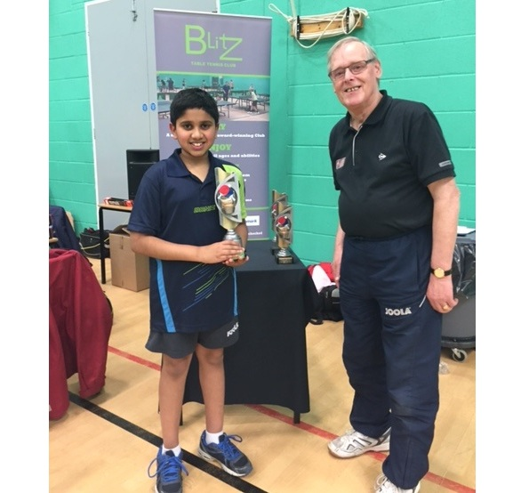
Nikit Sajiv receiving his trophy from Ken Elliott
Blitz 2-star
Nikit Sajiv of Lillington Free Church table-tennis club travelled to Gainsborough to compete in the Blitz 2-star tournament and emerged with the U13 title.
Nikit won his group easily against Thomas Lambert of Cleveland, Frazer Winfield of Lincolnshire and Max Chadwick of Yorkshire. He received a bye in the preliminary knock-out round before eclipsing Harrison Dean 6,6,8 in the quarter-final. In the semi-final he had his toughest test coming back from 1-2 down to win 3-2 against Che Goldbourne of Yorkshire. England number 21 Charlie Turner of Yorkshire who is ranked one place behind Nikit, was his Final opponent. However, the result was never in doubt as the Leamington boy triumphed 9,3,5.

