Table-tennis Report
Courier 8th February 2019
Last week was a catching-up week in the Leamington League. In Division 1, fourth placed Rugby A took all 10 points against relegation threatened Nomads Aces, Ryan Lines, Adrian Pilgrim and Danny Ricks proving too strong. Phoenix A squeezed past Whitnash A 6-4 despite a hat-trick from Mark Woolerton. Tony Deren added one for the losing side but Callum Martin and Mark Rose both won two and the doubles, with Taran Dhillon managing one. However, with Martin beating Deren 12-10 in the 5th and Rose accounting for Kevin Arris 11-9 in the 5th the result could easily have been different.
Free Church E romped to a 7-3 win over County Council C in Division 2. A mixture of experience and youth saw them home as Ian Beasley and Josh Yarrow won the points. Tony Ford, Mark Freeman and Cliff Jackson all won singles in reply. In another re-arranged match Free Church E were on the reverse of a 7-3 scoreline, falling to St Georges A. Damon Fenton notched a triple, Gary Jackson won two and Barry Hook one with Hook and Jackson the winning doubles partnership. Yarrow grabbed two excellent wins, both in 5 set tussles, and Beasley beat Hook, also in 5. However, St Georges A kept up their quest for promotion when defeating Nomads Enigmas 10-0. Fenton, Matt Jordan and Earl Sweeney were unstoppable on the night.
St Georges D defeated Free Church G 8-2 in Division 3. Jerry Simmons starred with a treble and a hand in the doubles win with Richard Grover. Grover and Andy Caine lent good support with braces whilst Church replied through Milly Green and Tom Yarrow. Leaders Flavels A had a 9-1 victory to celebrate when entertaining CountyCouncil D. Shivam Kapur and Mick Bennett were unbeaten but Trevor Bradley suffered his first defeat of the season at the hands of Derek Harwood. However, he put that aside when winning the doubles with Kapur. Free Church J pipped their H team 6-4. Gurudutt Chandrasekhar was the main difference winning his three though Ben Hall gave terrific support when winning two and grabbing the doubles with Chandrasekhar. In reply Jerry Chung won twice, Nicholas Ho once and Owain Jones once, going down in 5 in his two other singles. However, Free Church H did much better in a second derby fixture against Free Church I winning 8-2. Chung and Ho won trebles, Jones took one and Ho and Jones lifted the doubles 11-8 in the 5th. Joe Shrimpton and Keith Knott won singles in response.
Ashorne D enjoyed a 9-1 win at home to Eathorpe D in Division 4. Steve Kay and Roger Pye recorded maximums and also paired for a doubles success. Mark Bridgeman got the other two points but was beaten by Thomas Backhouse. Nomads Dragons kept up their hopes of promotion with an 8-2 win over County Council F. Janice Rowan won her three, Catherine McAuley won twice, as did Jill Weaving, and Rowan and Weaving bagged the doubles. Simon Chalker had two wins for Council. Rugby F are also going well and secured 8 points on their visit to Warwick University B. Alex Bowe won his three singles, Dan Farrow’s two included a 5 set win over Taran Birdee and Grace Newman won twice. Farrow and Newman won the doubles in 5. Sam Pattison gained the students’ two points. In the derby match between Eathorpe’s B and C sides, B emerged as 9-1 winners. John Ablett and Roger Palmer returned maximums and Jim Levack lost just the one to Shaun Martin. Ablett and Levack took a close doubles 11-9 in the 5th. Free Church K sneaked a 6-4 win against County Council F. Young George Barnes was in excellent form winning his three, Marc Briscoe and Phil Booth added singles and won the crucial doubles. Bernard Hardingham (2), Eric Barthorpe (1) and Jeremy Sampson (1) replied. Leaders Warwick University A could only muster 2 players on their visit to Eathorpe D but Calvin Becker and Kryzsztof Bolhuis wrapped up all 7 points on offer.
Division A leaders Eathorpe D overcame Rugby G 4-1. Chris Atkins won his two and partnered Luca Bloodworth to the doubles. Bloodworth won one but could not get the better of Tie Chen. Free Church L are chasing the top side and amassed all 5 points against Eathorpe F with brothers Chris and Nicholas Ho in top form. They then visited the strong Rugby H side winning 4-1. Nicholas won his two, Chris won once and the brothers snatched the doubles. Snitterfield B pocketed 5 points against FISSC A through Michael Klein and Dennis Mockford. However, it was closer when they visited AshorneA to return with a 3-2 win. Klein again won two and paired with Mockford for a doubles win. Steve Kay and Roger Pye kept the home side in it.
Free Church N accounted for their P side 4-1 in Division B. Nathan Jackson won his two, Alfie Ransom supported with a single and helped Jackson to land the doubles. Daniel Stone was good value for the consolation. The third Free Church side in this Division, FC M, swept aside newcomers Radford 5-0 courtesy of Nick Darwen and Dan Shaw. Ashorne B made a good start by beating Rugby J 4-1. Mark Bridgeman (2) and Steve Bolton (1) plus the doubles led them to success with Kuba Kucharczyk avoiding a whitewash.
The biggest winners in Division C were Rugby I whose visit to Eathorpe I netted them 4 points. Oliver Ferguson won two and his grandmother Olive added one and steered him to the doubles. John Gymer prevented a rout. Eathorpe G edged their J team 3-2 with Richard Freeman and Paul Holtby both winning once and then combining for a winning doubles. Ben Anderton secured a brace for J. FISSC A also had a narrow 3-2 win against County Council F. Martin Hamer and Mandip Takhar each took a single and then teamed to win the doubles. Bernard Hardingham won Council’s points.
Eathorpe H were relegated to Division D in December but made a winning return when beating Free Church S 3-2. Declan Jay won two and brother Joshua won one, losing to Arnav Mulay who also guided Deva Bakthisaran to seal the doubles. Eathorpe followed this up with a 5-0 win over Free Church R, the Jay brothers enjoying unblemished records.

Warwickshire Schools Individual Championships
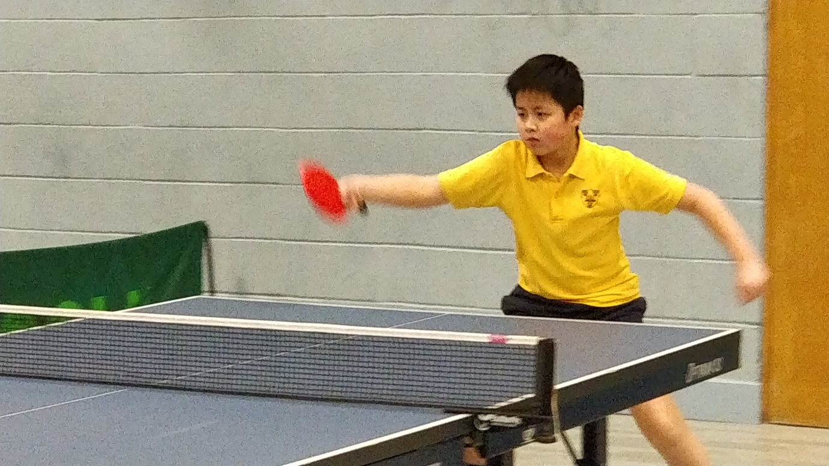
The Girls’ events and the younger Boys’ events of the Warwickshire Schools Individual Championships were held at Lawrence Sheriff School, Rugby on Thursday night.
In the under 11 Boys the entrants were split into two initial groups and were joined by Mia Chan who was the only entrant in the Under 11 girls.
Mia, of the Croft School in Stratford, beat Denzel Ambilicku and Alfie Sam before losing to Louis Emmanuel of Pearl Hyde Primary, Coventry, an eventual finalist. This put Mia into the semi-final where she faced her cousin, Jun Chung of Stratford Primary who had beaten Jack Sutton and Luke Gospel, both of Pearl Hyde, in his group. Jun won his semi in three before taking the Final 8,7 and 4 to become the Schools Champion.
Chris Ho of KES Grammar School in Stratford entered the under 13 Boys Singles and defeated Ben Jenner and Sam Byrd in his group. In the first round of the knock-outs he dispatched Alfie Bee to give himself a place in the Final group of 4. Chris beat Matthew Clarke 3-1, Matthew Burgess 3-2 and Oliver Ferguson 3-0. All of his opponents attend Lawrence Sheriff.
Chris, Jun and Mia, as under 11 Girls Champion, go forward to the National Schools Finals on 27th April.
Erin Darwen of North Leamington School entered the Under 16 girls event. There were just two entries but the pair were joined by Angel Chen, the under 19 representative. Erin did very well to take a set off Sophie Rinnhofer, the England number 16 cadet, and then another good performance saw her lose narrowly to Chen in 5.

