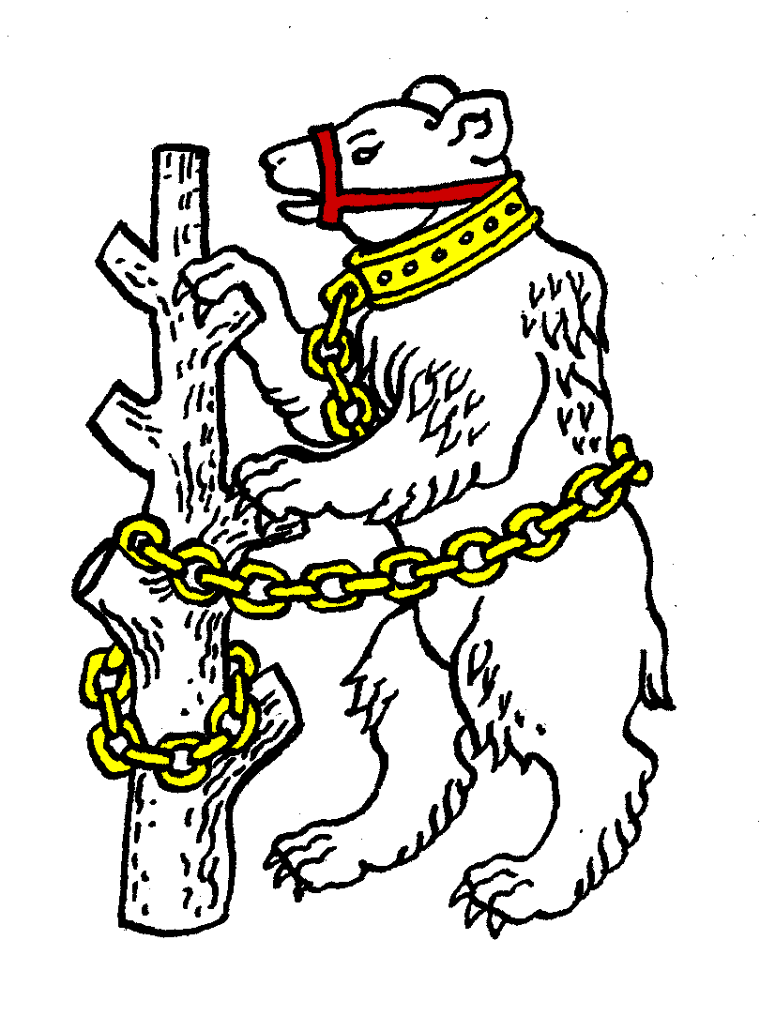
Warwickshire
Table Tennis Association

Affiliated to Table Tennis England

Handbook
2017/18

Table tennis... a sport for all, for life!

www.wtta.org.uk

Officers

President - Philip Paine 01926 772067 philpaine14@gmail.com
Chairman/National Councillor - Estyn Williams 01926 855729 estynwilliams@gmail.com
General Secretary/Welfare Secretary - Caroline Williams
01926-855729 carolineandestyn@gmail.com
Treasurer/Deputy National Councillor/County Match Secretary - Malcolm Macfarlane 07974 649067 mmacfarlane@tabletennisengland.co.uk
Publicity Secretary Michael Browne 07960 378790 browne.m@blueyonder.co.uk
Umpires Secretary – Stephen (‘Inky’) Moss 0121 706 1065 inkymoss@yahoo.co.uk
Coaching Secretary – Ian Ferguson 07843 560628 fergsta1@gmail.com
Schools Representative - Jo Outhwaite 07799 650635 warwickshireschoolstabletennis@gmail.com
Life Members – Ian Ferguson, Veronica Jackson, Bob Montgomery, David Palmer, Geoff Taylor, Thalia Whitehead

Websites
ITTF – ittf.com
Table Tennis England – tabletennisengland.co.uk
Midland League – tabletennis365.com/midland
Warwickshire – wtta.org.uk
Birmingham & Solihull – tabletennis365.com/Birmingham
Coventry – tabletennis365/Coventry
Leamington – ldtta.co.uk
Nuneaton – tabletennis365.com/Nuneaton
Rugby – rugbytabletennisclub.net
Stratford – tabletennis365.com/stratford-upon-avon

Age Categories for Season 2017/18
Age categories are determined by age on 31 December 2017.
Under 11 – born in 2007 or later
Under 13 – born in 2005 or later
Cadet (under 15) – born in 2003 or later
Junior (under 18) – born in 2000 or later
Youth (under 21) – born in 1997 or later
Senior – any age
Veteran (over 40) – born in 1977 or earlier
Over 50 – born in 1967 or earlier
Over 60 – born in 1957 or earlier
Over 70 – born in 1947 or earlier
Schools events use different age groups based on the school year.

Warwickshire Table Tennis Association

Welcome to Warwickshire Table Tennis Association which promotes table tennis in the traditional county of Warwickshire comprising the areas of Birmingham City, Coventry City, Solihull Metropolitan Borough and Warwickshire County Councils.

If you are an Affiliated Member of Table Tennis England and one of Warwickshire’s five local leagues (Birmingham & Solihull, Coventry, Leamington, Nuneaton and Stratford) you are a member of Warwickshire Table Tennis Association.

This mini handbook gives as much information as it can in the space available. More details are on our website www.wtta.org.uk

If you would like to be considered to represent for Warwickshire please tell the County Match Secretary (see under officers). Full information on playing for Warwickshire is given on the website. Warwickshire's registered colours are red shirt with black shorts.

Schools Table Tennis
Schools table tennis in Coventry, Solihull and Warwickshire is organised by Warwickshire Schools TTA – Jo Outhwaite (see under officers) - and in Birmingham by Birmingham Schools TTA – Ed Lynn 07500-601219 edward.lynn@colebridge.co.uk

Table Tennis England
To play competitive table tennis you must be a Player Member of Table Tennis England, the National Governing Body of the sport in England which costs £14 (£7 juniors). If you do not play competitive table tennis you are advised to join as an Associate Member which is free of charge. This includes those who attend coaching or practice at a club, coach, umpire or assist and family members. You can join on line via the Table Tennis England website.

Table Tennis England provides public liability cover for its Player and Associate Members and personal accident cover for its Player Members in connection with table tennis. As with all insurances conditions & exclusions apply. Details are on the Table Tennis England website.

International Table Tennis Federation (ITTF)
ITTF is the world governing body of the sport with over 200 National Associations and over 30 million competitive players worldwide. Table Tennis is an Olympic and Paralympic sport.

Safeguarding Young People in Sport
All young people have the right to have fun and be safe in sport. For advice on any safeguarding issue please contact the Welfare Officer, Caroline Williams (see under officers) or, if you prefer, the Table Tennis England child protection helpline 07507 860034 or judy.rogers@tabletennisengland.co.uk

County Championship Results 2016/17

Cadets 1B | P | W | D | L | Pt
Durham | 7 | 7 | 0 | 0 | 14
Lincoln | 7 | 5 | 1 | 1 | 11
Stafford | 7 | 4 | 1 | 2 | 9
Warwickshire | 7 | 3 | 2 | 2 | 8
Cambridge | 7 | 1 | 2 | 4 | 4
Suffolk | 7 | 1 | 2 | 4 | 4
Leicester | 7 | 1 | 1 | 5 | 3
Norfolk | 7 | 1 | 1 | 5 | 3
Juniors 1A | P | W | D | L | Pt
Nottingham | 7 | 6 | 1 | 0 | 13
Yorkshire 2 | 7 | 5 | 0 | 2 | 10
Cambridge | 7 | 4 | 2 | 1 | 10
Cheshire | 7 | 4 | 1 | 2 | 9
Norfolk | 7 | 2 | 2 | 3 | 6
Warwickshire | 7 | 1 | 2 | 4 | 4
Stafford | 7 | 1 | 1 | 5 | 3
Northants | 7 | 0 | 1 | 6 | 1
Seniors Premier | P | W | D | L | Pt
Sussex | 7 | 7 | 0 | 0 | 14
Nottingham | 7 | 5 | 1 | 1 | 11
Warwickshire | 7 | 5 | 0 | 2 | 10
Berkshire | 7 | 3 | 1 | 3 | 7
Middlesex | 7 | 1 | 2 | 4 | 4
Derby | 7 | 1 | 2 | 4 | 4
Dorset | 7 | 2 | 0 | 5 | 4
Lincoln | 7 | 1 | 0 | 6 | 2
Senior 1A | P | W | D | L | Pt
Yorkshire | 7 | 6 | 1 | 0 | 13
Leicester | 7 | 5 | 1 | 1 | 11
Cheshire | 7 | 4 | 1 | 2 | 9
Norfolk | 7 | 4 | 1 | 2 | 9
Northants | 7 | 2 | 1 | 4 | 5
Middlesex 2 | 7 | 1 | 2 | 4 | 4
Essex | 7 | 1 | 2 | 4 | 4
Warwickshire 2 | 7 | 0 | 1 | 6 | 1
Veterans Premier | P | W | D | L | Pt
Nottingham | 7 | 6 | 1 | 0 | 13
Leicester | 7 | 6 | 1 | 0 | 13
Yorkshire | 7 | 3 | 2 | 2 | 8
Warwickshire | 7 | 4 | 0 | 3 | 8
Kent | 7 | 3 | 0 | 4 | 6
Dorset | 7 | 2 | 0 | 5 | 4
Hertford | 7 | 1 | 1 | 5 | 3
Sussex | 7 | 0 | 1 | 6 | 1
Veterans 3A | P | W | D | L | Pt
Warwickshire 2 | 7 | 7 | 0 | 0 | 14
Cambridge 3 | 7 | 4 | 2 | 1 | 10
Northants 3 | 7 | 4 | 1 | 2 | 9
Cheshire 2 | 7 | 4 | 1 | 2 | 8
North Wales | 7 | 2 | 1 | 4 | 5
Norfolk 3 | 7 | 1 | 1 | 5 | 3
Shropshire | 7 | 1 | 2 | 4 | 3
Norfolk 2 | 7 | 0 | 2 | 5 | 2
Over 60s 1A | P | W | D | L | Pt
Cheshire | 7 | 7 | 0 | 0 | 14
Warwickshire | 7 | 5 | 1 | 1 | 11
Yorkshire 2 | 7 | 4 | 2 | 1 | 10
Worcester | 7 | 3 | 2 | 2 | 8
Cheshire 2 | 7 | 3 | 1 | 3 | 7
Cheshire 3 | 7 | 2 | 0 | 5 | 4
Nottingham | 7 | 1 | 0 | 6 | 2
Warwickshire 2 | 7 | 0 | 0 | 7 | 0
County Championship Divisions 2017/18
There are championships for cadets, juniors, seniors, veterans and over 60s. Each age group has a premier division, then two or more equal status 1st divisions (1A, 1B etc), 2nd divisions (2A, 2B etc) and so on. Divisions normally have 8 teams; the top team in each is promoted and the lowest two are normally relegated.

Division | Counties
Cadet 1B | Cambridge, Lancashire, Leicester, Lincoln, Stafford, Suffolk, Warwickshire, Yorkshire 2 (8)
Junior1A | Cheshire, Durham, Lincoln, Norfolk, Stafford, Warwickshire, Worcester, Yorkshire 2 (8)
Senior Premier | Berkshire, Derby, Devon, Middlesex, Nottingham, Sussex, Warwickshire, Yorkshire (8)
Senior 2A | Cambridge, Hertford, Northumberland, South Yorkshire, Stafford, Warwickshire 2, Worcester (7)
Veteran Premier | Avon, Dorset, Kent, Leicester, Northumberland, Notts, Sussex, Warwickshire, Yorkshire (8)
Veteran2A | Derby, Leicester 2, Leicester 3, Northants, Northants 2, Stafford, Warwickshire 2, Yorkshire (8)
Over 60 1A | Cheshire 2, Cheshire 3, Lancashire, LIncs, Notts, Warwickshire, Warwickshire 2, Worcestershire, Yorkshire 2 (9)

Warwickshire Championships 2016/17
Men: Xiaoyang Ma beat Ryan Stockham
Women: Kate Hughes beat Dawn Sagoo
Men’s Doubles: Simon Griew/Mark Jackson
beat Ryan Lines/Ryan Stockham
Women’s Doubles: Helen Adams/Dawn Sagoo
beat Kate Hughes/Neetha Ramash
Mixed Doubles: Simon Griew/Dawn Sagoo
beat Kate Hughes/Ryan Stockham
Veterans: Mark Jackson beat Pat Glynn
Over 50: Stephen Robinson beat Simon Griew
Over 60: Patrick Glynn beat Paul Calloway
Over 70: Terry Cooper beat Roger Ellerington
Veteran Doubles: Michael Browne/Pat Glynn
Beat Nilton Green/Simon Griew
Junior Boys: Timmy Cooper beat Jack Green
Junior Girls: Livvy Fletcher beat Lisa Rinnhofer
Cadet Boys: Ricardo Bolanos beat Nikit Sajiv
Cadet Girls: Emily Beasley beat Ciara Hancox
Under 13 Boys: Eduardo Bolanos beat Nathaniel Saunders
Under 13 Girls: Sophie Rinnhofer beat Erin Darwen
Under 11 Boys: Nathaniel Saunders beat Wafiq Wajid
Junior Boys Doubles: Ricardo Bolanos/Timmy Cooper
beat Sam Cafearo/Callum Ball
Junior Girls Doubles: Emily Beasley/Ciara Hancox
beat Jenny Singleton/Milly Green

Calendar of Events 2017/18

Arrangements can occasionally change. Please check on the website www.wtta.org.uk or with the contact shortly beforehand.

Date | Event | V | C
Sat 9 Sep | Graded Tournament | N | 2
Sat 16 Sep | U13/U15 Talent ID day/U18 Trials | R | 1
Sat 7 Oct | Cadet County Champs Div 1B | R | 7
Sat 7 Oct | XLNT Sports W Mids Jnr/Cadet 2 star | W | 1
Sat/Sun 21/22 Oct | Vet County Championship Premier Div | A | 1
Sat/Sun 28/29 Oct | Senior County Champs Premier Div | P | 1
Fri 17 Nov | Schools Team Competition | R | 5
Sat 3 Dec | Junior County Championship Div 1A | R | 4
Sun 10 Dec | Warwickshire Closed (Juniors/Vets) | N | 1
Sat 16 Dec | Cadet County Champs Div 1B | R | 7
Sun 17 Dec | Warwickshire Closed (Seniors) | N | 1
Sat/Sun 13/14 Jan | Vet County Champs Premier Div | D | 1
Fri 19 Jan | Schools Indiv U11/U13 Boys/all Girls | R | 5
Fri 26 Jan | Schools Indiv U16/U19 Boys | R | 5
Sat/Sun 3/4 Feb | Senior County Champs Premier Div | * | 1
Sat 3 Feb | Graded Tournament | N | 2
Sat 24 Mar | Junior County Championship Div 1A | R | 4
Sun 1 Apr | Easter Sunday | - | -
Sat 28 Apr | Nittaku West Midlands Senior/Vet 2 star | W | 1
Sat 12 May | Graded Tournament | N | 2
Thu 21 Jun | Warwickshire AGM | K | 3
* To be confirmed

V - Event Venues
A – Ashford TTC, Woodthorpe Rd, Ashford TW15 3JX
B – Blitz, Gainsborough Academy, Sweyn Lane, Gainsborough DN21 1PB
D – Draycott TTC, New Street, Draycott, Derbyshire DE72 3NJ
K – Kenilworth Wardens, Glasshouse Lane, Kenilworth CV8 2AL
N – St. Nicholas Park, Banbury Rd, Warwick CV34 4QY
R – Lawrence Sheriff School, Clifton Rd, Rugby CV21 3AG
W - Wood Green Academy, Wood Green Rd, Wednesbury WS10 9QU

C – Event Contacts
1. Malcolm Macfarlane (see under officers)
2. Jill Weaving 01789 470975 jill_weaving@yahoo.co.uk
3. Caroline Williams (see under officers)
4. Ryan Lines 07854 901353 ryan.lines1994@gmail.com
5. Jo Outhwaite (see under officers)
6. Ian Ferguson (see under officers)
7. Harry Purewal 01926 771776 afroharry@hotmail.co.uk

