Table-tennis Report
Courier, 8th November, 2013
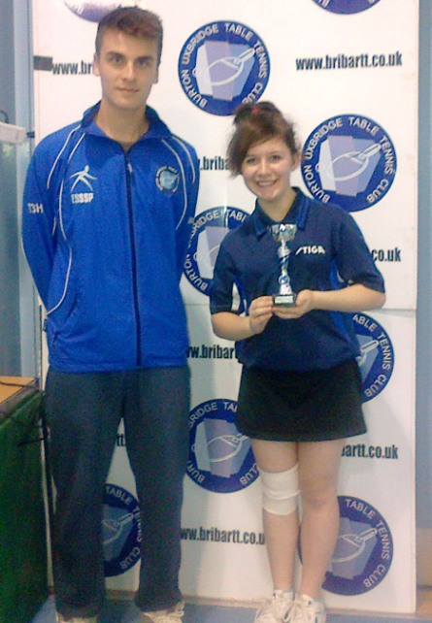
Katie Singleton receiving her trophy
Lillington Free Church’s Katie Singleton took a mighty leap in her development at the weekend when she got to the Under 18s Girls’ Final of the Burton Uxbridge 1-star tournament, losing to Katie Holt. On the way she had an excellent win over Amber Basford and also knocked out her club-mate Jenny Singleton. Jenny finished 4th nailing wins over Georgia Harris and Amie Gittins. Both girls, still under 14s, reached the semi-finals of the Under 15 Girls’ competition. Jenny beat Amy Bestall and Amie Gittins losing out to Charlotte Boston in the semis. Katie again beat Amber Basford before tasting defeat to Katie Holt. Sam Weaving made it a club double by reaching the Under 18s Boys’ Final. Sam won a tough initial group, including a 3-1 success over Alex Tomlinson, whom he had never beaten before. He then strode to the semi-final where he beat Ashley Offley 3-2 in a thrilling match in which Sam was trailing 0-4 in the 5th.
In Division 1 Rugby A moved to top spot with a convincing 8-2 win over 3rd placed Free Church A. Jesse Kendrick-Hill and Matthew Outhwaite were unbeaten and Ryan Lines added two. Phoenix A edged Rugby B 6-4 with Aaron Riley and Ryan Stockham undefeated. Paul Lilley, Danny and Sam Ricks all notched a singles win and the brothers took the doubles. County Council A crushed Free Church B 10-0 through Chris Brewer, Pat McCabe and Phil Paine.
Two emphatic wins from Colebridge B saw them march into 4th place in Division 2. Flavels A were trounced 10-0, John Chandler, John Taylor and Neil Wheatley the heroes and the same trio accounted for St. Georges D 9-1, Chandler and Taylor maximum men. Enigmas have gone third with games in hand and eased their way past St Georges E 8-2 with Dong Wei securing a treble. Gary Jackson and Malcolm Macfarlane won twice with young Sam Coombes taking an eye catching two victories for the visitors. Nomads A came away from Snitterfield A with 8 points, Andy Davies invincible and Ian Beasley and Sam Weaving winning twice. Whitnash A also enjoyed a trip to Snitterfield, winning 7-3 including a Paul Riman hat-trick. Dennis Woodhead (2) and Richard Smith (1) were the other singles winners. Free Church C had an excellent 6-4 win at Phoenix O after an exciting triple from 15 year old Kit Turner. Sam Wiggins (2) and Sol Hayes (1) gave solid support.
In Division 3 early leaders Rugby D were surprised by Free Church F in a re-arranged match. Kim Wong took his three and the doubles with German debutant Sarah Barkowski who had two fine wins. Young Josh Wyatt-Smith made it seven points with a well-earned victory. Rugby bounced back to take a strong County Council C 7-3 with Dave Cox and James Robertson posting trebles and Jo Outhwaite a vital win. Free Church E are looking a strong side and crushed Nomads B 9-1. Tom Harris conceded the first game of the night to Ian Stevens but he, Andrew McIlvaney and Harry Purewal were unstoppable thereafter with Harris particularly effective in the doubles. Nomads B did get the better of Whitnash B winning 7-3, Ian Stevens (3), Steve Poole (2) and Chris Moore (1). Millennium’s Rob Warnes and Colin Astbury overcame the loss of 3 conceded points to win 6-4 at Free Church H, Warnes in great form to record 4 points. H also lost 6-4 to their G team in a match where no player remained unbeaten. Reserve Tom Fletcher took two for G, as did Adam Pulman, and Lleryn Gardner with two was best of the H side.
Second placed Eathorpe B had a close tussle with lowly Rugby E in Division 4, winning 6-4. Sophie Cooper and Michael Rossington won twice and Dave Hawker’s single ensured it went to the doubles, Cooper and Rossington triumphant. Mark Wilson (2), Millie Bradshaw (1) and Grace Newman (1) kept things competitive. Ashorne A overwhelmed Free Church K 9-1, Steve Bolton and Roger Kelley undefeated, and Free Church J and WCC D fought out a draw with Council’s Pat Woolvin unstoppable. David Dunn and William Hung added singles with Sam Bradley (2) and Lewis Singleton (2) plus the doubles taking Church’s points.
Division A leaders Snitterfield B hammered Flavels B 4-1 with Nello Mauri scoring twice and Henry Lu once before pairing for the doubles. Mick Bennett replied. Eathorpe D thumped bottom side FISCC 4-1 with Richard Freeman (2) and George Miller (1) plus the doubles doing the damage. Topspinners went one better against FISCC, whitwashing them through Bradley Matthews and Steve Shaw.
Free Church N have crept into runners-up spot in Division B after taking four points from their M side. Sarah Barkowski and Jay Virdi won all the singles. M also lost out to their O team, 3-2 in what was a family affair. Josh Wyatt-Smith (2) teamed with Dad Miles (1) for O, Ashley Knott winning a single and seeing Dad Keith and brother Jeremy take the doubles for M. St Georges F eclipsed FC O, however, with Kevin Rose and Alex Wright proving too strong.
Norton Lindsay thwarted Eathorpe F 3-2 in Division C, Andrew Mountney winning both singles and partnering Jocelyn Coulter to the doubles. Jamie Sayer and Norbu Sunang-Joret scored for Eathorpe, who then fell 5-0 to FC P’s Joe Mills and Daniel Strand. Rugby F dropped their first point in this division when Ashorne B’s Steve Handsley succeeded where all others had failed. Sam Cafaero (2) and Sam Basford (1) took the rest of the games.
Eathorpe G top Division D and clipped FC R’s wings 3-2 despite Matthew Hayes recording his two singles victories. Cory Hancock and Max Turvey took a single apiece plus the doubles. Free Church T won 5-0 against their S side in what was nonetheless an exciting and competitive match. Milly Green and Ciara Hancox were the point scorers.

