**Fakenham Table Tennis League**

[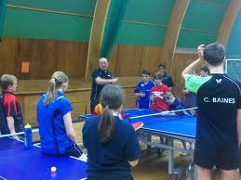](http://www.google.co.uk/imgres?q=steve+gertsen&safe=strict&biw=1366&bih=641&tbm=isch&tbnid=tqtXzjETA_jSjM:&imgrefurl=http://updates.etta.tv/east/2011/05/19/latest-from-the-east/&docid=Bt-bmyunB06wrM&imgurl=http://updates.etta.tv/east/files/2011/05/img00096-20110419-11362.jpg&w=1568&h=1176&ei=lxPMUqSVD4fKhAf_4oHACw&zoom=1&ved=1t:3588,r:53,s:0,i:250&iact=rc&page=3&tbnh=183&tbnw=259&start=44&ndsp=28&tx=109&ty=82)

**Are hosting a**

**Coach Education Day**

**Aimed at UKCC Level 1 Coaches, Teachers and anyone looking to learn about Table Tennis Coaching.**

**SATURDAY 15TH March 2014 - 10.00am to 3.00pm at**

**Fakenham Academy (High School), Field Lane, Fakenham, Norfolk NR21 9QT**

**An opportunity to work with Norfolk’s Head Coach Mark Dare**

**along with a group of young players from the Fakenham area.**

**Free to all Coaches**

**Further Details & Bookings contact Chris Fuller** [**chrisfullersnoring@hotmail.com**](mailto:chrisfullersnoring@hotmail.com)

[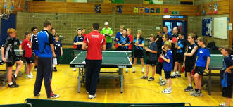](http://www.google.co.uk/imgres?q=steve+gertsen&safe=strict&biw=1366&bih=641&tbm=isch&tbnid=rx7RdQv4Trc6JM:&imgrefurl=http://updates.etta.tv/east/2013/06/20/east-region-open-day-in-stowmarket/&docid=goyOddd-0hwImM&imgurl=http://updates.etta.tv/east/files/2013/06/open-2.jpg&w=960&h=442&ei=lxPMUqSVD4fKhAf_4oHACw&zoom=1&ved=1t:3588,r:23,s:0,i:160&iact=rc&page=2&tbnh=152&tbnw=312&start=19&ndsp=25&tx=145&ty=67) 

[www.tabletennis365.com/fakenham](http://www.tabletennis365.com/fakenham)

[Fakenham on facebook](https://www.facebook.com/pages/Fakenham-District-Table-Tennis-League/610420415643382)