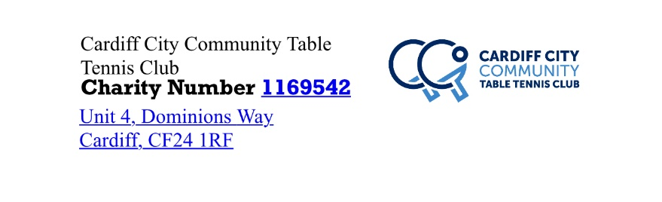

Dear

You are invited to join the History of Table Tennis in Cardiff project at the Memories Match event where we will be taking you back to 1951. The event will be held at Cardiff City Community Table Tennis Club on Friday 26th October at 7pm.
The event will be funded by Heritage Lottery Fund and is a social event where you can play table tennis using 1950s rules and equipment, look at old records, photos and magazine, share memories and stories as well as socialising with friends. Light refreshments will be provided.
The event is free and we would encourage you to bring friends, family and team mates. Fancy dress is encouraged but not essential.
If you have any photos or records from playing table tennis in Cardiff over the years please bring them along. We hope to take copies of any items for use in the project but I’m sure others would like to see them too. The project is an opportunity to celebrate the sport and show how it has developed over the last 100 years.
If you would like to take part in the project in other ways, then please get in contact via email on historyccttc@gmail com or phone Julie on 07967803825.
We look forward to seeing you there

Kind Regards

The History Project Volunteers

