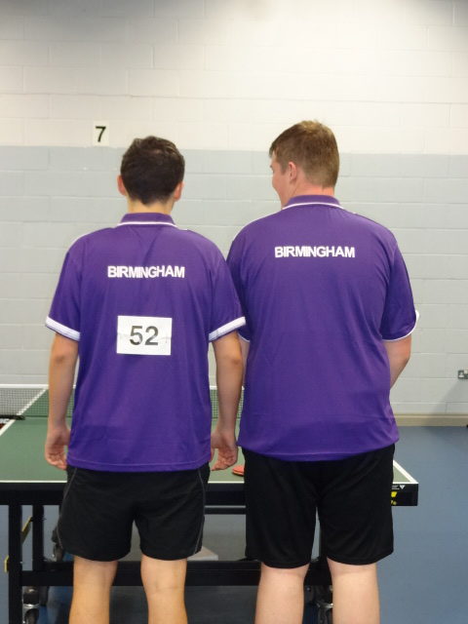

Who are they ?
Full report by Kate Hughes in Carter Cup 2015 Tab above
Thanks should also go to Kate for sideline support, coaching and
probably transport too.

