Worcestershire AGM 2021

County 2020 2021 Season
Please note, the County Championships has been cancelled for the 2020/21 season because of the pandemic.
County 2019 2020 Season
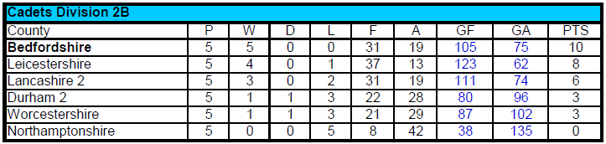
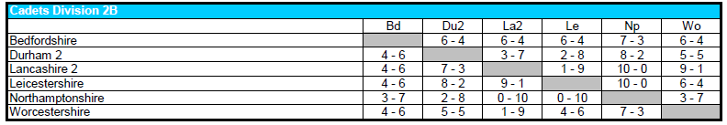
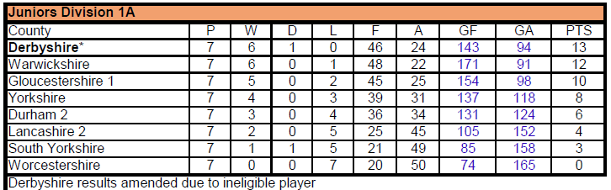
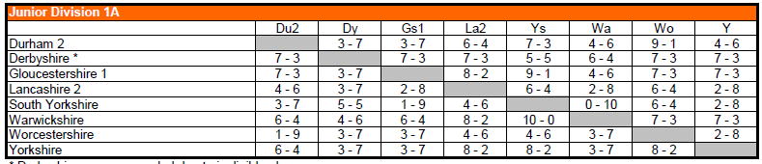

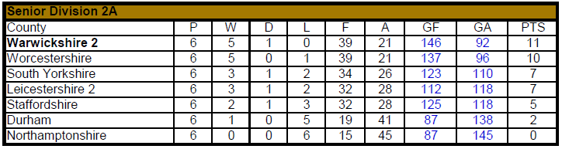
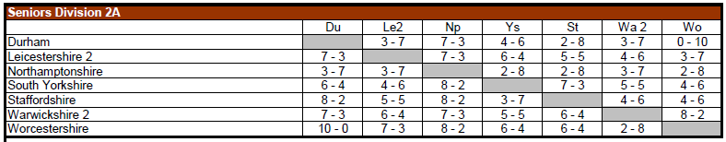
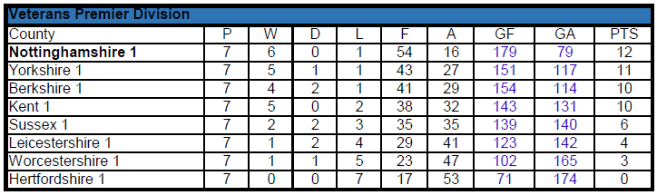
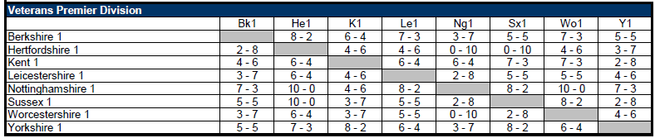
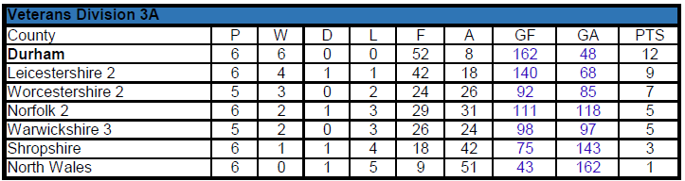
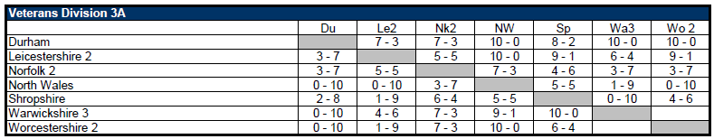
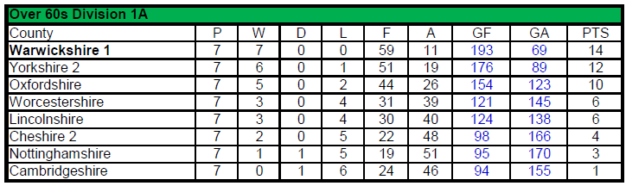
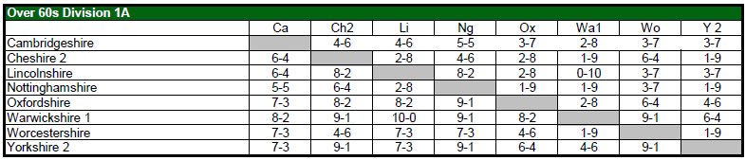

John Stalker

