SWINDON AREA JUNIOR TABLE TENNIS TOURNAMENT
Organised by the Swindon Table Tennis League
SATURDAY 17 NOVEMBER 2018
at
Lawn Manor Academy, Salcombe Grove, Swindon SN3 1ER
Commencing 9:30 a.m

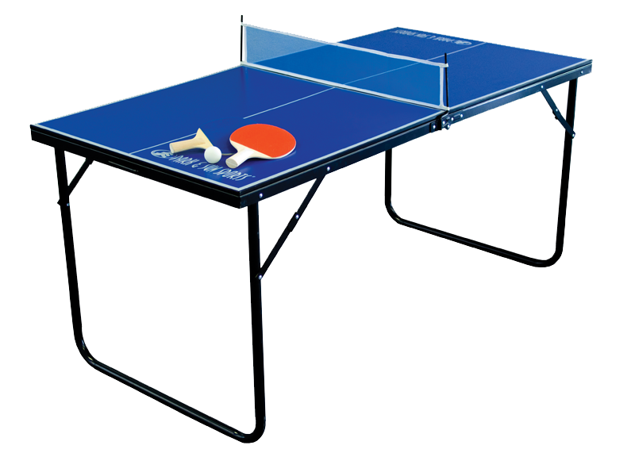

DO YOU ENJOY PLAYING TABLE TENNIS?
DO YOU LIVE WITHIN A 20 MILE RADIUS OF SWINDON TOWN HALL?
WILL YOU BE UNDER 15 OR UNDER 18 AS AT 31ST OF DECEMBER 2018?
THEN DO ENTER THE COMPETITION AND JOIN US AT LAWN ACADEMY ON 17TH NOVEMBER. REMEMBER CLOSING DATE FOR ENTRIES IS MONDAY 29TH OF OCTOBER 2018.
FOR MORE INFORMATION PLEASE SEE OUR ENTRY FORM AT: - www.tabletennis365.com/swindon
OR CONTACT ME VICKI PEPPER TEL: 01793 764854 MOB: 07808 852585
OR ALAN DUKE TEL: 01793 531234 alan-duke2@talktalk.net

