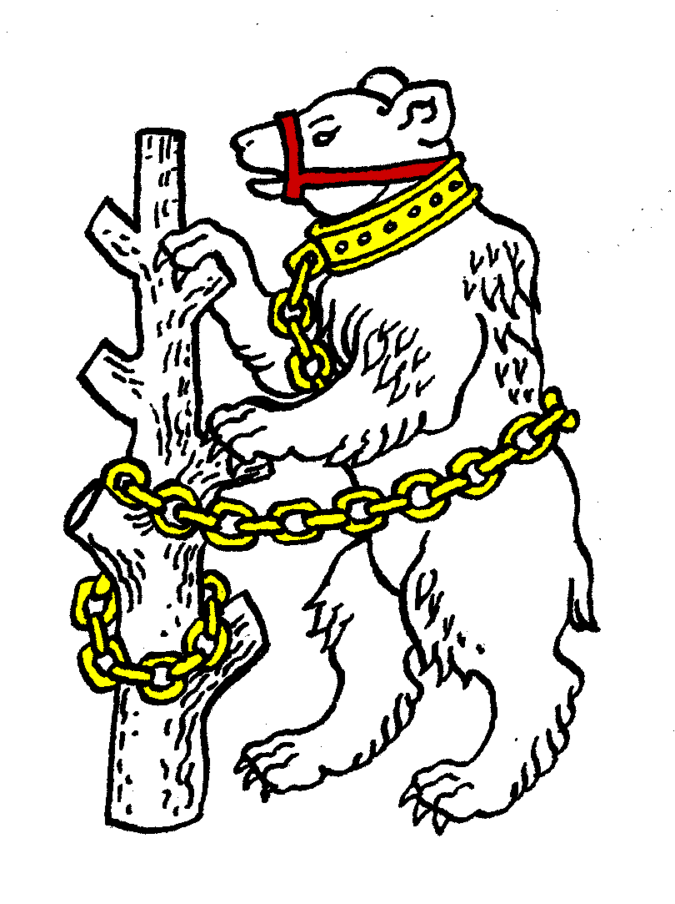
Warwickshire Table Tennis Association
Minutes of the Warwickshire Executive Committee Meeting held on Thursday 17 September 2013, at Kenilworth Wardens Cricket Club
Members present
Estyn Williams, Caroline Williams, Malcolm Macfarlane, Peter Morris, Jo Outhwaite, Kate Hughes, Steve Smith (Birmingham deputy), Neil Wheatley, Inky Moss.

- Apologies – Phil Paine, John Chandler, Tim Fell, Richard Grover, Ian Ferguson

- Minutes of the previous meeting 27 June 2013
The minutes were approved and signed as a correct record.

- Matters arising from the previous meeting
- Item 3a: It was reported that unfortunately Adrian Pilgrim had not been informed that he had been replaced as Cadet team captain. CW to write to him to thank him for his work and apologise that he had not been informed.
- Item 3c: Helen Lower has agreed to come on Sat 30 November. Free Church & Rugby coaches to be invited to a coaching workshop, juniors session in the afternoon.
- Item 8a: Mixed coaching session held by KH on 21 July & a girls only in late August. Both went well. KH hopes to do more. Committee gave thanks to KH.
- Item 8e: Congratulations to Adrian Pilgrim who played in England Vets at Tipton, where the England team won gold. They played again last weekend in Dublin & won silver with AP gaining a silver in the doubles & only lost in semi-final of individual competition.

- Matters arising from the 2013 AGM
Item 13: KH contacted Edward Lynn after the AGM to ask him if he was prepared to be on the committee to represent clubs but he declined as he has “enough on his plate”.
Amend Item 14 re Life Members to read “All five names are to be listed in the handbook.”

- Warwickshire Trials and Talent Identification Day
Held on Sunday 1 September 2013 with again some problems with communications. Agreed that next time we should send details to all players registered with ETTA for Warwickshire. Also agreed to hold it a week later if possible as some players on holiday.

- Warwickshire Closed
To be held Sunday 5 January 2014, with closing date 26 December.
Discussion to change eligibility rule to similar to Worcestershire but motion was defeated, 1 in favour, 6 against, 2 abstentions

- General Secretary’s report and correspondence
ETTA Correspondence:
- AGM: 13 July 2013 agenda and previous AGM & EGM minutes.
- ETTA Approved Laws of Table Tennis 2013/14
- List of authorised racket coverings
- Letter re Portas recommendations regarding the updating of ETTA
- List of ETTA Vice-chairmen for 2013/14
- List of National Councillors & Deputies for 2013/14
- Minutes of National Council held on 27 July 2013 (see later)

- Any other correspondence
MM had received county match sheets. TSP balls now not from Teesport.

- Financial report none

- Leagues report
Birmingham – 5 divisions (1x12, 4x10) starting 30 September, so one less division but the same number of teams.
Leamington – 42 teams in 3 aside (2x12, 1x11, 1x8) & 23 in 2 aside in 4 divisions starting 23 September. Has been a lot of discussion on venue distances, currently 12 miles from Leamington with discretion. Now been agreed that lowest division should be entry level and very strict on distance, whilst more liberal in top division. Guidelines to be drawn up considering distance, journey times, benefits, how prepared to mitigate problems, etc.
Nuneaton – 20 teams in 2 divisions of 10 starting 30 September. Had a good presentation night & have a good handbook.
Coventry and Stratford – no news

- National Councillor’s report
92% of ETTA funding is from sources outside players fees.
Portas report given to National Council on 27 July. As recommended, National Council agreed to delegate all its powers directly to the Board. It is proposing to have an EGM in March for new shorter simpler rules to be agreed. As a result of Portas the Board will change as well with professional staff running departments & 3 non-executive directors on the Board. ETTA will possibly move away from Hastings.

- County Championships’ report
Senior A 5/6 April at Cippenham
2 November, 1 February Juniors at Westfield
25/26 January Cadets at Westfield
Senior B still to be sorted.
MM will pass on trophies from 2012/13 County Champs at Warks Closed in January

- County Umpires’ report
Karen Tong doing a seminar on 6 October at Wood Green for new umpires “Introduction to Umpiring”, 3 to go on it. School Games were held last week, IM read the oath. Committee congratulated him.

- Coaching report – none

- West Midlands Regional Committee report
Committee to work on local initiatives
- Birmingham YMCA are keen, & have re-painted the walls & hope to improve the lighting
- Ping – disappointed that Solihull was turned down so Solihull want to do it on their own. As far is known there were varying results for B’ham Ping. It was run more low-key this year, more as social rather than developmental so did not involve tt clubs.
- TT in care homes “PingCare”
- No regional committee meeting until ETTA sorted.

- Warwickshire team championship report
Set for Sunday 27 April 2014.
Entry forms to be sent out end Feb / early March.

- Schools report
Thursday 28 November school team competition
Thursday 16 January Individual Boys Under 16 & Under 19
Friday 7 February Individual Boys Under 11 & Under 13 and All Girls.

- Webmaster report - none

- AOB
- Handbook – now getting out to all leagues.

- Date of next meeting – Tuesday 19 November 2013 7.45pm at Kenilworth Wardens Club.

Meeting closed at 9.17pm

