St John rise to the top as their impressive run continues
Table tennis round-up by Chris Blake - www.tabletennis365.com/Sunderland

St John A are the new leaders of Division 3 of the Sunderland & District league following a fine 8 – 2 win over 3rd placed West CA B.

Their win, together with last week’s leaders East Boldon’s heavy 8 – 2 defeat to Lanchester CC, was enough to see the strong Saints side go top - and remain the only side in the top half of the league yet to taste defeat this season.

Craig Hilton (St John A) who, going into the match, had only tasted defeat once this season, was voted man-of-the-match following an impressive display which saw him beat opponents Michael Redfearn and Tom Turner by the same margin (3 – 1) but was forced to dig deep against No. 1 player Alan Whitwham (previously undefeated) coming from behind 8 – 4 in the deciding end winning 6 points in a row before finally closing out the set 11 – 9 in a fascinating encounter.

Hilton then combined with Istvan Soos to win the only doubles set. With teammates Soos and Craig Burton both chipping in with 2 sets a piece the Saints gained maximum points for their win and continue their impressive start to the season.

Whitwham played exceptionally well to win 2 of his 3 sets and can count himself unlucky not to successfully close-out his match against Hilton and continue his unbeaten run.

Lanchester CC opened their season’s account with 3 excellent wins against Sacriston Desperadoes (10 – 0), St John C (7 – 3) and most notably a superb 8 – 2 win over early pacesetters and last week’s league leaders East Boldon - with Boldon’s Manager Dave Butler describing the performance of the young side

‘… The Lanchester players were a credit to their club and played some very good table tennis for their years – an impressive all-round display with excellent services – my tip to win the division this season…’

In their match against Boldon Lanchester’s Joseph Hume played excellently throughout and his performance was recognised when he was awarded man-of-the-match after winning his 3 singles and combining with John Cook to win the only doubles set against Butler and Peter Smallcombe – 11 – 7 in the 4th.

In his singles sets Cook had a relatively comfortable win over William Walton but was made to work hard for his 2 remaining sets with wins over Jeff Hope and Butler 11 – 7 and 12 – 10, respectively – both in the deciding end.

With Francis Guthrie picking up a set Lanchester picked up a very important 4 points to kick-start their season.

Hope and Butler won a set a piece for East Boldon.

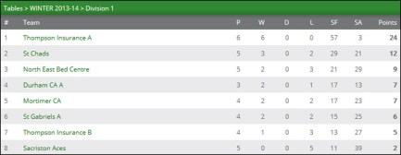

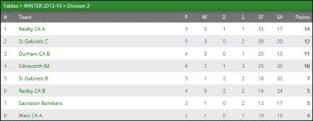

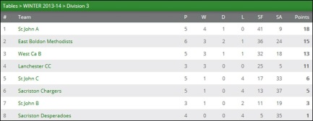

In Division 2 Redby CA B and St Gabriels B shared the points following a hard-earned 5 – 5 draw.

Howard Foster finished the night undefeated for Redby with good wins over Geoff Young (11 – 7 in the 5th), Dave Revell (13 – 11 in the 3rd) and Steve Young (11 – 8 in the 3rd). No. 1 player Joe Muldowney picked up 2 sets but was narrowly defeated 11 – 8 in the deciding end against St Gabriels No. 1 player Revell.

With the Saints winning the doubles, Revell also beating Allan Girdwood and the Young brothers picking up a set a piece together the game ended in a 5 – 5 draw.

In the only other match played in Division 2 Silksworth IM had an excellent win over second placed St Gabriels C. Howard Brown was man-of-the-match for winning all of his matches and was well supported by Bob Sanderson (3) and Graham Sleep (1) – Murden and Helm picked up a set each for the Saints with the latter also combing with teammate Gooding to win the doubles.

Division 1 leaders Thompson Insurance A continued their unbeaten run with a 10 – 0 win over North East Bed Centre which saw Chris Blake, Marc Cotton and Andrew Wilkinson finish the night undefeated with the latter also combining with player/manager Allan Thompson to claim the doubles.

Dave Pringle (NEBC) played very well throughout losing narrowly to Cotton 3 – 1 and Blake 3 – 2 (11 – 9 in the deciding end).

2nd placed St Chads were defeated by St Gabriels A. Tony Gelder (2), Jim Stamas (2) and Tom Bainbridge (1) did the damage for St Gabriels with Gelder and Stamas combining to narrowly win the doubles 11 – 9 in the 5th.

Keith Weatherby was voted man-of-the-match after finishing the night unbeaten. With Barry Cuthbertson also picking up a set St Chads were rewarded with a point despite their loss.

Thompson Insurance B were forced to work hard for their 6 – 4 win over Sacriston Aces – Lynne Herrington (2), Shirley Gelder (2) and Eddie Coxon (1) put Thompson’s in a winning position and with Herrington / Gelder combining to win the all-important doubles set victory was assured. Duncan Fraser and Jon Mawson both played well to win 2 of their 3 singles matches.

****

RESULTS

Division 1
NEBC 0 Thompson Ins. A 10
St Chads 4 St Gabriels A 6
Thompson Ins. B 6 Sacriston Aces 4

Division 2
Redby CA B 5 St Gabriels B 5
St Gabriels C 3 Silksworth IM 7

Division 3
Lanchester CC 8 East Boldon 2
West CA B 2 St John A 8
Sacriston Desperadoes 0 Lanchester CC 10
St John C 3 Lanchester CC 7

****

