League positions beginning to take shape as teams challenge for top place
Table Tennis by Chris Blake - www.tabletennis365.com/Sunderland

The league tables are beginning to take shape with a third of the seasons fixtures now completed in the Sunderland & District League.

In Division One Thompson Insurance A continued their dominance of the top flight with a fine 7 – 3 win over last season’s runner’s-up Durham CA A and have opened up a commanding 16 point lead over second placed St Chads - although the Saints have games in hand.

Thompson’s Andrew Wilkinson was once again in excellent form displaying impressive attacking play on both wings to leave his opponents with little opportunity to gain a foothold in their sets. Wilkinson finished the night unbeaten without dropping a single game and losing only 33 points.

With Darren McVitie teaming up with Wilkinson to win the doubles set and also finishing the night unbeaten Thompson’s were good value for their win.

Geoff Salter, Colin Hunt and John Williamson picked up a set a piece to ensure Durham were at least awarded a point for their efforts – the first point to be dropped by Thompson’s this season.

Mortimer CA and North East Bed Centre can boast an excellent start to the season and are currently lying in third and fourth position, respectively.

At the other end of the table Sacriston Aces have yet to pick up a win this season and the pattern continued following their 6 – 4 defeat at the hands of Mortimer. Dave Cutler was awarded man-of-the-match for Mortimer after finishing the night unbeaten and was well supported by teammates Dave Bannon (2) and Dick Karczewski (1).

Sacriston’s Duncan Fraser, Jon Mawson and Mark Walton showed good team spirit to win a set each with Fraser/Mawson combining to win the only doubles set.

Durham CA B are joint leaders of Division Two alongside St Gabriels C and Redby CA A following their impressive 7 – 3 win over St Gabriels B. Only four points now separate the top 6 sides so it promises to be a very close season with any one of a number of teams having a fighting chance of promotion if they can string together an unbeaten set of results.

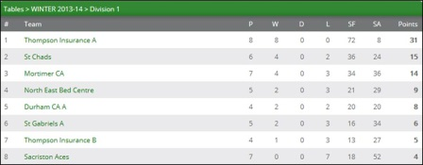

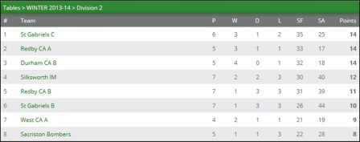

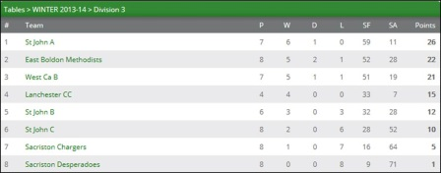

Durham’s Brian Bateman finished the night unbeaten with victories over Dave Revell, Steve Young and Mark Burton before combining with teammate Billy Upton to win the doubles.

With Upton registering a further 2 sets – losing narrowly to Revell 11 – 9 in the fourth and Paul Wiggins fine 3 – 1 win over Burton, Durham were guaranteed their win and keep their promotion hopes alive.

With the bottom two sides having games in hand over a number of teams there promises to be a number of twists and turns as the season unfolds where many teams can expect to find themselves in promotion and relegation positions at various stages of the season.

In Division Three St John A continue their strong bid to return to the 2nd Division at the first time of asking with an 8 – 2 victory over their ‘C’ team. Istvan Soos was awarded man-of-the-match after an impressive display which saw him finish the night unbeaten.

He was joined by Craig Burton (2) and Lynda Todd (1) with Burton joining with Soos to claim the doubles match in straight sets.

David Aldridge and Derek Buller registered a set each - Richie Patterson was particularly unlucky not to pick up a set on the night after narrowly losing out in all of his sets – most notably his sets against Burton (12 – 10 in the 4th) and Lynda Todd (11 – 9 in the 5th).

In the match between Sacriston Chargers and Lanchester the power of Lanchester proved too much for their opponents especially with the experienced John Cook playing and wining his sets convincingly.

The big surprise was the debut made by Anna Kiwitt for Chargers who shocked Joe Hume and took an immediate 2 – 0 lead before Hume restored parity to leave the game in the balance. This was how the game should be played ‘fast and furious’ and it was the power of Anna’s backhand drive that finally enabled her to claim victory.

The most impressive performance of the night was from Lanchester’s Sam Hume who was never overawed by his more experienced opponents and was only defeated by Kiwitt before helping his teammate Cook to win the only doubles set and his team to gain an 8 – 2 win.

In the match between Sacriston Chargers and West CA B ‘magic’ Mick Redfearn was voted man-of-the-match after winning all of his matches without losing a set and also combined with Whitwham to win the doubles. With Tom Turner and Whitwham both fighting hard to finish the night unbeaten West claimed a maximum points win for their 10 – 0 victory.

The West team were full of praise of the performance from Chargers Anna Kiwitt who played well throughout - in particular her set against Whitwham where she pushed her opponent all the way.

At the other end of the table Sacriston Desperadoes are finding the league tough losing to 2nd placed East Boldon and St John B (8 – 2) where Saints player Robert Renton was most valuable player. But the team of Erin Harrison, Oliver King and Sean Patterson are showing an excellent never-say-die attitude will help them as they gain valuable league experience.

Results, Div One: Sacriston Aces 4 Mortimer CA 6, Thompson Ins. A 7 Durham CA A 3

Div Two: Durham CA B 7 St Gabriels B 3

Div Three: East Boldon 10 Sacriston Desperadoes 0, Sacriston Chargers 2 Lanchester CC 8, Sacriston Chargers 0 West CA B 10, St John B 8 Sacriston Desperadoes 2, St John C 2 St John A 8

