**Unbeaten Soos stars as leaders see off Sacriston**

**Table Tennis by Chris Blake - www.tabletennis365.com/Sunderland**

It was business as usual in Division Three of the Sunderland and District Table League as the top four sides continued their dominance after securing comfortable wins.

Leaders St John A had a fine 8 – 2 win over Sacriston Chargers with Istvan Soos deemed to be man-of-the-match after finishing the night unbeaten and helping teammate Craig Burton to win the doubles set. Burton and Lynda Todd picked up a further 2 sets each to ensure maximum points for their victory.

Sacriston’s young starlet Anna Kiwitt once again played impressively to record excellent wins over Lynda Todd (3 – 0) and Burton (3 – 1: 14-12, 11-9, 7-11, 11-9).

Second placed West CA B beat St John B 10 – 0. Man-of-the-match was Vic Austin who played well to come through a very hard set against Luke Steel before winning his 2 other singles games. Alan Whitwham and ‘Magic’ Mick Redfearn also finished the night unbeaten before Whitwham teamed up with Tom Turner to complete the rout.

Steel showed his ‘metal’ when his fought hard all night taking sets off all of his opponents and can count himself unlucky not to pick up a set on the night.

Third placed East Boldon have been boosted by the signing of Carlos Caldeira – a strong addition to the squad who should help their bid for promotion to the 2nd flight.

Caldeira and Peter Smallcombe won the doubles in straight sets. Neil Wilkinson and Jeff Hope also finished the night unbeaten. Richie Pattinson played well throughout narrowly losing out to Hope and Wilkinson 3 – 2 (11 – 5 in the deciding end) and 3 – 1 (16 – 14 in the fourth set), respectively.

A superbly competitive game between the two youngest teams in the league saw Lanchester CC edge Sacriston Desperadoes by 7 - 3.

Lanchester were represented by Thaaqib Saleem, Francis Guthrie and Seb Seccombe with Sacriston fielding Erin Harrison, Sam Duffin and Luke Dumighan.

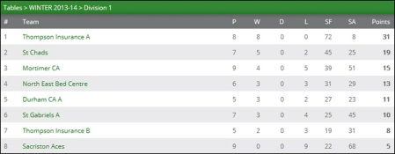

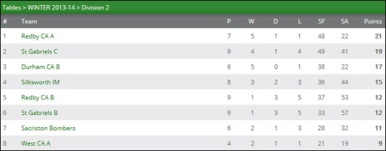

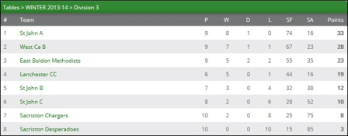

The first game gave a flavour of the games to come with Saleem struggling to beat Duffin over 4 ends. Erin restored the balance with a win over Seb before Luke took Seb to 4 games before finally being overcome. Sam beat Seb over 5 sets to leave the game balanced at 2 – 2. John Cook decided to play in the doubles and his experience helped partner Thaaqib beat Erin and Sam 3 – 1 in a close encounter.

The second half of the match saw 4 of the 5 sets go in the favour of Lanchester with Erin recording a win for Sacriston against Francis to leave the final result at 7 – 3 to Lanchester. Thaaqib Saleem was voted man-of-the-match for Lanchester with Luke Dumighan being rewarded player of the match for Sacriston for his excellent attitude and playing the game in the right spirit.

Sacriston Chargers edged a close match against club rivals Desperadoes by 7 – 3 to complete this week’s Division 3 fixtures.

In Division Two leaders Redby CA A came out on top in their clash against second placed St Gabriels winning 7 – 3 to maintain their position at the top of the league and keep the promotion hopes alive.

The match saw 7 out of the 10 sets being settled in the 4th or 5th and deciding end. Frank Booth – not for the first time – was voted man-of-the-match having won all of his 3 singles sets before teaming up with Malcolm Deneven to win the doubles set 3 – 0 against Jacob Helm and Syd Gooding.

Deneven chipped in with 2 sets for Redby with wins over Gooding and Graham Murdon before Amanda Paxton secured an excellent 3 – 2 win over Helm to ensure a fine 7 – 3 victory.

St Gabriels recovered well to record a 7 – 3 victory of their own against their ‘B’ team which saw Jacob Helm play excellently to finish the night as the strongest player and he was well supported by Murdon who won all of his 3 singles sets – with Gooding chipping in with a win over Geoff Young the ‘C’ team finally edged the match by 7 – 3.

This was a far closer match than the score suggested with 6 of the sets going to the 4th or 5th and deciding end with the ‘B’ side only managing to secure one of these sets – an epic 5th end (11–9) doubles win by Dave Revell and Young over Gooding and Helm.

With Revell and Mark Burton chipping in with a set a-piece the score finished 7 – 3 to earn the ‘B’ side a point for their efforts.

Sacriston Bombers completed a miserable week for St Gabriels B when they defeated their opponents 6 – 4. However, Saints player Burton was voted man-of-the-match after recording fine victories over Ian McPherson, Dan Nicholson and Daniel Hutchinson which helped to soften the blow.

In Division One Durham CA A were back to winning ways with a hard fought 7 – 3 win over St Gabriels A – Colin Hunt, John Williamson and Anth Ainley picked up 2 sets each with the latter 2 players pairing up to edge the doubles 3 – 1. Saints player Tony Gelder played excellently throughout to finish the night unbeaten.

Thompson Insurance B had a fine 6 – 4 win over rivals Mortimer.

**\*\*\***

**Results, Div One:** Durham CA A 7 St Gabriels A 3, Thompson Ins. B 6 Mortimer CA 4

**Div Two:** Redby CA A 7 St Gabriels C 3, St Gabriels B 4 Sacriston Bombers 6, St Gabriels C 7 St Gabriels B 3

**Div Three: \***East Boldon 10 St John C 0, Lanchester CC 7 Sacriston Desperadoes 3, Sacriston Chargers 7 Sacriston Desperadoes 3, Sacriston Charges 2 St John A 8, St. John B 0 West CA B 10

*\* Result not reflected in league table*