St Chad’s beat Division One rivals to keep title hopes alive
Table Tennis by Chris Blake - www.tabletennis365.com/Sunderland

St Chads continued their title push with two excellent wins to keep the heat on Thompson Insurance A at the top of Division One in the Sunderland and District league.

In their first match they safely disposed of 4th placed North East Bed Centre by 8 sets to 2 which saw Saints player Jimmy Scope finish the night unbeaten with an impressive defensive display throughout whilst at the same time looking to bringing in his backhand and forehand kills whenever the opportunity arose.

Barry Cuthbertson chipped in with two sets before teaming up with Scope to take the doubles set – with Dave Bissett also winning two sets the Saints secured a fine 8 – 2 and maximum points victory.

Next up saw the Saints take on Durham CA A and emerge victorious in a close encounter which finally finished 6 – 4.

Unfortunately Durham could only turn out with 2 players – Geoff Salter (currently ranked No. 2 in Scotland) and John Williamson (a long-standing and experienced Durham County player).

St Chads fielded father and son pair Keith and Joshua Weatherby together with David Bissett.

The Saints started the game with a 3 sets advantage due to the late withdrawal of their 3rd player. Keith Weatherby won his 2 singles before teaming up with his son Joshua to win an outstanding win in the doubles over the vastly experienced pairing of Salter and Williamson 11-8, 11-7, 7-11, 7-11, 11-9. Star of the show in this set was young Joshua who played beyond his years against players renowned for their unique styles which make them both extremely difficult to beat.

A brilliant effort by the pairing proved to be the match winner as the Saints won 6 – 4 – denting Durham’s hopes of a top 2 finish.

Current Leaders were back in action and were worthy 8 – 2 winners over bottom placed Sacriston Aces and have opened up a 9 point gap over St Chads.

Thompson Insurance were without Darren McVitie and Chris Blake (who continues to be troubled by a shoulder injury) and chose to bring in Diane Cartmell and player/manager Allan Thompson who were joined by Andrew Wilkinson who has yet to lose a single end this season.

Sacriston played Mark Walton, Ian McAllister and David McAllister who was making his league debut.

It proved to be a baptism of fire as David’s first set was against Wilkinson who won in straight sets 11-4, 11-5 and 11-3. But the Sacriston player recovered well to put up a good display against Thompson before narrowly losing out to Cartmell in a quite enthralling match which the home player finally edged 11-8 in the 5th.

With Wilkinson and Thompson both finishing the night unbeaten and Cartmell/Wilkinson winning the doubles the leaders recorded an 8 – 2 win to maintain their lead at the top of Division One.

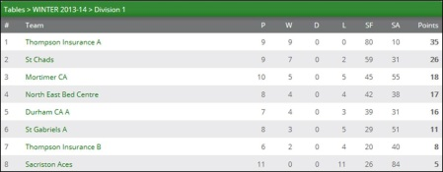

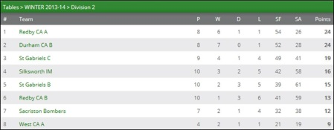

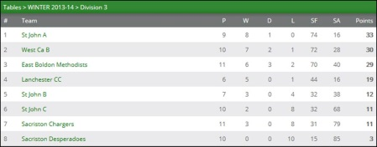

Mortimer CA excellent season continued with an impressive 6 – 4 win over St Gabriels A. Dave Cutler and Ian Moore both secured 2 sets each and were joined by Ray Purves who picked up a set before teaming up with Cutler to win an epic doubles set by the narrowest of margins 12-10 in the 5th against Tony Gelder/Norman Pescod.

Gelder (3) and Pescod (1) won the sets for the Saints to ensure they picked up a point for their efforts.

NEBC recovered from their defeat at the hands of St Chads to beat Thompson Insurance B 9 – 1 whilst Durham also secured a 8 – 2 against Sacriston Aces.

Two excellent wins by Durham CA B over Silksworth IM (8-2) and Redby CA B (6-4) was enough to see them go joint top of Division Two alongside Redby CA A who were 6 – 4 winners over Sacriston Bombers.

In Durham’s match against Silksworth, Brian Bateman (Durham) was deemed to be man-of-the-match whilst Howard Forster (Redby) was awarded most valuable in the game against Redby CA B after he played well to defeat Durham’s Billy Upton (13-11 in the 5th) and Bateman (16-14 in the 4th – the first defeat of the season for the Durham player).

St Gabriels secured an important 6 – 4 win over Silksworth IM and were awarded 3 valuable points in the process. Dave Revell was voted man-of-the-match after winning 2 sets and helping his teammate Geoff Young to win the doubles set but narrowly lost out to Bob Sanderson (11-9 in the 5th). This was a very entertaining game which saw 6 out of the 10 sets decided in the 4th or 5th end.

There were only 2 matches played in Division Three – West CA / East Boldon (5-5) and St John C / Sacriston Chargers (4-6).

The match between West CA and East Boldon - 2nd and 3rd placed. Mick Redfearn and Alan Whitwham won 2 matches each, and had to play at their best Neil Wilkinson and Carlos Caldeira to edge the doubles. Wilkinson finished the night unbeaten which included a titanic game against Whitwham where he saved two match points in the 4th set before clinching the 5th and deciding end.

Sacriston Chargers edged a close encounter against St John C to record a creditable 6 – 4 win - Anna Kiwitt (2), Barry Dingwell (2) and John Reid (1) picked up the sets together with the doubles.

***

Results, Div One: Durham CA A 4 St Chads 6, Mortimer CA 6 St Gabriels A 4, NEBC 9 Thompson Insurance B 1, Sacriston Aces 2 Durham CA A 8, St Chads 8 NEBC 2, Thompson Insurance A 8 Sacriston Aces 2

Div Two: Durham CA B 8 Silksworth IM 2, Redby CA B 4 Durham CA B 6, Sacriston Bombers 4 Redby CA A 6, Silksworth IM 4 Redby CA A 6

Div Three: St John C 4 Sacriston Chargers 6, West CA B 5 East Boldon 5

