Redby’s quest for top flight promotion takes them to the summit
Table Tennis by Chris Blake - www.tabletennis365.com/Sunderland

Redby CA A are the new leaders of Division Two of the Sunderland and District League following a fine 8 – 2 maximum points win over their ‘B’ team.

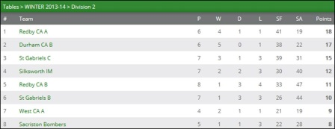

Frank Booth played impressively throughout, winning his 3 singles matches before teaming up with Malcolm Deneven (2) to claim the only doubles set – their 5 doubles win in 6 outings.

Amanda Paxton enjoyed a successful night in her first match of the season following injury – winning 2 of her 3 singles sets which included good wins over Howard Foster and Alan Girdwood but found Redby B’s top player Joe Muldowney too strong.

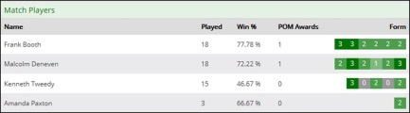
Redby CA A Team - Promotion Form

Consistency will be key to Redby’s promotion hopes - with over a third of the season played Booth and Deneven are showing the type of form required to help deliver a successful return to the top flight. With teammate Ken Tweedy chipping in with an almost 50% win rate - together with the timely return of Paxton to the fold - Redby will almost certainly be in the mix as the season unfolds.

Joe Muldowney (Redby CA B) continues to impress – winning 20/24 to average an 83% win rate prior to Redby’s match against Silksworth IM.

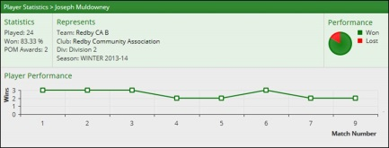
Joe Muldowney – Impressive Form

Durham CA B have moved into second place following a hard fought win over last week’s league leaders St Gabriels C which saw 6 of the 10 sets played being decided in either the 4th or 5th game.

With 2 sets remaining the match score stood at 4 – 4 before Durham secured the final 2 sets to win the match 6 – 4 guaranteeing 3 points in the process.

Not for the first time this season, Durham’s Brian Bateman was man-of-the-match with wins over Syd Gooding, Jacob Helm and Graham Murdon. With Billy Upton and Paul Wiggins winning a set a-piece and Bateman/Upton taking the doubles set Durham were good value for their win.

Jacob Helm and Graham Murdon were the set winners for the Saints winning 2 sets each.

Silksworth IM moved into joint 3rd position after securing a 6 – 4 over Redby CA B. Star player was Silksworth’s Howard Brown who finished the night undefeated which included an epic battle against Muldowney (13 – 11 in the 5th and deciding end). Brown was well supported by George Carlyon and Graeme Sleep who both played well to beat Alan Girdwood before Brown/Sleep combined to win the doubles.

In Division One 2nd placed St Chads had a comfortable 9 – 1 win over 3rd placed Mortimer CA. The Saints team of Keith Weatherby, Barry Cuthbertson and Steve Penman were simply too strong for their opponents. Their win helped to close the gap on league leaders Thompson Insurance A whose were out of action this week.

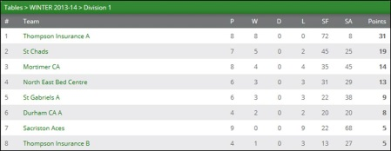

Dave Cutler picked up the only set for Mortimer with a fine 3 – 0 win over Barry Cuthbertson.

Tony Gelder turned back the clock in a fine performance in St Gabriels A’s match against Sacriston Aces. Gelder played well throughout finishing the night undefeated before partnering teammate Tom Bainbridge to grinding out a hard fought and important 11 – 8 deciding end win in the doubles.

Bainbridge and Norman Pescod both chipped in with a set each to ensure a 6 – 4 victory to the Saints.

A great team effort from Sacriston Aces saw Ian McAllister (2), Jon Mawson (1) and Duncan Fraser pick up sets to ensure the Aces picked up a point for their efforts.

St John A continued their dominance of Division Three with an excellent 7 – 3 win over East Boldon with Craig Hilton voted as most valuable player having played well throughout winning all of his singles sets before teaming up with Craig Burton to win the doubles 3 – 1 against Dave Butler and Neil Wilkinson.

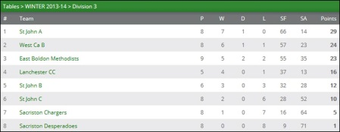

With Burton picking a further 2 sets and Lynda Todd having a good win over Butler the Saints secured a 7 – 3 win to continue their unbeaten run which has seen them win 8 out of 8 matches.

Neil Wilkinson played well to win 2 sets for East Boldon with wins over Burton and Todd as did Jeff Hope who also edged a close game over Todd.

West CA B took advantage of East Boldon by securing an excellent 6 – 4 over fast improving Lanchester CC to leapfrog their rivals to move into 2nd place.

In a very hard and keenly contested match it was Alan Whitwham who starred with great wins over John Cook, Thaaqib Saleem and Joe Hume before pairing with teammate Mick Redfearn to win the doubles. With Redfearn winning 2 sets West were assured of their 6 – 4 win denting Lanchester’s promotion hopes in the process.

Lanchester’s John Cook recovered from his early defeat against Whitwham to win his remaining 2 singles sets with good wins over Redfearn and Tom Turner. He was well supported by Saleem and Hume who picked up a set a-piece to ensure their team at least picked up a point for their efforts.

***

Results, Div One: Mortimer CA 1 St Chads 9, NEBC 10 Sacriston Aces 0 (match claimed), St Gabriels A 6 Sacriston Aces 4

Div Two: Durham CA B 6 St Gabriels C 4, Redby CA A 8 Redby CA B 2, Silksworth IM 6 Redby CA B 4 (result not reflected in league table – still awaiting scorecard)

Div Three: St John A 7 East Boldon 3, West CA B 6 Lanchester CC 4

