Thompson’s turn on the style in pulsating win
Table tennis round-up by Chris Blake - www.tabletennis365.com/Sunderland

Thompson Insurance A turned on the style during a pulsating 10 – 0 win over 2nd placed St Chads to open up a 9 point lead at the top of Division 1.

Both sides were forced to make last minute changes; Thompson’s Marc Cotton replacing Chris Blake (shoulder injury) and Saint’s player Dave Bissett coming in for Keith Weatherby (unavailable for selection).

The signs looked ominous for St Chads with Thompson’s fielding 3 players; Andy Wilkinson, Darren McVitie and Marc Cotton boasting 100% records this season – and so it proved to be.

As you would expect from the top 2 teams in the league, both sides played some excellent table tennis throughout with some unbelievable rallies taking place - most notably 3 fantastic points.

The first, mid-way through the 2nd end of the match between Wilkinson and Barry Cuthbertson (St Chads), saw impressive attacking play, counter hitting, lobs, drop shots, side-spins loops away from the table before Wilkinson finally won the point.

The second, during the match between Cotton and Bissett (St Chads) which saw Bissett turn back the clock with a ferocious forehand kill 3 metres off the table from an acute angle.

Finally, the third, the point of the night, a fast exchange of counter-hitting between McVitie and Jimmy Scope (St Chads), before McVitie played a drop shot which was well read and smashed by Scope only for McVitie to loop the smash off the bounce down the line for an outright winner.

All 3 Thompson Insurance players finished the night unbeaten.

In Division 2 Durham CA B have moved into 3rd place following back-to-back wins over Silksworth IM (6 – 4 in a very close match) and Redby CA B (8 - 2).

Durham’s Brian Bateman was voted man-of-the-match after finishing both games unbeaten winning all 6 of his singles sets and 2 doubles sets with teammate Billy Upton.

Bateman was well supported in both matches by Upton and Paul Wiggins who picked up 3 sets a piece to help the team register 7 points out of 8 for their efforts.

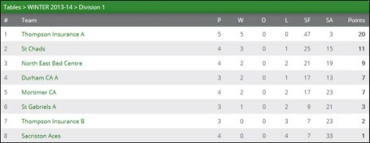

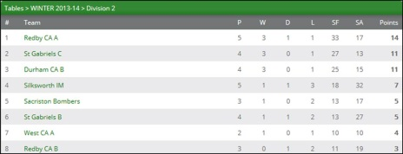

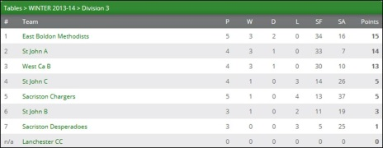

Alan Bickle and Howard Brown won 2 sets each for Silksworth but both narrowly lost out to Bateman 3-1 and 3-2, respectively. Graham Sleep was unlucky not to pick up a set on the night in particular in his match against Wiggins after losing 3-1 with 2 of these being deuce (12-10).

Joe Muldowney recorded the only 2 sets won by Redby in their match against Durham.

Redby CA A have leapfrogged St Gabriels C to go top of the league following their excellent 10 – 0 over Silksworth IM. The game was far closer than the score suggests with several games going to the deciding end - with both teams playing some impressive rallies throughout.

This was a great team performance by Redby who are hoping to mount a sustained challenge for promotion this season after finishing mid-table in last year’s campaign. Ken Tweedy, Malcolm Deneven and Frank Booth finished the match unbeaten with the latter being awarded man-of-the-match.

Silksworth finally had something to shout about when they produced a strong display to record a hard-earned draw against St Gabriels B.

Division 3 leaders East Boldon beat Sacriston Chargers 9 – 1 to remain top of the league. Dave Butler played very well finishing the night unbeaten and pairing up with Peter Smallcombe to win the doubles.

Butler was well supported by Neil Wilkinson (3) and William Walton (2) who was beaten by Barry Dingwell. Sacriston’s Paul Henderson and John Reid can count themselves unlucky not to pick up a set on the night - both losing 12 – 10 in the 5th and deciding game to Walton.

A strong St John A side played well to pick up maximum points in a fine 8 – 2 win over their ‘B’ side and are now only 1 point behind the leaders with a match in hand. Whilst Istvan Soos recorded 3 wins and played his part to win the doubles, man-of-the-match was awarded to young Robert Renton for his impressive display.

West CA B had a comfortable 10 – 0 win over Sacriston Desperadoes - with both teams unanimous in awarding Sacriston’s Erin Harrison most valuable player for her excellent performance and positive attitude throughout.

St John C edged a very entertaining match against Sacriston Chargers - eventually winning 7 – 3 to record their first victory of the season.

There were some great rallies throughout in what was an evenly contested match – most notably excellent defensive work from man-of-the-match Derek Buller who finished the night unbeaten and also combined with Viv Ford to win the doubles set 3-2.

With Ford (1) and Richard Pattinson (2) chipping in the Saints picked up 3 points for their efforts.

Dingwell (2) was most valuable player for Sacriston and he was joined by Reid who recorded a narrow 5th end 12-10 win over Ford. Number 1 player Henderson narrowly lost 3-1 in 2 of his sets and unfortunately was forced to concede his final singles sets due to time constraints.

RESULTS

Division 1: Thompson Ins. A 10 St Chads 0

Division 2: Durham CA B 8 Redby CA B 2, Silksworth IM 4 Durham CA B 6, Silksworth IM 0 Redby CA A 10, St Gabriels B 5 Silksworth IM 5

Division 3: Sacriston Chargers 1 East Boldon 9, Sacriston Chargers 3 St John C 7, St John A 8 St John B 2, West CA B 10 Sacriston Desperadoes 0

