Return to Play Processes and Information

  - Version 1.2 – 14032021 – AD White
Contents
1. General Information 3
2. Access to the PTTA centre 3
3. Returning to Play 4
4. Duty Managers 4
5. Payments 4
6. Access to TT365 5
7. General Rules 7
8. Cardinal Neman One Way System 8
9. Sports Hall Layout 9

General Information
This document is a guide to returning to playing table tennis at Cardinal Newman College under the Covid-19 governance. Social distancing of 2 metres must be observed at all times.

This year we are returning to using the TT365 website. Instructions can be found later in this document.

The PTTA have been granted access to the table tennis facilities at Cardinal Newman from Tuesday 18th May 2021 19:00 – 22:00, We commence with four weeks of practice Tuesday – Thursday.

Tables must be booked and paid for in advance. Table bookings are made through the TT365 website, instructions can be found later in this document.

The layout of the Sports hall MUST be followed at every session, shown in section 9.

At the end of this document in section 7 there is a ‘General Rules’ section that must be adhered to.

Access to the PTTA centre
Entry into the Cardinal Newman’s St Augustine’s building is as normal through the front door. Entry can be gained by pressing the bell at the right hand side of the door. The CNC duty manager will open the door automatically from within their office. A one way system is operation so please follow the route identified in the appendices.

Face coverings MUST be on from the moment of entering the building and MUST remain on at all times when not playing table tennis. Anybody attempting to enter without a face covering will turned away. This means when you are in your court seated waiting for your turn to play you MUST be wearing a face covering.

Parents / guardians MUST not enter the building

Returning to Play
Under the governance in returning to play we have to demonstrate our management of the hall at all times and one of the requirements is to have duty managers (two per evening) and that responsibility needs to be shared across the members who play from CNC.

Ideally 4 members playing on a specific date will volunteer to setup the hall at18:45, putting the tables and chairs in the courts with nets. Whilst doing this process the volunteers will be expected to wear gloves and face coverings. The gloves will be part of the sanitisation setup provided by the PTTA (costs to recover this are to be added to this years’ PTTA subscription). Ideally member will have their own re-usable face coverings, but we will have some disposable ones just in case.

At the end of the evening all the equipment used in a court must be sanitised and put back into storage by the members using it. Paper cloths and sanitising liquid will be provided by the PTTA along with hand sanitiser for each court to be used after every practice session (person ‘A’ playing person ‘B’).

Once again the ‘putting away’ process is to be conducted wearing face coverings and gloves. Not everybody will require the full time available so the tables will be sanitised and put back in storage in a staggered fashion, but dependent on numbers the duty manager will call time at 21:30.

Duty Managers
- The two duty managers will identify themselves to the players as they enter the sports hall
- All players MUST have their temperature checked on entry to the sports hall. If number of people are arriving simultaneously they MUST for a socially distanced queue in the corridor outside of the sports hall and await their temperature taken. Anybody with a temperature higher the 37.8°C will be refused entry
- The duty managers will:
- Ensure nobody wanders between tables except those playing in a 6 player bubble
- Ensure toilet breaks are staggered
- In the event of a player showing signs of any illness a duty manager must take care of that person and if necessary put on PPE and take that person to room AB08. A player in the same bubble will notify the CNC duty manager and contact their parents / guardian /partner

Payments
If you are intending using the practice sessions starting from September 15th then use the table booking system to get your team a practice session. The sessions need to be booked in advance for a 4 week period. Manoj and I will manage the sessions and a confirmation will be provided. It is the responsibility of the person booking the table to put the £20 into the PTTA bank account before playing.

Sort code 77-26-14 Account 0000 8383
Club and team as your reference

Access to TT365

To access the table tennis TT365 website use the following URL and then save it to ‘Your Favourites’

https://tabletennis365.com/preston

Logon as a member

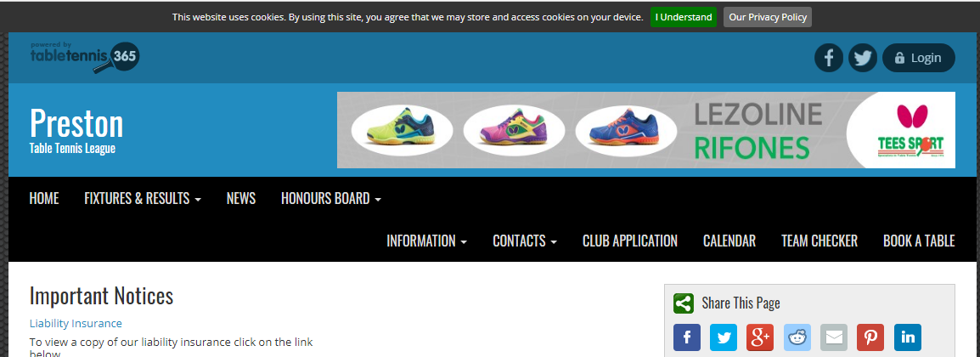

This is the logon you used the season before last. Use your TTE number and your password. If you cannot remember your password select and you will be asked to provide your membership number. Those who do not remember their membership number contact me Andrew White

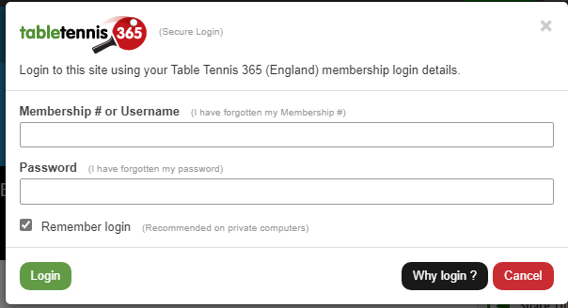

Once you have logged on you can now book a table by selecting ‘Book a table’

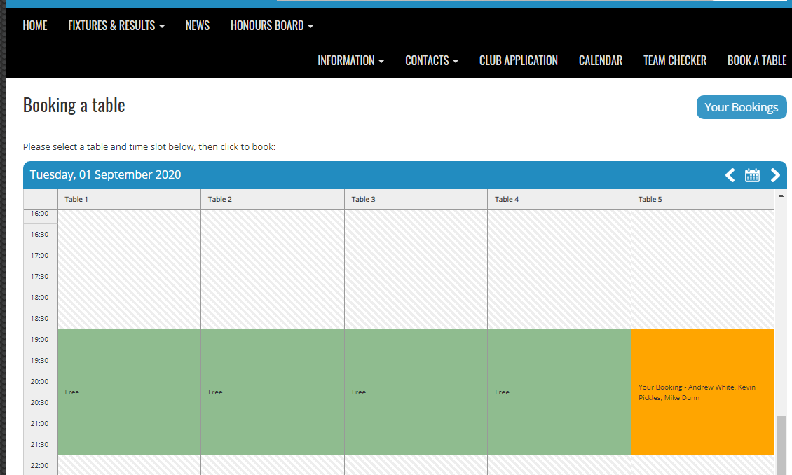

You can see by the example above I have booked a table on Tuesday 1st September between 19:00 and 22:00. The booking below is being made by Manoj and the members playing need to be captured in the ‘ref’ when making the booking

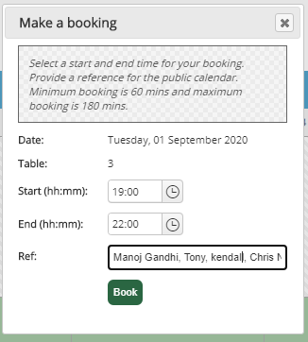

When you have entered the players names select ‘Book’
Once booked a payment must be paid and no bookings can be cancelled
General Rules

- Physical activity or exercise is undertaken at your own risk. If you have any concerns about playing table tennis you should seek guidance from a doctor or relevant health professional before participating
- Do not come to the centre if you are unwell, have any Covid-19 symptoms or have been told to self-isolate
- Arrive at your booked time, not early or late (unless you are a duty manager then arrive at 18:45)
- You will need to complete your activity, wipe down all equipment before and after use with the provided cleaning materials (these will be provided)
- There will be no changing areas and no availability of showers. Please come changed and shower at home.
- You must be out of the building by 22:00
- You must not go from playing in one court to playing in another court unless you are part of that social bubble (two tables side by side with 6 players)
- Listen to the duty officers in charge and follow their instructions
- Follow one-way systems and Covid-19 Secure notices and signage staying within marked zones or areas
- Respect social distancing at all times – keep 2 metres distance between you and other people.
- There is no equipment available to hire or borrow
- Bring your own drinking water
- We will pass on your contact details to the NHS ‘Test and Trace’ service if requested to do so.

By making this booking I agree to the above terms and conditions.

Cardinal Neman One Way System

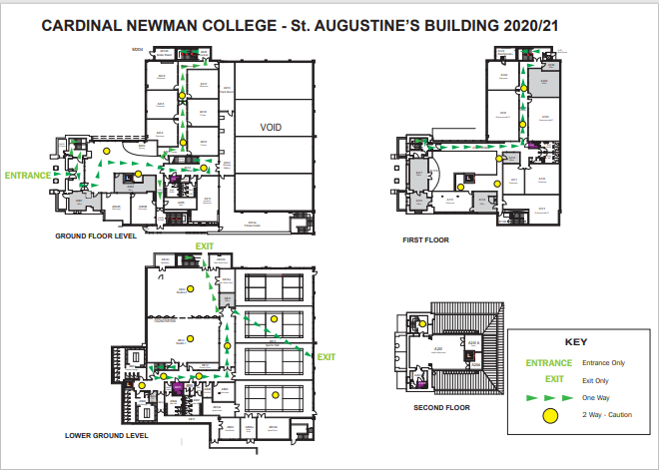

Sports Hall Layout
