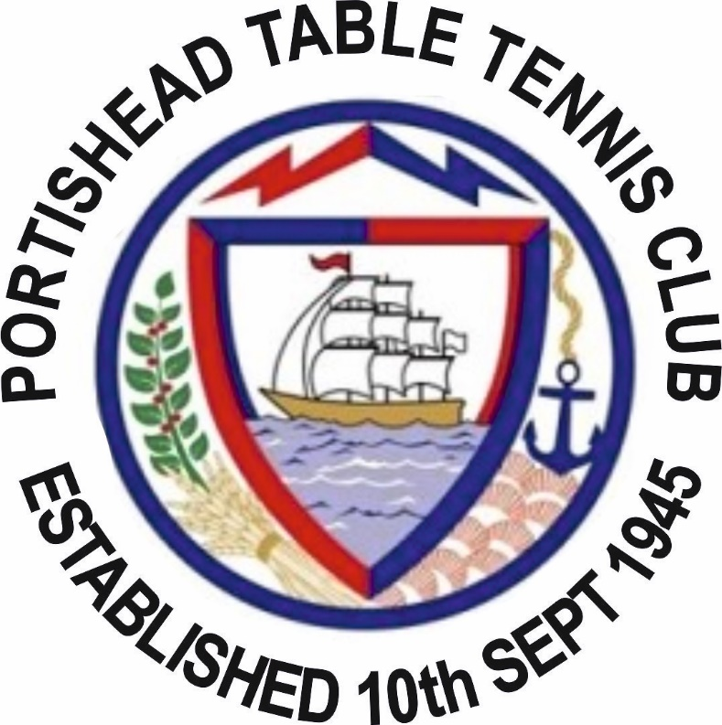

General Secretaries Statement and Report 2016 / 2017

Secretaries Statement
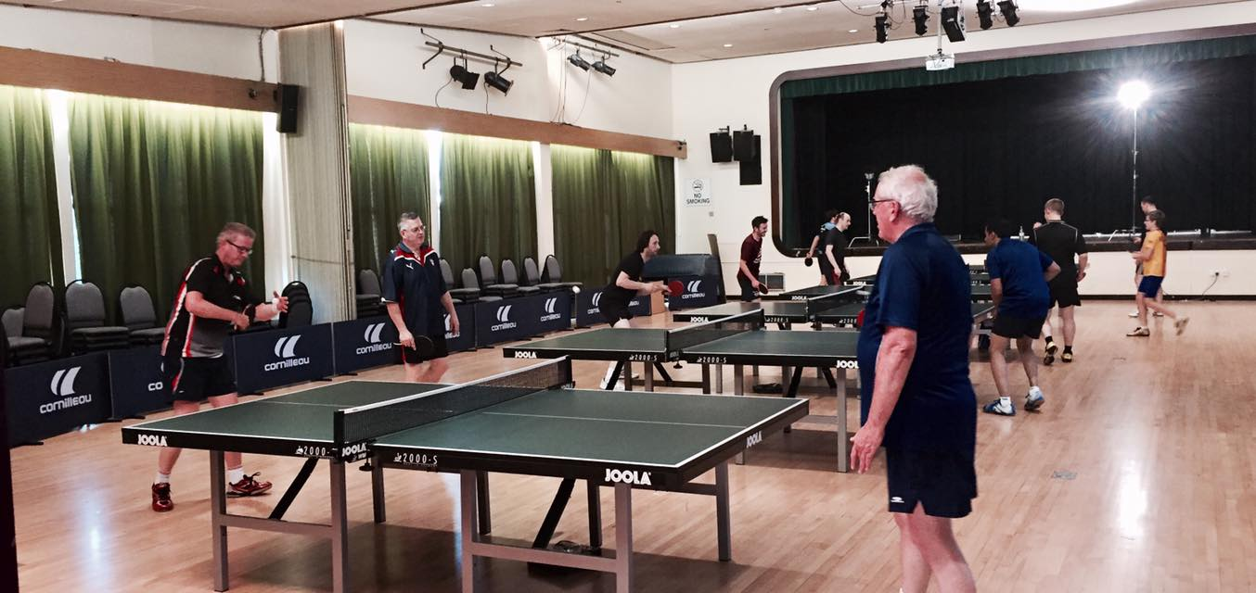
COME ON One way or another it’s been a monumental year for the Club but it started on a really sad note with the passing of Brian Pearson who for many years practically ran the club on his own. We also had to deal with the sad news that Les Taylor had to relinquish his role as Club president due to ill health.
One of Brian’s final acts was to formally stand down as General Secretary of the club and see the appointment of a new executive committee. I visited Brian many times during the last days of his life and he asked me if I would succeed him as General Secretary of the Club and out of my respect for Brian I agreed to do so.
So a new executive committee was voted in at last year’s AGM with myself becoming the General Secretary, Chris Stone becoming President, David Grounsell becoming Chairman and Ray Jenkins becoming Treasurer. We also voted in four additional members to form the clubs committee, and those members where Aziz Muscati, Michelle Knight, Steve Knight and Steve Pratt.
I think everyone will agree that the club has moved on under the governance of this new committee and I have personally worked very hard (with the support of the committee) to modernise the club while keeping to its traditions of being an open and friendly Sports and Social Club. To quote Steve Pratt from a committee meeting it was about “bringing the club into the 21st century.
Significant changes in the year would include
- We have a club branded match shirt (and other club branded items)
- We have an active Facebook group
- We have a clear club constitution
- We have signed up to the Premier Club Membership scheme with TTE which amongst other things has sorted out the Clubs Public Liability Insurance Cover
- We have been accepted into the BeTT Club development scheme
- We have put ourselves forward as a pilot club for a new Online Club Management System that is being developed by TTE on the Club Spark model.
- We purchased 6 ITTF competition standard tables
- We started a Club training and practice night
- We have a Club training shirt
- We are holding our first interclub day with the inaugural competition for the Dick Hawking and Brian Pearson Memorial Trophy
- We have an Online Member Database
- We have a Website.
- We entered the most teams in this year’s Bristol Summer League
- We started to have regular committee meetings.
- We have grown our membership
Phew
Ok so we have made progress and I am happy to put myself forward for re-election for another year to continue with the work I have been doing for the club and take us on towards the next level.
Derek “The Machine” Connop

2016 / 2017 Performance and Results
Bristol Closed
For those people who turned up for the Bristol Closed (and there were a few of us) we will all agree that it was a great day and something that we should look to attend each year.
The players representing the club on the day were. David Grounsell, Ivan Parker, Mark Ratajcak, Derek Connop, John Chivers, Joe Ratajzcak, Maria Hayes, Adam Ratajcak, Martin Britain, Moses Do Rozario and Stephen Knight. Big shout out to all who took part.
Bristol 2016 – 2017 Senior Winter League
43.62%
So what does this number mean?
This is the Clubs win average for the 2016/2017 season for singles as a club we won 43.62% of the all singles games we played, we played a total of 2116 games and we won 923 of them
This is a great number as it’s a number that we all contribute to. A great target would be to beat this % in the 2017 – 2018 season COME ON
All the players who achieved an average above the Club average in the 2016 -17 season

League Tables
PREM | Team | P | W | D | L | SF | SA | Points
1 | Failand B | 26 | 22 | 2 | 2 | 194 | 66 | 194
2 | Portishead A | 26 | 20 | 4 | 2 | 179 | 81 | 179
3 | Failand A | 26 | 20 | 0 | 6 | 179 | 81 | 179
4 | Cleeve And Claverham Adders | 26 | 16 | 2 | 8 | 155 | 105 | 155
5 | Nailsea Panthers | 26 | 16 | 0 | 10 | 155 | 105 | 155
6 | Filton Brigands | 26 | 13 | 3 | 10 | 146 | 114 | 146
7 | Knowle And Brislington AK | 26 | 10 | 4 | 12 | 135 | 125 | 135
8 | Filton Hercules | 26 | 13 | 4 | 9 | 128 | 132 | 128
9 | Thornbury A | 26 | 10 | 4 | 12 | 127 | 133 | 127
10 | Civil Service Saracens | 26 | 9 | 2 | 15 | 119 | 141 | 119
11 | Almonds Wales | 26 | 11 | 2 | 13 | 118 | 142 | 118
12 | Hcc A | 26 | 4 | 3 | 19 | 84 | 176 | 84
13 | Almonds A | 26 | 1 | 0 | 25 | 51 | 209 | 51
14 | Nailsea Ocelots | 26 | 1 | 2 | 23 | 50 | 210 | 50

STAR PLAYER JOE RATAJCZAK 97.30% P74 - W72

DIV 1 | Team | P | W | D | L | SF | SA | Points
1 | Thornbury BThornbury B | 26 | 19 | 4 | 3 | 186 | 74 | 186
2 | Hcc CHcc C | 26 | 18 | 7 | 1 | 178 | 82 | 178
3 | University Of Bristol A | 26 | 15 | 1 | 10 | 161 | 99 | 161
4 | Cleeve And Claverham Mambas | 26 | 17 | 3 | 6 | 160 | 100 | 160
5 | Winterbourne A | 26 | 15 | 5 | 6 | 160 | 100 | 160
6 | Nailsea Civets | 26 | 15 | 2 | 9 | 152 | 108 | 152
7 | Knowle And Brislington B | 26 | 14 | 1 | 11 | 134 | 125 | 135
8 | Cleeve And Claverham Rattlers | 26 | 9 | 4 | 13 | 124 | 136 | 124
9 | Almonds D | 26 | 13 | 2 | 11 | 123 | 137 | 123
10 | Failand C | 26 | 8 | 3 | 15 | 117 | 143 | 117
11 | Portishead B | 26 | 9 | 2 | 15 | 100 | 159 | 100
12 | Civil Service Warriors | 26 | 6 | 2 | 18 | 93 | 167 | 93
13 | Westbury B | 26 | 3 | 3 | 20 | 74 | 186 | 74
14 | Bitton Mallards | 26 | 1 | 1 | 24 | 57 | 203 | 57

STAR PLAYER RAY JENKINS 50% P58 – W29

DIV 2 | Team | P | W | D | L | SF | SA | Points
1 | Nailsea Pumas | 24 | 19 | 3 | 2 | 179 | 61 | 179
2 | Page Headlines | 24 | 15 | 3 | 6 | 148 | 92 | 148
3 | Fromeside C | 24 | 15 | 5 | 4 | 144 | 96 | 144
4 | Bitton Puffers | 24 | 11 | 4 | 9 | 125 | 115 | 125
5 | Knowle And Brislington C | 24 | 10 | 7 | 7 | 124 | 116 | 124
6 | C S Vikings | 24 | 8 | 7 | 9 | 117 | 123 | 117
7 | Portishead C | 24 | 9 | 5 | 10 | 116 | 124 | 116
8 | Cleeve And Claverham Boas | 24 | 9 | 5 | 10 | 116 | 124 | 116
9 | Almonds C | 24 | 8 | 5 | 11 | 109 | 131 | 109
10 | Bristol Club A | 24 | 8 | 4 | 12 | 107 | 133 | 107
11 | Civil Service Spartans | 24 | 7 | 6 | 11 | 103 | 137 | 103
12 | Thornbury C | 24 | 5 | 5 | 14 | 90 | 150 | 90
13 | Filton Olympus | 24 | 0 | 5 | 19 | 82 | 158 | 82

STAR PLAYER MOSES DO ROZARIO 81.67% P60 – W49

DIV 3 | Team | P | W | D | L | SF | SA | Points
1 | St George Dragons | 24 | 24 | 0 | 0 | 197 | 43 | 197
2 | Knowle And Brislington D | 24 | 19 | 1 | 4 | 167 | 73 | 167
3 | Nailsea Tigers | 24 | 15 | 2 | 7 | 153 | 87 | 153
4 | Hcc B | 24 | 16 | 4 | 4 | 147 | 93 | 147
5 | Nailsea Cheetahs | 24 | 15 | 2 | 7 | 136 | 104 | 136
6 | Civil Service Saxons | 24 | 12 | 4 | 8 | 132 | 108 | 132
7 | Southmead Merlins | 24 | 9 | 2 | 13 | 110 | 130 | 110
8 | Almonds F | 24 | 8 | 4 | 12 | 102 | 138 | 102
9 | Fromeside B | 24 | 8 | 1 | 15 | 95 | 145 | 95
10 | Civil Service Buccaneers | 24 | 6 | 5 | 13 | 90 | 150 | 90
11 | C S Partizans | 24 | 6 | 1 | 17 | 85 | 155 | 85
12 | University Of Bristol Table Tennis B | 24 | 3 | 0 | 21 | 74 | 166 | 74
13 | Failand E | 24 | 1 | 2 | 21 | 72 | 168 | 72

DIV 4 | Team | P | W | D | L | SF | SA | Points
1 | Filton Bulldogs | 26 | 23 | 2 | 1 | 184 | 76 | 184
2 | Avspol | 26 | 17 | 6 | 3 | 156 | 104 | 156
3 | Filton Pegasus | 26 | 17 | 4 | 5 | 155 | 104 | 156
4 | Hcc D | 26 | 16 | 2 | 8 | 155 | 105 | 155
5 | Almonds E | 26 | 14 | 1 | 11 | 136 | 124 | 136
6 | Westbury D | 26 | 12 | 4 | 10 | 134 | 126 | 134
7 | Portishead D | 26 | 11 | 6 | 9 | 133 | 127 | 133
8 | Yatton | 26 | 8 | 4 | 14 | 121 | 138 | 121
9 | Bristol Club C | 26 | 8 | 3 | 15 | 119 | 141 | 119
10 | CS Trojans | 26 | 7 | 4 | 15 | 118 | 142 | 118
11 | Portishead F | 26 | 8 | 5 | 13 | 116 | 144 | 116
12 | Page Rippers | 26 | 2 | 7 | 17 | 102 | 158 | 102
13 | St George Knights | 26 | 6 | 3 | 17 | 99 | 161 | 99
14 | Nailsea Jaguars | 26 | 5 | 5 | 16 | 91 | 169 | 91

STAR PLAYER TONY CARNEVALE 67.27% P55 – W37

DIV 5 | Team | P | W | D | L | SF | SA | Points
1 | Nailsea Cougars | 24 | 20 | 2 | 2 | 173 | 67 | 173
2 | Nailsea Leopards | 24 | 17 | 1 | 6 | 165 | 75 | 165
3 | Bitton Engines | 24 | 16 | 5 | 3 | 159 | 81 | 159
4 | St Georges Legends | 24 | 16 | 3 | 5 | 156 | 84 | 156
5 | Portishead H | 24 | 18 | 1 | 5 | 155 | 85 | 155
6 | Nailsea Lynxes | 24 | 12 | 1 | 11 | 134 | 106 | 134
7 | Westbury C | 24 | 12 | 1 | 11 | 125 | 115 | 125
8 | Bitton Locos | 24 | 9 | 3 | 12 | 124 | 116 | 124
9 | Page Editors | 24 | 9 | 0 | 15 | 102 | 138 | 102
10 | Fromeside D | 24 | 8 | 2 | 14 | 102 | 138 | 102
11 | Portishead J | 24 | 4 | 3 | 17 | 78 | 162 | 78
12 | Page Articles | 24 | 3 | 2 | 19 | 61 | 179 | 61
13 | Portishead E | 24 | 0 | 0 | 24 | 26 | 214 | 26

STAR PLAYER DEREK CONNOP 87.72% P57 – W50

DIV 6 | Team | P | W | D | L | SF | SA | Points
1 | Westbury E | 24 | 20 | 2 | 2 | 172 | 68 | 172
2 | St George Crusaders | 24 | 19 | 4 | 1 | 169 | 71 | 169
3 | Winterbourne B | 24 | 12 | 5 | 7 | 148 | 92 | 148
4 | Almonds S | 24 | 17 | 2 | 5 | 146 | 94 | 146
5 | Civil Service Commandos | 24 | 16 | 2 | 6 | 146 | 94 | 146
6 | C S Gladiators | 24 | 11 | 2 | 11 | 133 | 107 | 133
7 | Civil Service Cavaliers | 24 | 13 | 0 | 11 | 130 | 110 | 130
8 | Hcc F | 24 | 8 | 2 | 14 | 110 | 130 | 110
9 | Bristol Club B | 24 | 10 | 1 | 13 | 105 | 135 | 105
10 | Nailsea Lions | 24 | 6 | 2 | 16 | 92 | 148 | 92
11 | Hcc E | 24 | 5 | 1 | 18 | 87 | 153 | 87
12 | Page Sports | 24 | 6 | 2 | 16 | 85 | 155 | 85
13 | Southmead Kestrels | 24 | 0 | 1 | 23 | 37 | 203 | 37

DIV 7 | Team | P | W | D | L | SF | SA | Points
1 | Civil Service Cadets | 22 | 19 | 1 | 2 | 164 | 56 | 164
2 | Triangle | 22 | 16 | 2 | 4 | 152 | 68 | 152
3 | Filton Tornadoes | 22 | 17 | 2 | 3 | 150 | 70 | 150
4 | Filton Britannias | 22 | 13 | 0 | 9 | 127 | 93 | 127
5 | Civil Service Pirates | 22 | 11 | 3 | 8 | 121 | 99 | 121
6 | St George Heroes | 22 | 10 | 3 | 9 | 111 | 109 | 111
7 | Westbury F | 22 | 11 | 2 | 9 | 107 | 113 | 107
8 | Bristol Club D | 22 | 6 | 4 | 12 | 98 | 122 | 98
9 | Portishead G | 22 | 7 | 2 | 13 | 94 | 126 | 94
10 | Portishead K | 22 | 5 | 4 | 13 | 74 | 146 | 74
11 | Filton Typhoons | 22 | 2 | 4 | 16 | 71 | 148 | 72
12 | Page News | 22 | 1 | 1 | 20 | 50 | 169 | 50

STAR PLAYER AZIZ MUSCATI 60% P45 – W27

2016 -2017 POMS
13
13
Moses Do Rosario 13
Derek Connop 10
John Chivers 8
Joe Ratajczak 15
11111qqqq
Keith Jenkins 1
Colin Fisher 1
Hans Johnson 1
George Milburn 1
Jack Jenkins 3
Ray Jenkins 5

Adam Ratajczak 2
Rodger Davis 3
Aziz Muscati 5
Barry Lewis 1

Amelia Gibson 1
Steve Pratt 1
Martin Britain 1
Mark Ratajczak 1
Steve Charlton 1
Matt Perry 2
Nathan Guttridge 2
Tony Dyas 3
Tony Carnevale 6

Bristol 2016 – 2017 Mordicia & Belston Cup

We competed in both cup competitions but were unable to progress to the later stages of the Mordicia and lost in the semi final of the Belston Cup.

Bristol 2017 Summer League

We are the current Summer League Champions and we have had a really successful summer league so far. As a club we can be very proud that we entered the most number of teams into this year’s competition. We have a team through to the quarter finals so hopefully we can get to the finals day again and if possible defend our title There are some very strong teams still in the competition so it will be a great achievement if we can do it.

BeTT Club Development.

Just a mention that the Club is now part of the BeTT Club Development scheme being run by Table Tennis England. I will be working on this in the coming year and I will bring anything from it that might benefit the club to the committee for discussion. Exactly what is on offer is unclear at the moment but though meetings with TTE hopefully this will become more clear. To stay up to speed on where I am with all this check out my updates on the Club Development menu on our website.

That’s it I hope today’s club day proves to be a big success and let’s get excited about the new Winter League Season

We are Portishead Table Tennis Club. COME ON

Derek “The Machine” Connop

