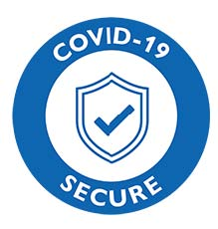

**North Devon Table Tennis League “Code of Conduct” for Covid-19**

**All players in the NDTTL should agree and sign this agreement.**

For the 2021-22 season of the North Devon Table Tennis League and in accordance with Table Tennis England and Government Guidelines, the following Code of Conduct is recommended to minimise the risks from Covid-19.

The following principles apply:

* If you are showing coronavirus symptoms, or any of your household are self-isolating, you must stay at home.
* You must contact the Secretary or Fixture Secretary by telephone or email if you or any of your contacts/household test positive for Coronavirus

*Please be advised that your details may be shared with NHS Track and Trace in line with Government guidelines*

* You must adhere to the current Governments social distancing guidelines at all times
* Members to provide their own refreshments and drinks bottles.
* Good hygiene practices should be maintained including:

Clean table tennis equipment to minimise risk

Communal equipment such as net, table etc. should be cleaned after use

Hand washing with soap (or use of hand sanitiser) should occur before and after each session.

* You must comply with any requirements/restrictions applicable to the venue being used.

***I confirm that I have read and agree to the code of conduct/principles listed above.***

**Member Name:**

**Member Signature:**

(Return of this email with your name completed is sufficient to signify acceptance)