Natland and Oxenholme Table Tennis Club

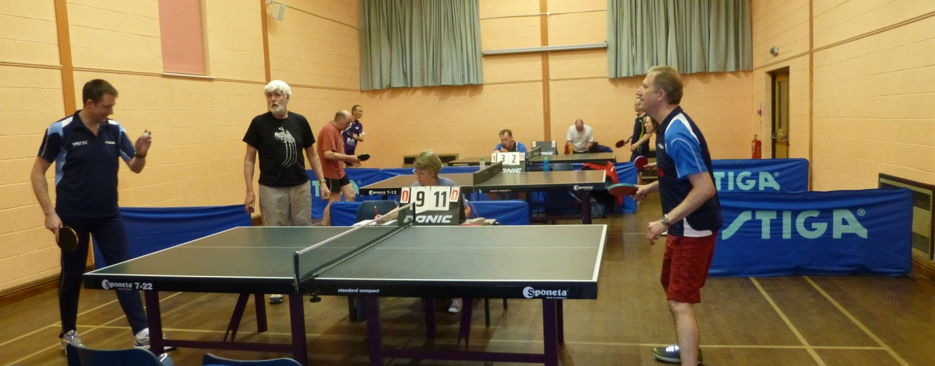
invites you to a
Friendly Table Tennis Evening
Friday 14 October 2016, 7.00 to 9.30 pm
Natland and Oxenholme Village Hall

A fun evening of friendly table tennis games, aimed particularly at non-league players from any of the local table tennis clubs, and hosted by Natland and Oxenholme Table Tennis Club members.

Cost £2 adults, £1 juniors
Supper provided

Contact: Mick Taylor 07743 579222, micktaylor1502@yahoo.co.uk

