HCTTA OPEN TABLE TENNIS TOURNAMENT
POINT 4 Venns Lane, Hereford, HR1 1DT
Wednesday 28th December 9.30am to 5.00pm

This is a tournament open to anyone from the HCTTA.

The format will be for 32 players of any ability. Entry will be strictly on a first come first served basis. Entry form and payment secures entry.

Round 1
There will be 8 seeded groups of 4 initially.

Round 2
The top 2 from each group will progress to 4 new groups of 4 against other 1st round winners and runners up.
The lower 2 from each group will progress to the consolation with 4 new groups of 4 against other lower placed players.

Round 3
In round 3 the top 2 from each of the winners and runners up groups will progress to QF, SF and finals or playoffs depending on their results. This will give all 8 players a further 3 games.
The 3rd and 4 placed players from the top 4 groups of round 2 will continue to the KO stages for positions 9 to 16.

The same format will be used for the consolation as above with the remaining 16 players.

Round 3 format example:
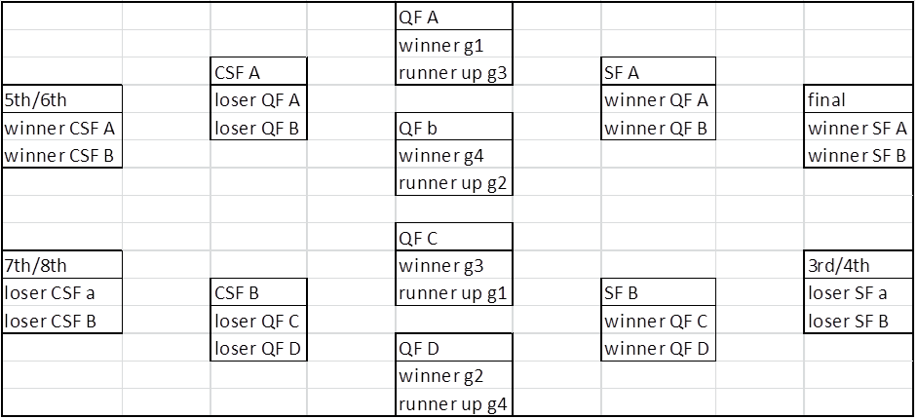

This will give all players 9 matches during the day with roughly equal gaps between matches.

There will be 8 players seeded into each of the 8 groups.
There will be a further seeding from 9 to 16, these players will be drawn into groups 1 to 8.
There will be a further seeding from 17 to 24, these players will be drawn into groups 1 to 8.
The remaining players will be drawn into the 8 groups.

The format will mean everyone has the same amount of games and everyone by rounds 2 and 3 will be getting games against players of a similar ability if the entry is of mixed abilities.

The matches will be played on brand new Joola tables at point 4 on the indoor futsal pitch.
All courts will be at least 9m by 5m.

The entry fee will be £15.

Name:

Phone no:

Email address:

Entry fee enclosed:

Cheques payable to Herefordshire County Table Tennis Association
Closing Date for entries:
November 30th:

Entries returned to:
Simon Morgan
19 Fielding House
Hereford
HR1 1XT

