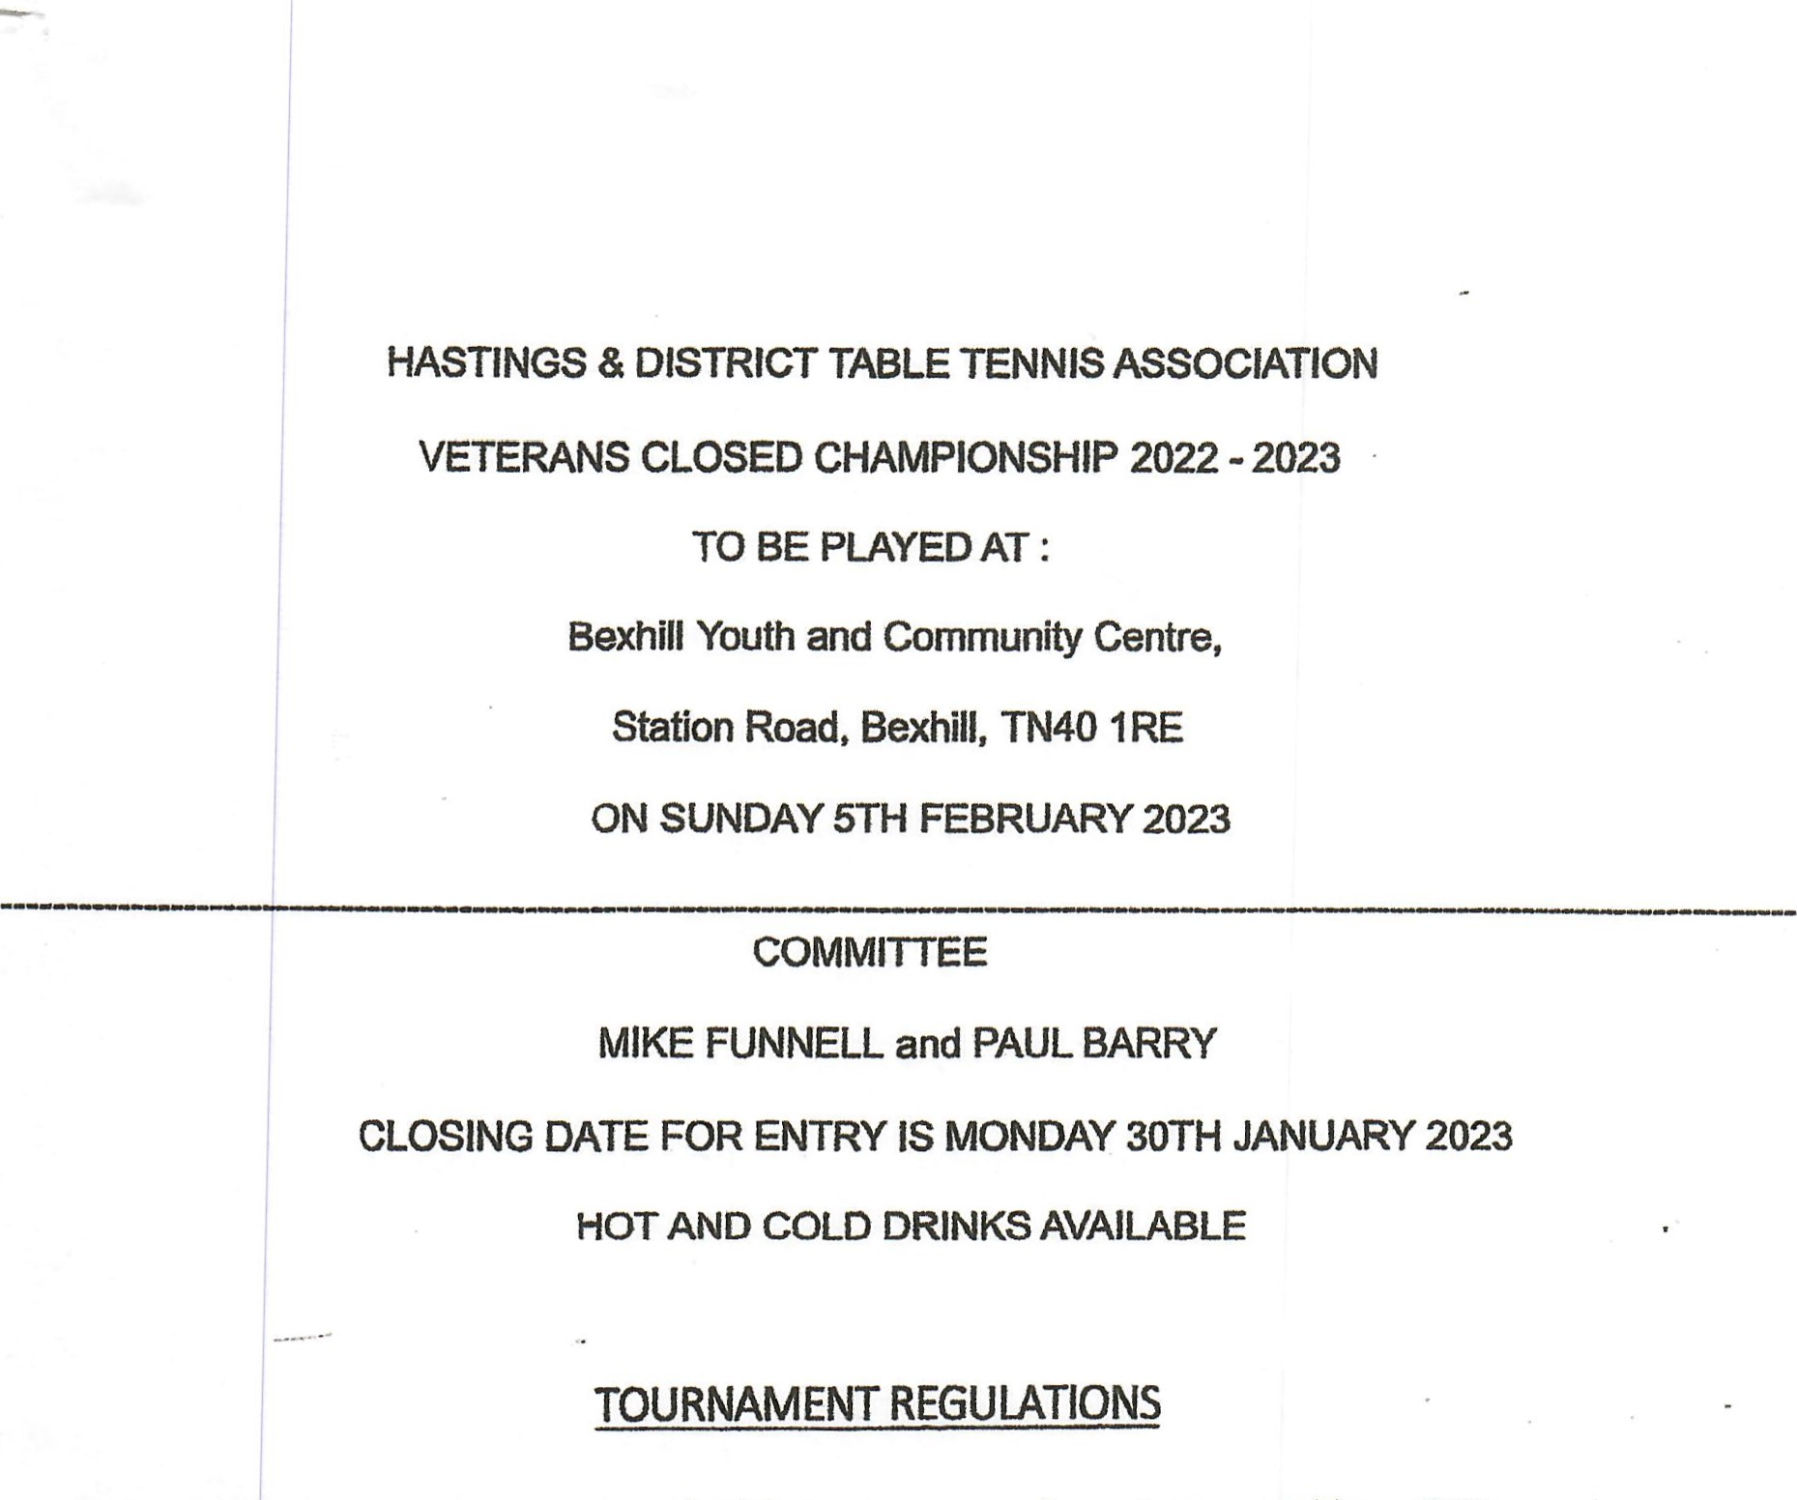
- All Competitors must be registered with the Hastings Association and be a TTE member.
- Competitors must have attained the age stated by the closing date.
- No white clothing permitted above the knee.
- Competitors who wish to leave the hall whilst still competing must first obtain permission from Control
- Competitors not ready to play when required will be liable to be scratched from the event in progress.
- Approved Star balls will be used throughout the Tournament.
- Losing players are requested to umpire the following match in all events played on the knockout system.
- The tournament committee reserves the right to make any alteration they may deem necessary and its decision on all matters affecting the Tournament will be final.
- NO gambling of any kind is permitted except in activities approved by the Committee.
- Players will be informed of starting times. Entries should be supplied with a contact phone number or e-mail address and payment,
- Where possible all singles events will be played on the group system.
- Players may enter only one singles event that they are eligible for and the doubles.
- Expedite rule will be enforced at the discretion of the Committee.
- FORMS WILL NOT BE ACCEPTED WITHOUT PAYMENT.
15. Events will take place unless less than two entries in the singles or two pairs in doubles events have been received.

ENTRY FORM
Entries to be sent to — Mr. M Funnell, 193 Wishing Tree Road, St Leonard's on Sea, TN38 9LD Payments Methods Accepted- Cash, Cheque or Bacs transfer to the HDTTA bank account.
Bank details or HDITA are as follows: Sort code 09-01-29 and account number 11564319.
If you are paying by BACS, please put your first Initial, your surname and VETS as the reference for the

ENTRY FEE - E13 (this covers all events, please tick events being entered )
Mixed Over 40s Singles
Mixed Over 50s Singles
Mixed Over 60s Singles
Mixed Over 70s Singles
Open Doubles
Handicap Singles / if time
Name
Age
Telephone Number
Email Address
Club
Home Address
Postcode
Doubles partner or wanted.

