CHESHIRE SCHOOLS TABLE TENNIS ASSOCIATION
INDIVIDUAL CHAMPIONSHIPS

ENTRY FORM
Please enter the following players, listed in England ranked order.

BOYS | GIRLS
UNDER 19 dob | UNDER 19 dob
UNDER 16 dob | UNDER 16 dob
UNDER 13 dob | UNDER 13 dob
UNDER 11 dob | UNDER 11 dob

CHESHIRE SCHOOLS

TABLE TENNIS ASSOCIATION
INDIVIDUAL
CHAMPIONSHIPS
Tuesday 9th February 2016
Halton Regional TT Centre
Halton (Select Security) Stadium
Lowerhouse Lane

Widnes WA8 7DZ
Commencing at 9.45 am
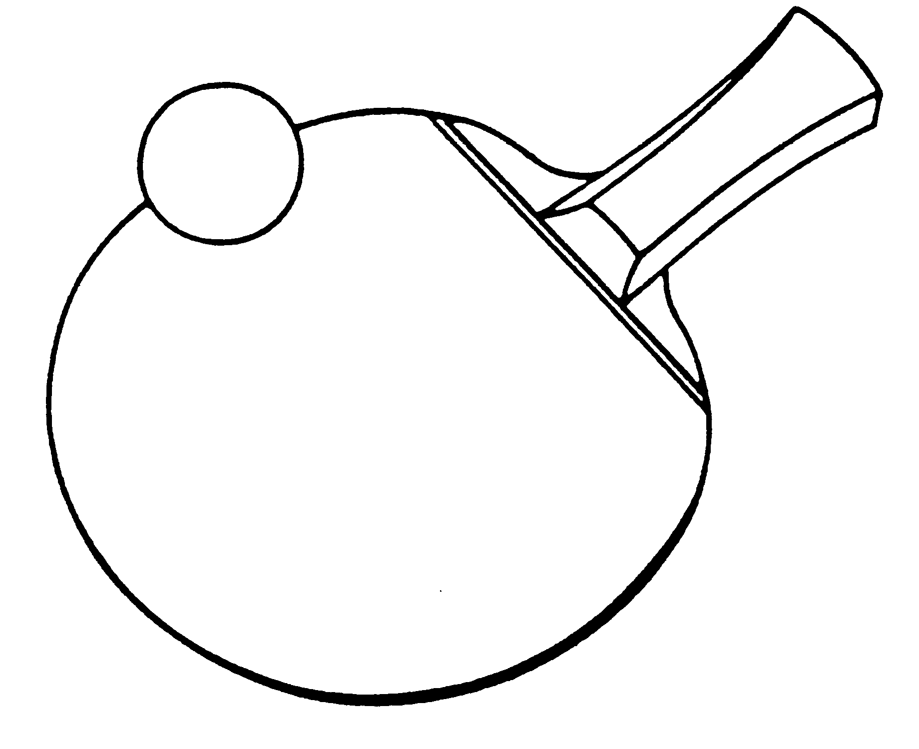

Closing date for entries
Monday 1st February 2016

Cheshire Schools Table Tennis Association
Individual Championships - Entry Form
Name of School
Address of School

Post Code Tel No
Teacher in charge
E mail ____________________________________________________________
Home Address (for emergency contact)

Post Code Tel No

EVENTS
1. Please enter _______ individuals in the Boys under 19 event
2. Please enter _______ individuals in the Girls under 19 event
3. Please enter _______ individuals in the Boys under 16 event
4. Please enter _______ individuals in the Girls under 16 event
5. Please enter _______ individuals in the Boys under 13 event
6. Please enter _______ individuals in the Girls under 13 event
7. Please enter _______ individuals in the Boys under 11 event
8. Please enter _______ individuals in the Girls under 11 event
I enclose £2 per individual entered and named overleaf _______
I enclose an affiliation fee of £10 (if school not already affiliated) _______
Affiliation period is 1/9/15-30/8/16 Total to pay £ _________
Cheques and P.O's should be made payable to C.S.T.T.A.

Signature of Teacher/Head Teacher_________________Name________________
Please return to:
Mrs Karen Tonge MBE 1 Malpas Road, Runcorn, Cheshire WA7 4AD
Tel: 01928 563640

The individual championships of the C.S.T.T.A. will be held at Halton TT Centre, Halton Stadium, Widnes on Tuesday 9th February 2016 commencing at 9.45 am
(Tel on day 0151 510 6024 or reception 6020)

RULES
- All players must be in full time education in Cheshire West & Chester, Cheshire East, Halton or Warrington and all must be affiliated to CSTTA (part year is £10)
- Eight events - Boys and Girls under 11, 13, 16, and 19. Ages as at 1st September 2015. ie under 13 on 1/9/15
- Players may enter ONE EVENT only. A teacher/lecturer or head teacher MUST sign the form to confirm you are representing the school/college. A parent can attend the event instead of a teacher as chaperone but cannot sign the form
- Entries to Karen Tonge, 1 Malpas Road, Runcorn WA7 4AD

Tel: 01928 563640

E-mail: k_tonge@sky.com

- Closing date for entries is Monday 1st February 2016.
- Players, or parents, teachers in charge should report to control by 9.45 am for. The organisers reserve the right to limit entries if it becomes over subscribed.
- Late arrivals are liable to be scratched....please phone if you are delayed
- Correct attire MUST be worn. NO WHITE shirts. Players must also bring their own table tennis bat.
Refreshments will be available for purchase.

National Finals will be on Saturday 23RD April 2016 at
Aldersley Leisure Village, Wolverhampton.
No entries will be accepted unless accompanied by the appropriate fees by closing date but entries can be emailed through.
The winner in each category will be invited to represent CSTTA in the ESTTA
National Finals.

