Playing Schedule
All events will be run on a group basis with up to 4 players in each group. The Winner and Runner Up from each group will go into a Knockout Competition to decide the overall Winners. There will be a Consolation Event for Competitors who are knocked out at the Group stage. The above schedules are subject to sufficient entries for any of the events.

Medals are awarded to all Winners and Runners Up.
A perpetual Trophy is held at the Club with the Winners Name on it.

Venue Location and Directions:
Draycott is only 10 minutes from the M1 and is situated between Derby & Nottingham.
From Junction 25 of the M1 take the A52 towards Derby. After 3 miles turn left (signposted Draycott) into Cole Lane. At the bottom of Cole Lane turn Right (towards Borrowash). Take the 4th left (signposted A6005) to Draycott, Breaston & Long Eaton. On entering Draycott keep a look out for the Draycott Table Tennis Centre on the right hand side, opposite The Travellers Rest Pub. There is ample car parking to the rear of the premises.
The centre consists of an 18.3m x 11m Community Hall and a larger purpose-built 22m x 12m Table Tennis Hall. On site there are toilets, changing facilities, showers, a social area and disabled facilities.

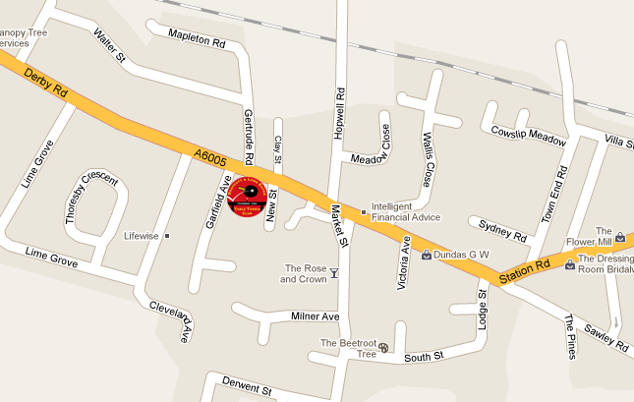
Please support our sponsors, Bribar www.bribartt.co.uk:



Derbyshire Sports Awards - Club of the Year for 2010 and 2012
Announces
Draycott
Junior 1* Open
(Approved by TTE & DTTA)

This is a TTE Tournament which will be held at

Draycott Table Tennis Centre
Derby Road, Draycott, Derbyshire, DE72 3NJ

Saturday September 19th 2015

Tournament Organiser: Graham Gobey

Referee: Brian Savage
10 Rebecca House, Uttoxeter Old Road, DE1 1GF
Tel: 01332 208694
E-Mail: tabsavage@yahoo.co.uk

Organising Committee;
Brian Savage (TO2), Phil Vickers (TO2), Graham Gobey (TO2)



Closing date for entries: September 8th 2015
If unable to supply an E Mail address please
Enclose a SAE so that your entry can be confirmed
TOURNAMENT REGULATIONS
- All entrants must be affiliated as Player Members to Table Tennis England or another National
association in Membership of the ITTF.
2. Table Tennis England Tournament Regulations apply to this event.
3. ITTF Regulations for International Competitions apply except those relating to matters covered by
items marked (x) in this Entry Form.
4. Completion and submission of this Entry Form signifies agreement by the Entrant to the Conditions
of the Competition including variations from the ITTF requirements.
5. All matches shall be the best of five games up to 11.
6. Preliminary matches will be on a group basis and the final order in a Group shall be determined as
per ITTF regulation 3.7.5 for Group competitions.
7. Players clothing main colour must not be white.
8. No competitor or official shall engage in betting on players or matches.
9. All competitors shall be required to umpire.
10. Doping is not permitted before or during play and doping control tests may take place.
11. All competitors must report to the Referee on arrival and should not leave the premises without
first obtaining the Referee’s permission. Players absent when called upon to play are liable to be
scratched.
12. Should there be insufficient entries in any Event the Referee reserves the right to cancel that
Event or merge Events or place the entrant in a similar Event.
13. The Referee’s decision shall be final on a point of law and on any question arising not provided for
in these regulations.
14. Players must have been born in 1998 or later for the Junior Event, 2001 or later for the Cadet
Event, 2003 for the Under 13 Event and must have no more than 1000 points on 15/8
Ratings list due to be published in August 2015.

Tournament Information
- Extra Entry Forms can be obtained via post or E Mail from the Organiser.
- Each Entrant is limited to a maximum of 2 Events.
- The Draw will take place on Thursday 10th September 2015 at 7pm at Draycott Table
- Tennis Centre.
- If an Event is over subscribed entries will be on ‘first come first served’ basis.
- Notification – Competitors supplying an E Mail address will be informed that their entry has been received and any other information that the Organisers need to make them aware of.
- Practice – There will be no separate practice facilities but competitors will be allowed to practice on tables not currently in use at the discretion of the Referee.
- Play will be 8 Tibhar 28R tables with Tibhar nets and White 3* Butterfly Plastic balls. Court size will be 9.5m x 5m enclosed by surrounds. Scoring machines will be used for all matches. The floor is semi sprung construction and the high frequency fluorescent lighting is a minimum of 4m above the playing surface. Assistant umpires will not be appointed.
- Medals are awarded to all Winners and Runners Up. A perpetual trophy is held at the Club with the Winners names on it.
- There will be Consolation Events at the discretion of the Organisers.
- Admission – there is no entry charge for Supporters or Spectators.
- The last day for receipt of entries is Tuesday 8th September 2015. The groups will be out to any E Mail address provided by entrants on Friday 11th September 2015.
Provisional Schedule
09:00 – Cadet Boys Groups
10:30 – Cadet Girls Groups & U13 Boys
12:00 – Junior Boys & Girls Groups & U13 Girls
13:30 – Cadet Knock Out
15:30 – Junior Knock Out

The provisional Schedule may be amended after 11th September 2015 by the Referee.

Light hot and cold refreshments will be on sale throughout the day at the Venue.
Further copies of this entry form are available to download from the TTE website.

DRAYCOTT JUNIOR 1* OPEN – Saturday September 19th 2015
Entry Form
Please complete sections 1-9 in BLOCK CAPITALS using a ball-point pen.
A separate entry form must be completed by each player and posted to the Referee accompanied by the appropriate fee.
Entries by E Mail or telephone cannot be accepted.
Please return completed forms to:-
Brian Savage, 10 Rebecca House, Uttoxeter Old Road, DE1 1GF.
Closing Date for entries is Tuesday 8th September 2015.

Full Name: | 1)
Parents E Mail: | 2)
Address: | 3)
 |  | Postcode: | 4)
Telephone: | 5) | Date of Birth: | 6) / /
 | If not affiliated to TTE Ltd, name of National Association: |  | 7)

Player Membership No | 8) | County:
Note - You MUST have a Player Membership Number for 2015/16 to enter.
 | Events | Fee | Amount
1) | Under 13 boys singles | £5.00
2) | Under 13 girls singles | £5.00
3) | Cadet (u15) boys singles | £6.00
4) | Cadet (u15) girls singles | £6.00
5) | Junior (u18) boys singles | £7.00
6) | Junior (u18) girls singles | £7.00
 | Admin Fee | n/a | £1.00
 | TTE Tournament Levy | n/a | £1.00
 | Cheques made payable to: dlettc | Total Enclosed
NOTE – Entrants may only enter a maximum of 2 events
I undertake:
To observe the regulations of the tournament.
To abide by the decisions of the Referee and Organising Committee.
To fulfil the schedule of play arranged for me unless prevented by circumstances beyond my control and accepted as such by the Referee.
Signature:_________________ Date________

