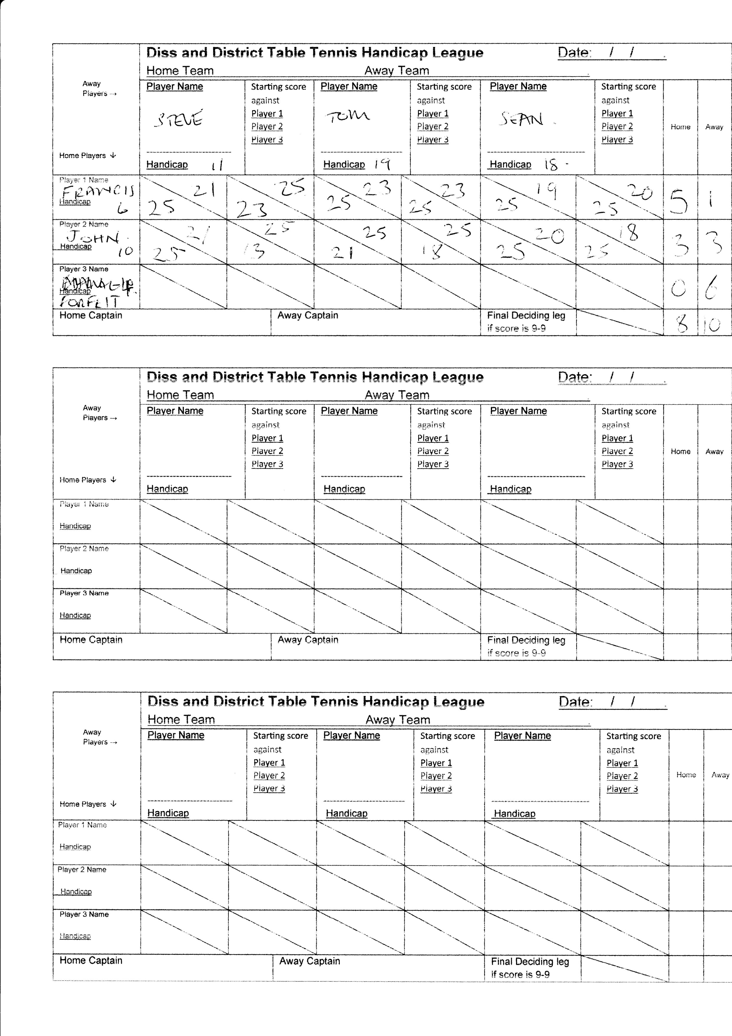

Heywood Hitters

Shotguns E