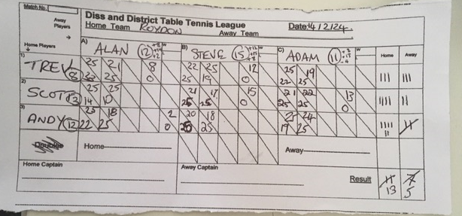
Away player 2 was brought in to make up the number. However he is treated as a forfeit for score purposes.
The Actual result is 12-6

