Table Tennis England INDIVIDUAL MEMBERSHIP
All players are required to obtain their own individual registration and registration number direct from TTE. All Diss league players must be registered to enable them to play.
Registration enables a member to play in any affiliated League and only registered players are covered by the TTE insurance scheme.
GENERAL RULES
1.The league shall be called the Diss & District Table Tennis League, and shall be affiliated to and play under the rules of the Table Tennis England (The sports governing body).
2.All officers and committee members deemed necessary, are to be elected at the Annual General Meeting, which shall be held at the conclusion of each season. With the exception of the League President, these officers must be re-elected each season. The officers shall consist of Chairman, Secretary, Treasurer. The Committee shall Consist of Divisional Results Secretary plus six members in addition to the aforementioned officers.

3.ALL TEAMS SHOULD BE REPRESENTED AT THE A.G.M. Non attendance can incur a fine to be determined by the Committee.

4.Each club shall pay to the league a registration fee for each team and player, with reduced rates for junior teams (to include 1 adult player). These fees will be determined at the AGM for the subsequent season. If a team wishes to register 5 players or more in a team, then the fifth player and upwards will be eligible for a 50% reduction.
All players are to be registered with the Results Secretary and payment must he received before they can take part in any league matches or competitions. New players may be registered by telephone during the season, but the registration fees must be received by the Treasurer within 7 days.

5.Transfer from one club to another can take place, with the player and the new club each paying a fee as determined by the league.

6.The fees for participating in the League and League tournaments shall be determined by the committee and payable in advance, irrespective of non-attendance. All these fees include affiliation to Table Tennis England and the Norfolk Table Tennis Association .

Closed Championships Qualifying conditions
7.All registered players must have played a minimum of 4 League matches, in the current season, to qualify to play in the Annual Closed Championships. Under 18 year olds can enter the tournament at the discretion of the committee.
Handicap Competition
7a. Players taking part in the Handicap Competition must have played at least 3 league matches to qualify to play in that competition. The Committee may waive this rule in certain circumstances, but no handicaps will be given without at least 2 committee members agreement.
7b. Premier/First Div experience allowance. (Table that determines handicap start figure). If a first division player plays a premier division player, then he receives an extra 1 point. If a first division player plays a first division player, then no one receives an extra one point. In the unusual circumstance when a first division player is standing in for a premiership player, then if he is playing a premiership player then he will receive an extra 1 point, but if playing a first division player will receive no extra point.
Match Rules
8. All matches must be played according to the fixture list. Any changes must be approved by the Results Secretary.
9. Matches must not be postponed, except in exceptional circumstances. e.g. Very bad weather. The Results Secretary must be informed immediately of any postponement.
10. If a team fails to turn up for a match they will have 10 points deducted.
10a. If a team postpones a fixture, they must rearrange the match to be played within 4 weeks of the original date, AND notify the Results Secretary of the both the postponement and rearranged fixture date.
10b. If a team fails to complete its fixture list, it will suffer a points forfeit as well as giving away 10 points to the opposing team. The forfeit will be set by the Committee and will be between 0 and 10 points, depending on the reasons for failing to complete the fixture.
11. Any complaint must be made in writing to the League Secretary within 7 days of the offence, in order that any action can be taken by the league committee.
12. Matches start at 7:00pm. Players arriving after this time will be entitled to the normal pre-match knock up. If a team is a player short and the missing player does not arrive by 9:00pm, then the team is liable to forfeit that players points to the opposing team.
13. Home teams will have at least one player who permission to enter the League result online, within seven days of the match being played. Handicap match results can be entered by completion of the online handicap match scorecard, but this does not, as yet, produce an immediate effect on the website.
13a. Final League results to reach the Results Secretary not later than 5 days prior to finals night.
14. Each League match shall consist of 9 singles and 1 doubles match. Played by 3 players of each team playing each of the opposing 3 players. Each match to be the best of 5 games. The first player to reach 11 points with 2 points clear is the winner (i.e.11-9) or after 11 points continue until there are 2 clear points (i.e.16-14). The doubles should be played by any registered players of the 2 teams but must include one of the singles players on each side. (TTE rule).
15. Names of home team to be entered are to be entered on the left of the scorecard whilst the visiting team names are entered above the scores.
16. Umpires are to be arranged between the captains.
17. Clubs may enter two or more teams, provided that each team is composed of different players. If an “A” team player is unavailable to play, a player may be borrowed from a “B” or “C” team, for a maximum of 3 matches only per player. If this is exceeded then that player becomes a part of the “A” team and then would be ineligible for the “B” or “C” team.
17a. Premiership teams may borrow a willing first division player from any first division team if the premiership team is short of a player. (the player can only do this on a total of 3 occasions).
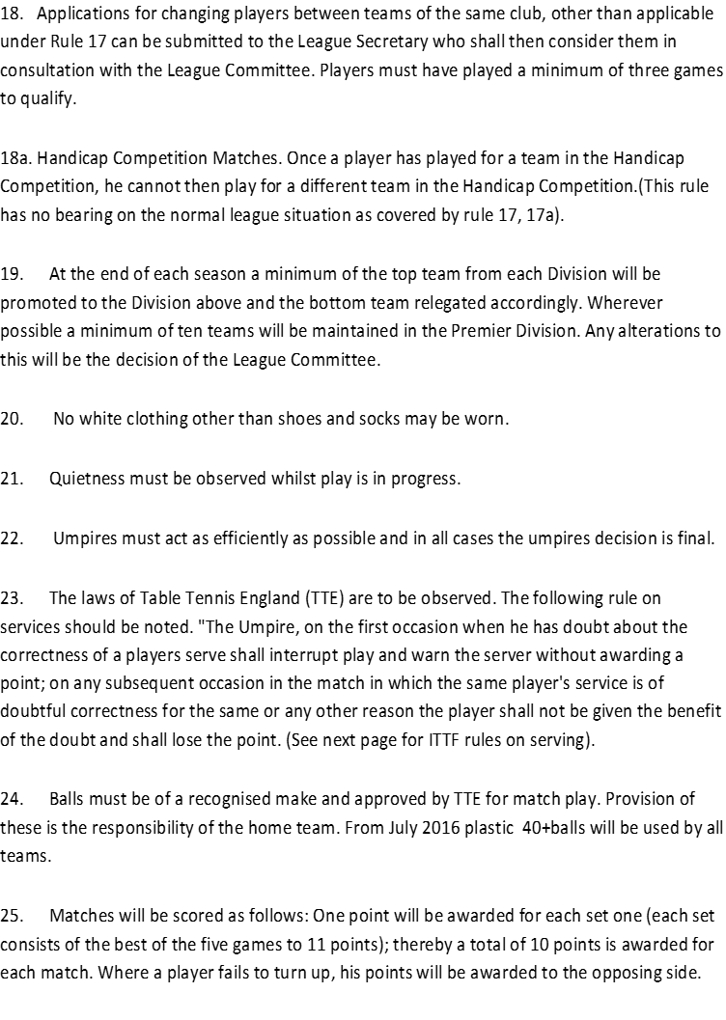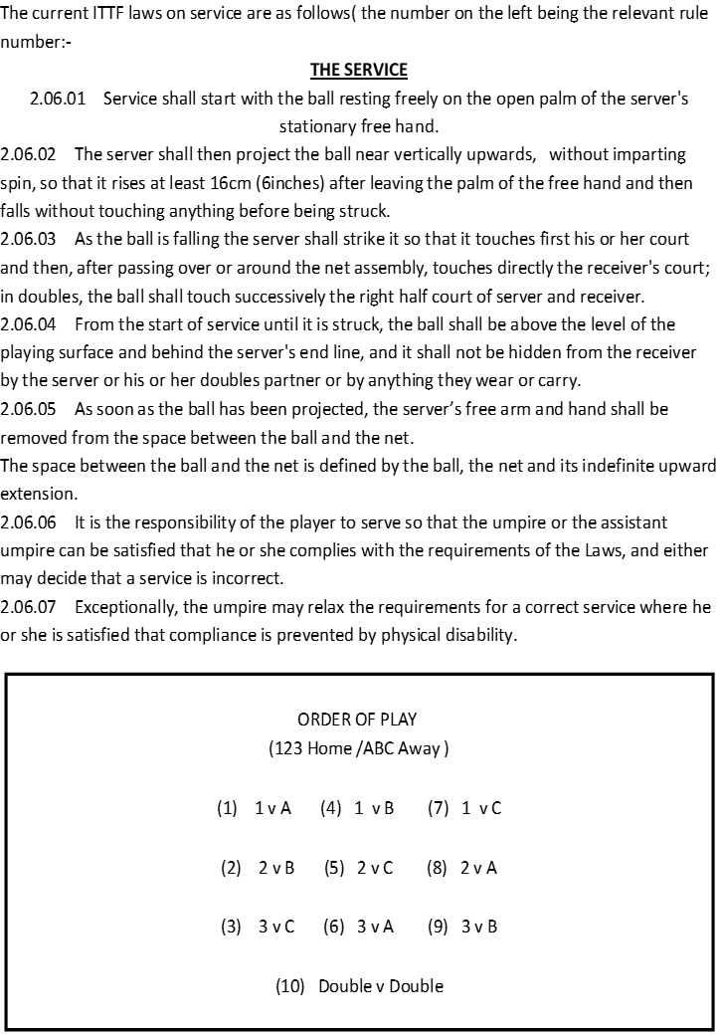
HEALTH AND SAFETY
In common with most businesses and organisations, whether voluntary, charitable, leisure or sporting, organisations such as the D. & D. T. T. L. are obliged to adopt an appropriate Health & Safety policy.
The League is responsible for reporting all incidents, however minor seeming, to the League's insurers as part of the terms of its policy. The following gives guidance to members and advises them of the procedures to be followed in the event of an incident.
Any incident of a Health & Safety nature should in the first instance be reported to the appropriate management member of staff of the venue concerned, to enable them to record it in their own accident book. In the event of such an incident, members should then contact the League General Secretary as soon as possible so that appropriate entry can be made in the League accident book and also, any other additional but necessary actions can be taken.
Some safety guidance for members -All members of teams have a responsibility to ensure that all their playing equipment is safe for use and any detects likely to affect safe play are remedied before being used. This applies equally to the playing area.
Any members who have a medical history e.g. heart or back problems should if possible, avoid lifting and moving heavy objects such as tables, especially those without wheels.
Where heavy objects are lifted, members should be mindful of correct, safe lifting procedure, i.e. keeping a straight back.
When setting up a table, members should be extra vigilant to ensure that fingers/hands do not become trapped in any way. i.e. between two halves or in folding mechanisms.
Any obstacles which may pose a danger to those engaged in match play should be moved to a safe location.
Where a venue is used by several teams, care should be exercised to ensure that when more than one match is taking place, there is adequate space for these to be played in safety without any risk of collision with object or person.
Care should be taken to ensure that players are not in danger of slipping during play and, similarly, individual players should ensure that footwear worn for matches is suitable for safe play.
Under no circumstances should a bat, or indeed, any items, be thrown.
Finally, it is emphasised that all members have a duty to behave in a responsible manner to ensure as much as is possible, their own safety and the safety of others.

