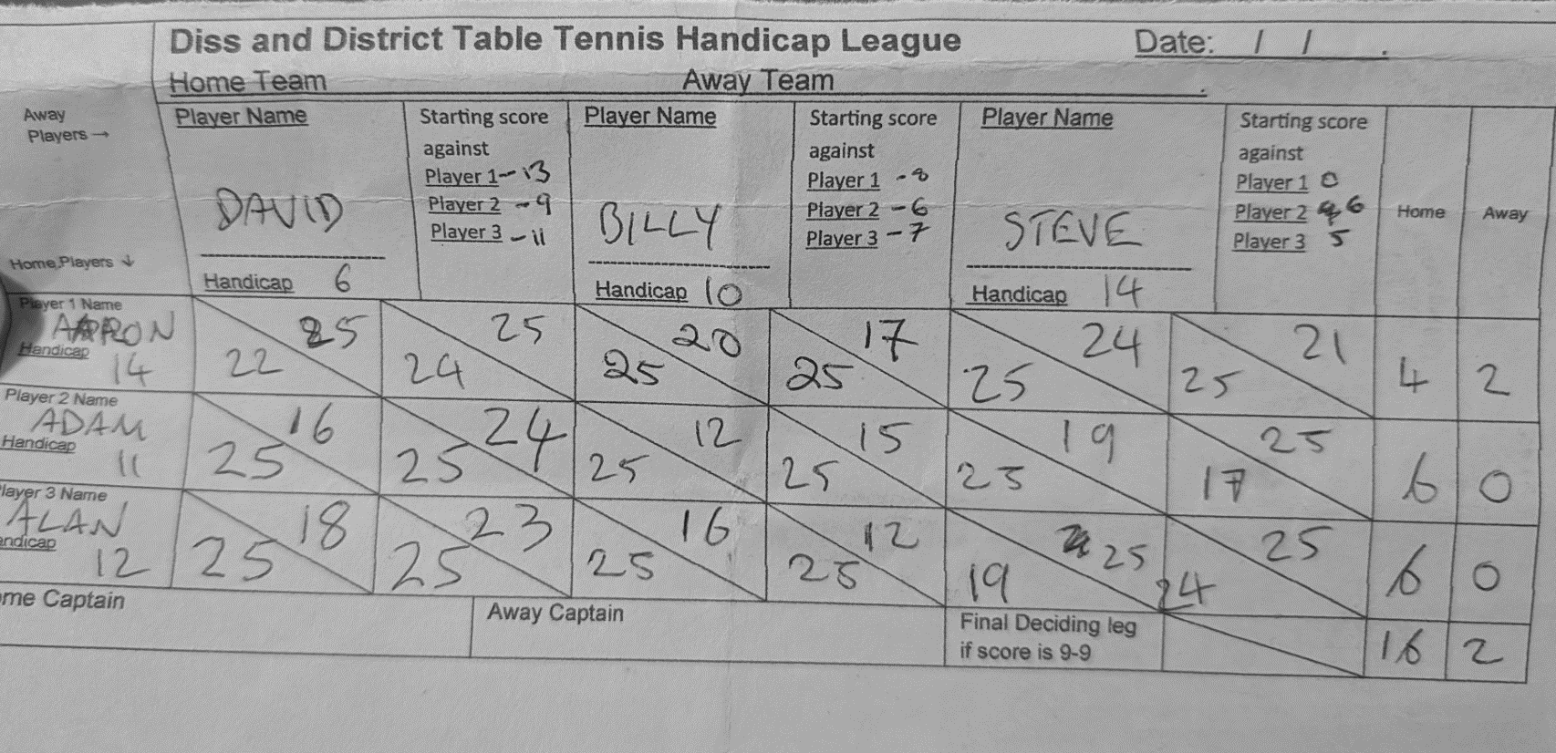
Shotguns C only fielded two players, Steve was played to make up the numbers only, so his scores do not count.

