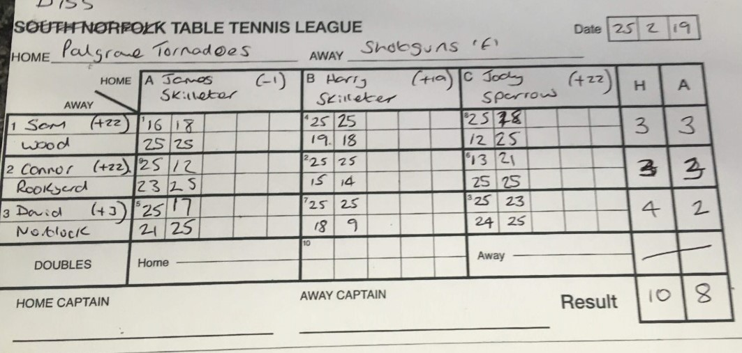

Note that Jody Sparrow and Connor Rookyard are both ineligible players and therefore stand and 2 forfeits. The actual score therefore is Palgrave 9 (276 points) and Shotguns E 7 (207 points)