Venue Location and Directions:
Draycott is only 10 minutes from the M1 and is situated between Derby & Nottingham.
From Junction 25 of the M1 take the A52 towards Derby. After 3 miles turn left (signposted Draycott) into Cole Lane. At the bottom of Cole Lane turn Right (towards Borrowash). Take the 4th left (signposted A6005) to Draycott, Breaston & Long Eaton. On entering Draycott keep a look out for the Draycott Table Tennis Centre on the right hand side, to the right of the Chip Shop. There is ample car parking to the rear of the premises.
The centre consists of an 18.3m x 11m Community Hall and a larger purpose-built 22m x 12m Table Tennis Hall. On site there are toilets, changing facilities, showers, a social area and disabled facilities.

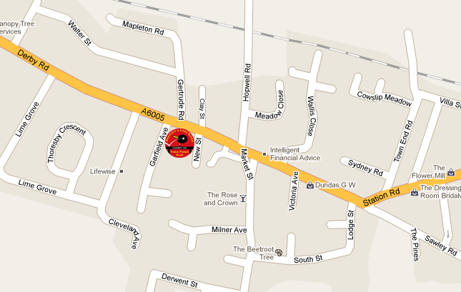

Derbyshire County Closed
Table Tennis Championship

Sunday 28th January 2018

Draycott Table Tennis Centre
Derby Road, Draycott, DE72 3NJ

Referee: Leslie Allwood
13 Prospect Road, Heanor, Derbyshire, DE75 7NF

Phone No: 01773 761369 E Mail: l.allwood49@talktalk.net

Organising Committee


Leslie Allwood (TO2)(CU) and Graham Gobey (TO2)

Closing date for entries: Sunday 21st January 2018.

If you can’t provide an E Mail address please enclose a SAE for confirming your entry.

TOURNAMENT REGULATIONS
- The Derbyshire County Closed Table Tennis Championships are held under Table Tennis
England Regulations and entries will be to those, who are player members of an
Association/League affiliated to the Association, player members of a directly affiliated club,
directly affiliated individuals and members of organisations of good standing, with the
exception that only players, who are eligible for selection for the County in County Championship matches can enter the Championships. In the event of a dispute the decision of the Organising Committee will be final.
2. All singles competitions will be drawn into groups were possible. Further rounds will be
played on the knock out principle as will doubles events and the first round will be drawn. All
matches will be on t he 11 up scoring system and the best of five games. The top 2 Players in
the initial Groups will qualify for the main knockout stage.
3. The Organising Committee will carry out the seeding.
4. Umpires will be provided from within the group. Following group play the losing player/s of
each match must remain at the table to be available to umpire the next match.
5. Players must report to the Referees table on arrival and permission must be obtained to leave
the sports hall.
7. The Organising Committee reserves the right to restrict entries and cancel events. No entry
will be accepted after the draw has taken place.
8. Players must wear rubber-soled shoes in the sports hall.
9. Match Balls will be white Joola.
10. The umpire’s decision on points of fact will be final. The Referees decision on points of law
disputes and interpretation of Regulations shall be final.

Winner Prize | Event | Entry fee | Tick
Trophies | Men’s Singles | £7
Medallions | Men’s Doubles * | £3
Trophies | Women’s Singles | £7
Medallions | Women’s Doubles * | £3
Medallions | Handicap Singles | £3
Trophies | Veteran Singles | £7
Trophies | Over 60’s Singles | £7
Medallions | Mixed Doubles * | £3
Trophies | U 21 Boys & Girls Singles | £4
Trophies | U 18 Boys Singles | £4
Trophies | U 18 Girls Singles | £4
Trophies | U 15 Boys Singles | £3
Trophies | U 15 Girls Singles | £3
Trophies | U 12 Boys & Girls Singles | £2
*Doubles Partner’s
Men’s Doubles
Women’s Doubles
Mixed Doubles

Tournament Start Time – 9:30am

This entry form will be available to download from the Derbyshire website or from either the Referee or Tournament Organiser.
Hot & cold refreshments will be available throughout the day.

The Derbyshire Closed Championships
Entry Form
Please complete sections 1-9 in BLOCK CAPITALS using a ball-point pen.
A separate entry form must be completed by each player and posted to the Referee accompanied by the appropriate fee.
Entry Qualifications – Players born after 31st December 2005 may enter under 12 events, Players born after 31st December 2002 may enter under 15 events, and players born after 31st December 1999 may enter under 18 events. Players born on or before 1st January 1978 may enter the Veteran Singles event and Players born on or before 1st January 1958 may enter the Over 60’s event.
Entries by E Mail or telephone cannot be accepted.
Please return completed forms to:
Leslie Allwood, 13 Prospect Road, Heanor, Derbyshire DE75 7NF
Closing Date for entries is Sunday 21st January 2018.

First Name | 1) | Surname | 2)

E Mail | 3)
Please print your E Mail address to make it readable
Address | 4)
 | PostCode 5)

Telephone | 6) | Date of Birth | 7) / /

Player Membership No | 8)

Note - You MUST have a Player Membership Number for 2017/18 to enter.

Total Fee Payable | 9) £ Cheques payable to Derbyshire TTA Trust
I undertake:
To observe the regulations of this tournament.
To abide by the decisions of the Referee and Organising Committee.
To fulfil the schedule of play arranged for me unless prevented by circumstances beyond my control and accepted as such by the Referee.
Signature_________________ Date________

