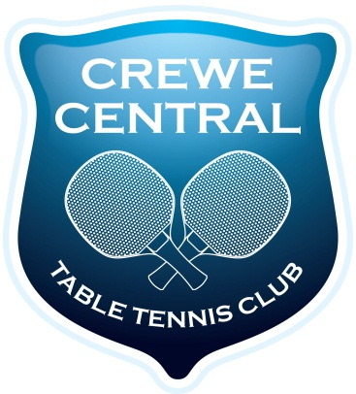Crewe Central Table Tennis Club
Welcome for New Members
Thank you for becoming a Member of the Crewe Central Table Tennis Club. You are very welcome and we hope that you enjoy your time with us.
The purpose of the Club is to provide opportunities for you to play competitive Table Tennis. We provide opportunities for you to play in Club competitions and to join teams that play in the local leagues.
We hope also that in order to improve your game you take part in practice and coaching sessions at the Club and at the South Cheshire Table Tennis Hub.
As a member of Crewe Central Table Tennis Club individuals take on a number of responsibilities.
- To contribute to the wellbeing of the Club
- To compete hard but fairly
- To play the sport in a manner that brings credit to you and the Club
- To respect other Club Members and treat them accordingly
- To be welcoming and friendly to players from other Clubs and Teams
- To participate in the setting up of the playing arena and keeping it smart and tidy
If you can think of ways to make the Club more interesting or effective we would like to hear your ideas.
Good luck
Mike Crompton
Chairman

