Chalfonts and District Table Tennis League AGM Report May 2016

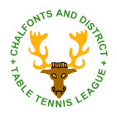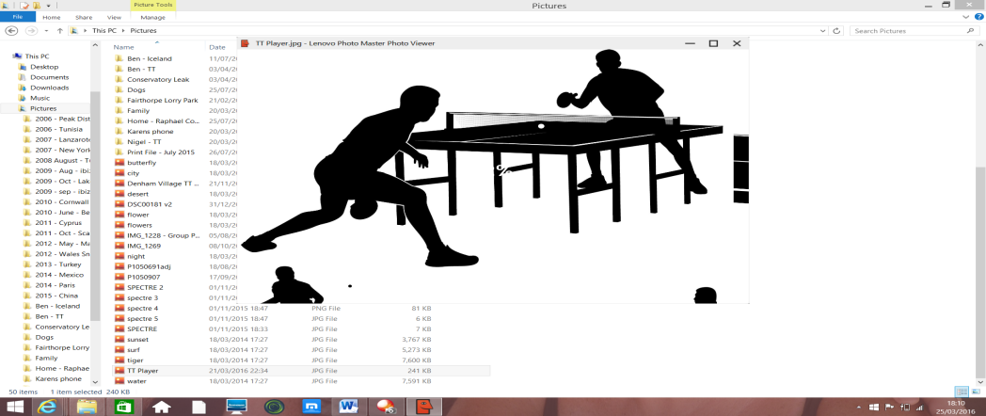

***Contents – 2015/16 Season:***

* ***Chairman’s Report***
* ***Fairbank Cup and Closed Championship Results***
* ***Fairbank Cup Competition and Closed Championship Competition Report***
* ***Match Secretary’s Report***
* ***General Secretary’s Report***
* ***Development Officer’s Report***
* ***Bucks County Representative’s Report***
* ***Treasurer’s Report***
* ***Final Player Averages***
* ***Final League Tables***

***ATTACK***

***TOP SPIN***

# Chairman’s Report for 2015-16 Season

**Welcome** to the 2015-16 edition of the Top Spin Attack. I hope you enjoy reading about our League, and the various competitions, results and other activities via the various Committee Member reports.

Let me start off by saying that leaving the Annual General Meeting (AGM) in the car last year was probably when it hit me the most! **“The realisation that with both Match Secretary and Closed Championship Secretary leaving the Committee at the end of the season, and after a number of years in the post, were we going to be able to run our League and associated competitions as successfully as before? Then in addition, throwing on top of those people changes, the move away from our bespoke internet site to the new Table Tennis 365 website, coupled together with the decision to expand from 2 Divisions to 3 given the increase in participating teams…….this really did have the potential to be a really challenging season as Chairman!”**

So with a theme of ***change***invading my mind as I type this, and looking back now that the season has closed, and the next AGM is on the horizon, I am not sure why I was so concerned, given the tremendous support from the remaining Committee members and those new ones that joined us. I firmly believe preparation for change has been the key to a successful season, whether that be via the creation of our new annual planner that spans all roles and activities, the commencement of a new Junior League, the creation of new terms of reference for each Committee role, the superb effort with regards implementation and ongoing management of the new TT365 website, through to the level of engagement and inter-working between subcommittee members running the Fairbank Cup and Closed Championships.

As always, enjoyment of this sport must come first, and I hope that has continued all the way through this season – I know there have been some hard battles out there, some incredibly close matches – but all seems to have been played in the right spirit, for which I thank all of you. To those new members of the League, from Hillingdon and Stoke Poges, thank you for your participation in the League this year, and we very much hope you will stay with us for many years to come. To those up and coming youngsters who played and experienced the League for the first time – well done – we hope you really enjoyed it, and will take that experience in to the new season ahead.

Let me say thank you to a few people…… Nigel, our General Secretary, without his help and support would make my position untenable; thank you Nigel…..to Hazel for her bravery in stepping up from Publicity Officer to Match Secretary (following David Stephan’s departure) and for making the new website so successful…..to Richard Cottle for his unstinting efforts in Junior development and setting up the new Junior League…..to Dave Morgan (and his helpers like James Johnson) for the smooth running of the Fairbank Cup……and Chris Lees who joined the Committee as the new Closed Championship Secretary, for the excellent running of the Closed Championships…..and finally to Derek Hughes for stepping in as County Representative (from Peter Leckie Snr) and more recently emergency minute taker!

For those Club Treasurers out there, we know that keeping control of finances is an ongoing challenge. For our League that is no different, keeping in balance the incoming revenue and outgoing cost, and our thanks therefore to Stefan Konig who has managed this effectively again this season. I am pleased to say that we have again managed to keep our fees the same for next season! It was with sadness that Peter Leckie Snr decided to stand down this season as County Representative, and leave the Committee, and I just want to, at this point, to pay tribute to him for so much support and service provided over the years…..thank you very much Peter.

As I wrote last year a number of our youngsters have continued to represent their County, Clubs, Country, or achieve great success in tournaments, and therefore our congratulations go out to Jemma, Shae, Ben, Guarav and Lee to name but a few – your commitment and skills are sometimes something us older players can simply dream of……!

The League competition, now across 3 Divisions, proved as competitive as ever with Division One seeing the ongoing battle between Denham Village A and Chiltern, Division 2 between Hillingdon A and Chalfont Community Centre D (both ending up on the same number of wins), and Division 3 between three teams – Stoke Poges, Hillingdon C and Hillingdon D. Congratulations to all the winners.

So where does the focus of the League need to be next year? I believe there are four aims:

* Encourage further participation and enjoyment through new competition formats
* Further develop the League structure with regards the number of teams in each Division, ensuring that each Division maintains a strong competitive edge
* Continue the expansion and development of our Junior League and Junior members, drawing upon the support (financial and operational) of both League and County

The above cannot be achieved without your contributions of time and effort, and I very much hope we can build upon the support received this year – please let us know how you can help.

So a year which saw many changes, but hopefully none that impacted your playing of the game or the administration of the League, and I hope we can embrace the challenges of the new season equally as well……

Enjoy reading the rest of the Top Spin Attack, **attend the AGM**. However, if you can’t, have a fantastic summer, and I look forward to seeing your participation in the new season ahead.

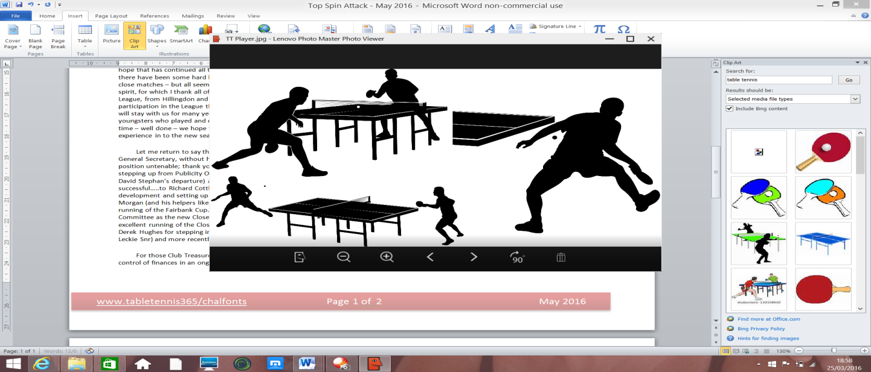

***Bob Baines***

Chairman

# Fairbank Cup Results - 2015-16 Season

***Round 1:* *Quarter-Finals:***

Denham Village E vs Denham Village A 2-5 Community Centre C vs Hillingdon A 1-5

Community Centre C vs Hillingdon B 5-0 Denham Village B vs Denham Village J 5-2

Denham Village D vs Rickmansworth C 5-0 Stoke Poges vs Denham Village C 3-5

Hillingdon A vs Hillingdon C 5-0 Community Centre B vs Chiltern 2-5

Denham Village B vs Community Centre A 5-0

Rickmansworth B vs Denham Village F 2-5

Ickenham vs Community Centre D 3-5

**Runners Up: Timur Hashimi, Steve Buck, Richard Cottle**

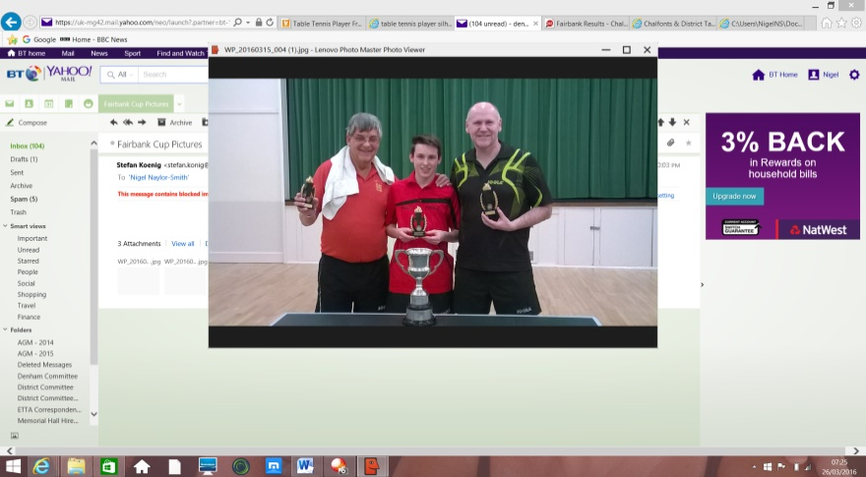

***Round 2:*  *Semi-Finals:***

Denham Village A vs Community Centre C 3-5 **Hillingdon A vs Denham Village B 2-5**

Denham Village D vs Hillingdon A 2-5 **Denham Village C vs Chiltern 5-0**

Denham Village B vs Denham Village F 5-3

Community Centre D vs Denham Village J 3-5

St. Joseph’s vs Stoke Poges 3-5

Rickmansworth A vs Denham Village C 2-5

Community Centre B vs Hillingdon D 5-0 ***Final:***

**Winners: Gerry Hawkins, Ben Naylor-Smith, Nigel Naylor-Smith**

Denham Village G vs Chiltern 0-5 **Denham Village B beat Denham Village C 5-3**

# Closed Championship Results - 2015-16 Season

**Men’s Singles**

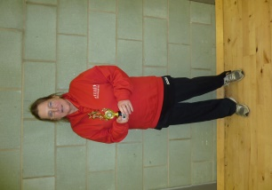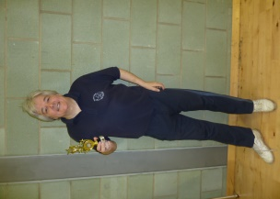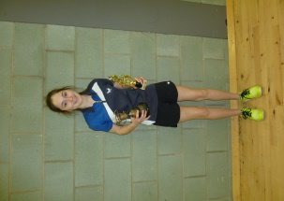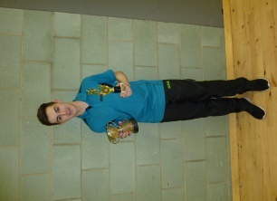Winner: Mitchell Jones

Runner Up: Richard Cottle

**Ladies Singles**

Winner: Carys Evans

Runners Up: Sue Merican

**Ladies Singles Runner-Up:**

**Sue Merican**

**Ladies Singles Winner:**

**Carys Evans**

**Men’s Singles Runner-Up:**

**Richard Cottle**

**Men’s Singles Winner: Mitchell Jones**

**Restricted Singles**

Winner: Ron Bryant

Runners Up: Steve Dunn

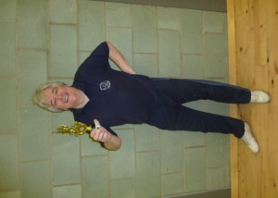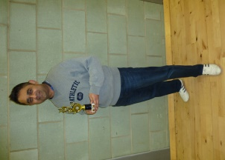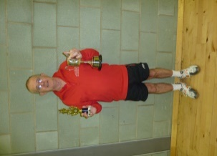

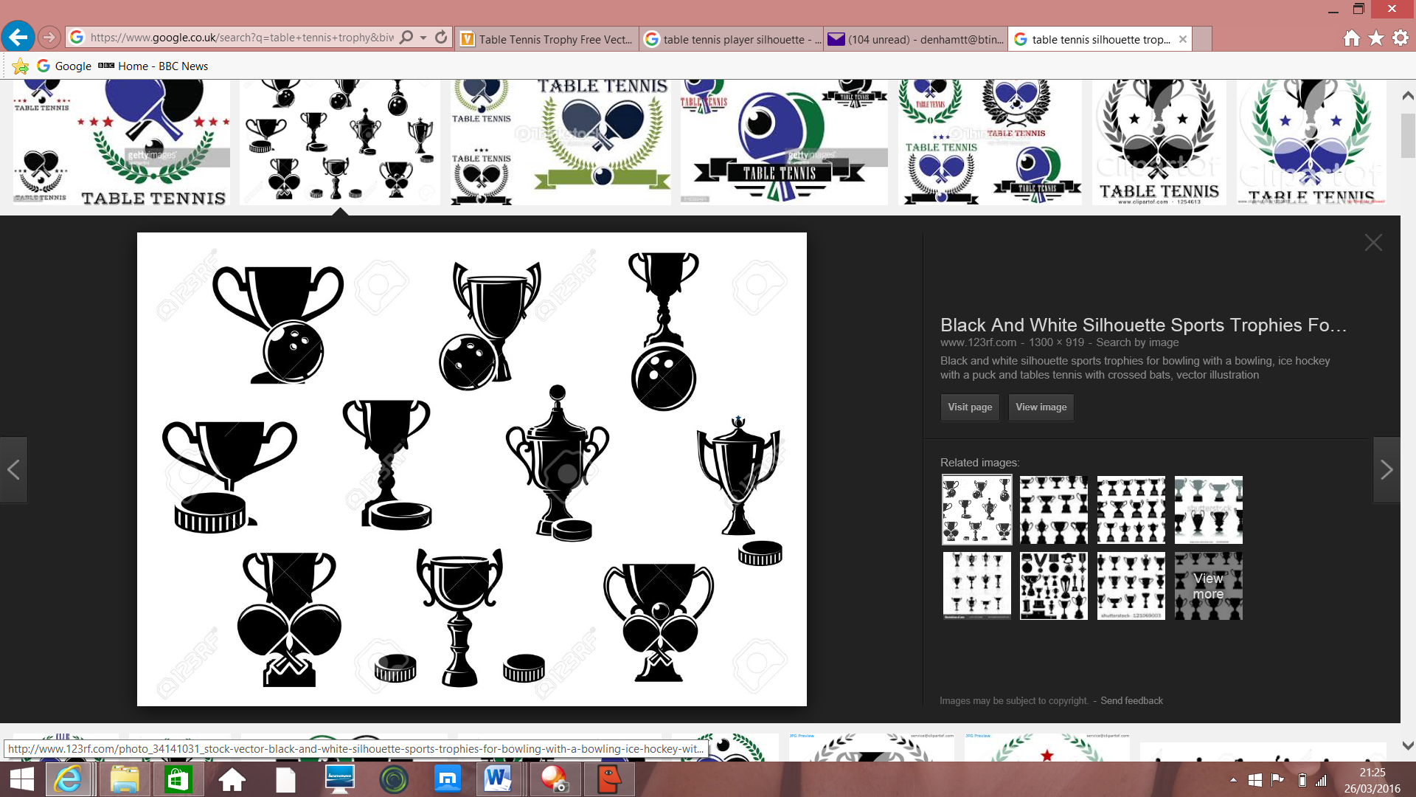

**Veterans Singles**

Winner: Ajay Gohil

Runners Up: Richard Cottle

**Men’s Doubles**

Winner: Mitchell Jones, Shae Thakker

**Veterans Singles Runner Up: Richard Cottle**

**Veterans Singles Winner: Ajay Gohil**

**Men’s Restricted Singles: Winner: Ron Bryant**

Runners Up: Mark Croucher, David Croucher

*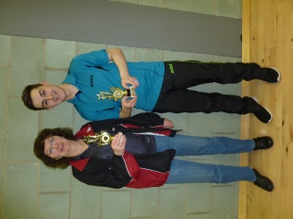***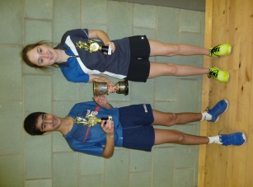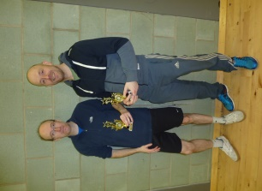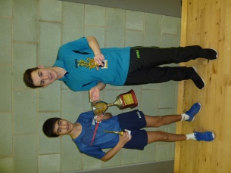Mixed Doubles**

Winner: Carys Evans, Shae Thakker

Runners Up: Hazel Williamson, Mitchell Jones

*The following events were not played due to*

**Men’s Doubles Runners Up: Mark Croucher / David Croucher**

**Men’s Doubles Winners: Mitchell Jones / Shae Thakker**

**Mixed Doubles Runners Up: Mitchell Jones / Hazel Williamson**

**Mixed Doubles Winners: Shae Thakker / Carys Evans**

*the number of entries: Under 15’s, Junior Boys,*

*Junior Girls, Junior Doubles*

# Fairbank Cup Competition

The Fairbank Cup proved once again to be an exciting and interesting affair with just three teams unable to compete either due to lack of eligible players or time restrictions. Unfortunately the proposed Plate competition didn't happen due to teams catching up on postponed matches in the cup weeks.

Tuesday evening (15th of March) saw the Final of the Chalfont’s and District Table Tennis League Fairbank Cup. It was an all Denham Village affair with Village B playing Village C. The night produced some outstanding table tennis from both sides and up to the sixth set was level at 3 sets apiece. In the seventh set Steve Buck from Village C was unable to overcome the skill and speed of young Ben Naylor-Smith although Steve was giving away a seven points start. It was then all down to Richard Cottle of Village C to beat Gerry Hawkins to stay in the match but despite one amazing rally Richard finally succumbed and Village B took the honours 5-3. Congratulations to the whole Village B squad of Gerry Hawkins, Ben and Nigel Naylor-Smith, Steve Brown and Ajay Gohil. All the results from each round and pictures of both teams competing in the Final are shown in the Fairbank and Closed Championships Results page.

I would finally like to thank James Johnson and Derek Hughes for their valuable assistance with the thankless task of setting the handicaps with the often limited information on player’s current performances.

***David Morgan***

Fairbank Cup Officer

# Closed Championships Competition

This year’s Championships were held on Sunday 20th March at the Harefield Academy. Given the number of entrants was low this year the Tournament Committee agreed to take out the junior events & run those later in the year, via the Development Office, Richard Cottle.

The members of this year’s Tournament Committee were Chris Lee, Stefan Konig, Hazel Williamson & James Johnson.

The Committee would like to express a special thank you to James Johnson for his help in putting together the running list to make the tournament run so successfully.

In a change from last year’s Championships it was agreed to run the tournament matches on 4 tables with 3 additional practice tables, which based on feedback from participants seemed to work well.

The number of entries, 28, was one of the lowest in recent years due to player’s other commitments such as National Schools. The 6 events followed the same successful format as last year. The Committee would like to thank all the umpires and assistants for their invaluable support, and once again, there were some spectacular matches to be seen….in fact it is very hard to select the most memorable matches as there were so many. Particularly memorable however was Marc Croucher against Ajay Gohil which was refereed by Ron Bryant, (must have been the longest match of the tournament). It was sad in the Men’s singles that Timur Hashimi, after beating Shae Thakker in an exciting and tense quarter final, had to concede the semi-final due to illness, leaving Richard Cottle in the final against Mitchell Jones. Indeed, the tournament appears to be totally dominated by Mitchell Jones who won both Men’s singles and Men’s doubles.

There was one match where a top player lost one set 11-0 but their name is not mentioned in this report!

A special thank you to my wife Brenda for running the refreshments; and to the support received from the Harefield Academy on the Saturday when setting up the venue.

***Chris Lee***

Closed Championship Secretary

# Match Secretary’s Report

Before starting on the details of my first report as Match Secretary, I would like to say thank you to my predecessor, David Stephan for doing a brilliant job in this role for 14 years and leaving the League in such great shape.

Looking at the spec for this role I noticed that David spent 2.5 days each week performing this job. As I cannot afford to spend that much time working on this, something needed to change and so the Committee agreed to switch to the TT365 website, which automates a lot of the calculations for individual averages, team positions and many other things that David had to work out himself. I am pleased to say the switch has worked out really well.

Given this was my first year in post, I would like to thank all the other Committee members for their help and support in helping me with this role.

**League Update/Status**

This year it was decided that as we had 23 teams we could go back to 3 divisions with 7 or 8 teams in each.

At our 2015 Club Secretaries meeting it was agreed to stick with the format of teams playing each other twice, even though this does the make the season a bit shorter. We were hoping to include a plate competition for the Fairbank Cup to provide some extra matches but unfortunately this didn’t happen this year, but maybe it can be arranged for next year.

I would particularly like to welcome our 2 new clubs, Stoke Poges and St Josephs, and also mention our 3 new teams from Hillingdon. We did have a slight problem as the new teams were all for the lower divisions, whereas the space that we had was in Division 1, and therefore we decided to promote one of the stronger teams from Division 2 to make up the numbers in Division 1. Thanks to Mick, Scott and other members of Denham Village D for their brave (but welcome) decision.

So, our 23 teams were scheduled to play a total of 154 matches. Of these, 1 match was conceded, one was awarded to the opposition and there was one match for which I am still awaiting the result card! All in all, this is a great improvement on previous years and I hope that everyone had an enjoyable season.

In Division 1 the competition between the top two teams changed in favour of the Denham Village youngsters who managed to keep ahead of the experienced Chiltern team this year. In Division 2, Hillingdon A proved that they are ready for the first division and in 2nd place was the Chalfont Community Centre new D team, who have also recruited a new member in ex Division 1 player Bas Mocharrafie. So there will need to be some re-naming of the teams in the Community Centre next season.

New club Stoke Poges had a very successful return to the League by taking first place in Division 3, followed by 2 of the new Hillingdon teams.

My suggestion for next year is that the top two teams from Division 2 move up to Division 1 and only 1 team move down from Division 1, leaving 8 teams in Division 1.  
Similarly, the top two teams from Division 3 move up to Division 2 and only 1 team move down from Division 2, leaving 8 teams in Division 2. This would then leave only 7 teams in Division 3 and so room for any new teams to join the league.  
The League structure will also change to a possible 10 teams per division to allow for any new teams to join. We’ll discuss this in more detail at the Club Secretaries meeting in a few months’ time.

In summary, this has been a very successful and enjoyable season with some top class players in the first Division and a good standard throughout the divisions, providing some very close matches. In Division 1 there were 3 players with 100%, Gaurav Aravind, Steve Buck and Danny Lewis, all from Denham Village…..and there was also Mitchell Jones, also from Denham Village, who could have had 100%, if he hadn’t turned up late for one of his games and had to concede it!!

We have a number of new players to the league and as some of the new teams from Hillingdon have 9 or 10 players in, it would be good if they could enter some extra teams for next season to flesh out the League further.  
  
I wish you all an enjoyable summer break and look forward the next season.

***Hazel Williamson***

Match Secretary



***The Chalfonts and District Table Tennis League***

# General Secretary’s Report

In the Chairman’s Report, the theme of ***change*** described much of what has been undertaken and achieved this year, and in the role of General Secretary this represented our preparations for being ready for the future.

Twelve months ago, I commented on how the Committee will continue to challenge itself on how the Chalfonts and District League can be moved forward, benefiting the players, Club and communities.

The Committee has made great strides in this, and has moved forward through success in the following:

* Movement on to the Table Tennis England standard website, TT365
* Creating better visibility and scheduling of the Committee activities
* Re-defining roles for each member of the Committee
* Clearer role descriptions and accountabilities
* Set up and commencement of a Junior League
* Drawing on support of non-Committee members to assist in events such as Fairbank and Closed Championships

With the changes in the Committee members over the last 12 months, the Committee needed to re-evaluate the distribution of tasks, and ensure that all serving members picked up responsibility for key parts of our League activities.

Therefore a new annual planning calendar was created, effectively a plan on a page, which identified all the major actions / events that need to be completed during each month of the year for each of the Committee roles, complimented by a detailed role description of the Committee Officer role itself. Both of these has and will continue to enable the smoother running of the League, enable an equal distribution of workload, and be updated as we move forward.

The move away from our bespoke website onto [www.TT365/chalfonts](http://www.TT365/chalfonts) could not be understated with regards the effort that was needed to set the new website up, and the enhanced information that it now gives to all Clubs and members. Moving off the old website after so many years, and the successful creation of the fixtures structure, and movement of historic data and pictures in time for the new season was a massive achievement, and huge thanks should go to Hazel Williamson, our new Match Secretary, for her sterling work across so many weeks. The ease at which we can now see and extract all League information including player and Club statistics, such as those at the end of this Top Spin Attack report, has made the various tasks so much easier.

The re-establishment of the Junior League heralds another milestone for last season bringing together youngsters from many schools / clubs to participate, enjoy and enhance their sporting skills. Congratulations to Richard Cottle and all those involved for their dedication in making this happen.

The Chalfonts and District League has operated well this Season with good respect and spirit on the playing front, minimal postponed matches, and well run competitions such as Fairbank, Inter-County and Closed Championships – thank you to all those that have supported and organised these competitions and well done to all those who won and took part – some tremendous matches and individual battles.

However, the number of entries to the Closed Championship was disappointing lower than in previous years, partly due to the conflict with a Schools Regional tournament that reduced our intake of younger players, but also perhaps from a lack of publicity to drive the excitement around the tournament. The Committee has therefore begun discussions on whether new events are needed in the Closed Championships that allow for greater entry from 2nd and 3rd Division players and give players a chance to win against the more established players through a handicap system, and how we can better inform all the League members of the Championship and entry timescales……your thoughts to Chris Lees, myself, or other member of the Committee are always welcome on how we can improve further.

The Committee will continue to meet on a monthly basis, to administer all aspects of the League, from the health of our finances, to liaising with the County Table Tennis Association, to the planning and execution of the 3 Division League, and the associated competitions, and all that within the context of providing an enjoyable, fun and healthy League environment. I am pleased to say there is always an excellent turn out from the Committee at our meetings, and from next season we will be publishing the minutes of our meetings on our new website.

As always the successful running and management of the League is not possible without the support of all your Clubs and their administrative teams, and therefore a huge thank you for all your time and effort. Our search will continue for a Publicity Officer to join the Committee to create awareness of our League and events, and effective communications with all our members – if you think you could fulfil this role – please let a member of the Committee know.

Finally - the AGM will take place on the 16th May at the Gerrards Cross Memorial Hall and I hope to see as many of you there, as we run quickly through the meeting agenda, give out the engraved trophies, and socialise / reminisce over a drink. The date for the Club Secretaries meeting will also be announced where we will discuss the Divisional structure of the League for the 2016-17 season.

Wishing you all a great summer break.



***Nigel Naylor-Smith***

General Secretary

# Development Officer’s Report

Another senior league season is now completed and certainly the players I’ve talked to all seem to have enjoyed it, one small niggle I heard was about the lower number of matches played during this season, but that’s work in progress for next season and I’m sure will be addressed elsewhere.

From a development perspective things are moving along, albeit rather slowly but surely. It was nice to welcome our new club St. Joseph’s after a little arm twisting (!) but having completed their first season I’m hopeful we can build their club and their membership. Also nice to have welcomed Stoke Poges back into the League and it looks like they will also have more players/teams next season. Hillingdon of course are going from strength to strength and great to see their progress there. We are of course on the look-out for new clubs for the League, and I have made attempts to recruit some - there seems a trickle of interest here and there which we could build on, IHG at Denham for example, has a few employees who play for fun there but as soon as I mention individual membership and that teams need to fulfil weekly fixtures that tends to sound ‘too serious’ for them. Anyway, will keep on the case, but please do help spread the word and if you see any potential interest do put them in touch.

Our newly formed Junior league has gone very well, we’ve had 3 sessions so far with 2 more planned as this goes to print. It is essentially made up with teams from Denham village, Harefield Academy, CSP Academy and Chalfont Community College, who have a new keen teacher who I’ve met with and hope to strengthen links further with the league over the next year. One tricky area though these days seems to be the availability of the young players as they all have so many other activities going on, this was evident this year at our Championships and it was a shame we could not get enough entries to run the cadet and junior events, but I now have plans underway to hold a tournament later in May to which I shall also invite the youngsters from our Junior league.

It was nice again to see the young players battling it out through the season in the senior league with some big improvements being made along the way. Players such as Shae, Ben, Jemma and Carys having risen up through the divisions and are making great strides, good going you guys ! Of course we often lose some players along the way, next season will see some of the lads hanging up their bats, as they’re not feeling the vibe for TT anymore, that’s fair enough, it happens, but we also lose some to university and that’s where young Timur Hashimi is going next September, so we wish him all the best and will see him again for a knock, he’s been a really solid league player for the last 5 years with us.

Another welcome was made this season by the BUCKS county Inter league thanks to the efforts of Mike Atkinson. We sent a good squad of Rhys Thoroughgood, Adam Read along with Ben and Shae, and they played in the top division against strong opposition and ended up in joint third spot with Aylesbury A.

Finally, I’d like to say thanks to my fellow committee members for their efforts, especially Hazel who has taken on her new role as Match Secretary with great aplomb!

***Richard Cottle***

Development Officer

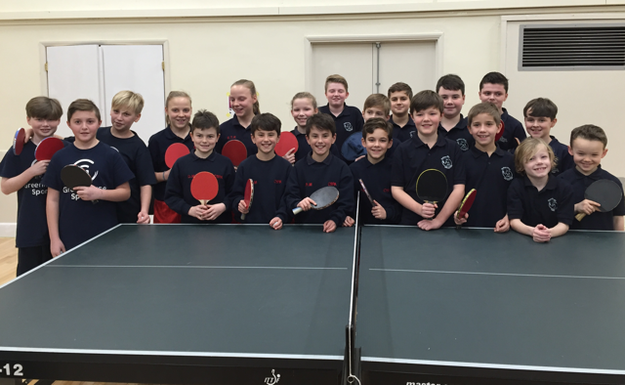

# Bucks County Table Tennis Representative’s Report

Peter Leckie (Senior) was the long-serving Chalfonts and District representative who handed over to me when we both attended the September 2015 County meeting. Many thanks from all the Committee for all his support in this role. The County meetings take place in Chesham Bois on the first Friday of the month.

I outline below for your information, some of the issues that have been discussed:-

1. Date clashes – a number of members expressed concern over the date clashes between events across the county and the General Secretary was to write to all local leagues to ensure they check with the County before finalising dates of championships and other events. Organisers please note.
2. Taking Part - entries to County events have been very disappointing, particularly Veterans and Over – 60’s. Could any Veterans or Over 60’s reading this please give some consideration to putting themselves forward for a County event in 2016/17?
3. Umpires – there is a shortage of Umpires across the County and Leagues were asked to identify any potential umpires to Tony Greenham the Umpires Secretary. Please let me know if you need contact details.
4. Juniors – the County Committee takes a great interest in the development of younger players (the future of our sport) and was very pleased to hear about the progress made towards a Junior League in Chalfonts and district. Amongst others I have helped out at one of the Junior League days, but Richard Cottle needs more helpers/volunteers to set up the hall, umpire etc. Details from Richard.
5. Condolences were formally expressed on behalf of the Committee to the family of Jean Williams who sadly died in 2015.
6. National - Buckinghamshire Table Tennis Association is represented on the ETTA National committee by Ron Washington and we have regular reports back from him. The main concern at present seems to be ETTA’s inability to hear the feedback that County Associations are giving them on the state of the sport and the need for better ways forward. I will report back on any developments.
7. AGM – the County AGM is on Friday June 10th. Please contact me if you require details.
8. Minutes – the minutes of our meetings are emailed to myself and to Nigel (our General Secretary) and can be forwarded to anyone interested.

Comments/feedback – please don’t hesitate to contact me if you have any comments or questions or want me to table any information to the County Committee.

You can email me on [dereknmarnie@hotmail.com](mailto:dereknmarnie@hotmail.com).

***Derek Hughes***

County Representative

**BUCKINGHAMSHIRE COUNTY**

**TABLE TENNIS ASSOCIATION**



# Treasurer’s Report – 2015-16 Season



**Financial Summary:**

* Financially the league finished the year 2015/2016 with a deficit of £206.76.
* Deducting from this the one-off cost of £193.25 for the leaving gifts presented to David Stephan and Brenda Cranfield-Thompson for the many years of support they had given to the League, the League broke more or less even apart from this special expenditure item.
* Notwithstanding this we are looking to reduce costs where we can in order to keep the League’s fees as low as possible and so that we can balance the books in the forthcoming years. Examples of this in action are the savings made through no longer providing stamped score cards thanks to Hazel accepting electronically submitted match results, or using electronic distribution of this year’s Top Spin Attack newsletter (no printed copies).
* With this approach in mind the League’s team and player registration fees will remain unchanged for the year 2016/2017.

# Final Player Averages – 2015-16 Season

Congratulations to all players who played in the League this season and especially those below:



# Final League Tables – 2015-16 Season

Congratulations to all teams for a great season – final positions below:



