Chalfonts and District Table Tennis League AGM Report May 2018

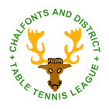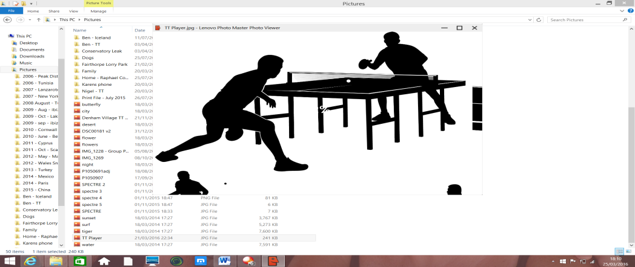

**This Top Spin Attack edition is dedicated in memory of Bob Baines – Chairman, Captain and Player**

***ATTACK***

***TOP SPIN***

***Contents – 2017/18 Season:***

* ***Chairman’s Report***
* ***Fairbank Cup and Closed Championship Results***
* ***Fairbank Cup Competition and Junior League Competition Report***
* ***Match Secretary’s Report***
* ***General Secretary’s Report***
* ***Development Officer’s Report***
* ***Bucks County Representative’s Report***
* ***Treasurer’s Report***
* ***Final Player Averages***
* ***Final League Tables***

# Chairman’s Report for 2017-18 Season

**Welcome to the 2017/18 edition** of our League’s Top Spin attack document. As always, you can find out about the work undertaken by your league Committee members, read reports on tournaments such as the Fairbank Cup, hear about the social tournaments that have been run, and of course see the status of our financial health, and confirmation of the final League positions across the three Divisions that we have run.

Stepping into the role as acting Chairman this season when this was filled by such a brilliant, confident and engaging character was never going to be easy. **Bob Baines was a hugely popular Chairman, respected and appreciated by all the Committee, and equally popular table tennis player…….we would all like to pay tribute to him via this Top Spin Attack edition for his commitment, energy, and support to the Chalfonts and District League.**

We are especially pleased that Bev, his wife, is planning to be with us at the AGM, and has kindly donated the “Bob Baines Award” in lasting memory of him. In so doing recognising the many qualities that Bob had shown, and that we aspire to see in all our circa 100 members and the way we go about engaging in our League activities.

This season has spectacularly raced by. It seemed that Christmas was only the other week, the cold snap was upon us, and the Fairbank was only in the preliminary rounds. I think that pace reflects not only how all our lives are generally going in today’s world, but also reflects the smooth running of the league and competitions, due completely to the superb efforts of all of your Committee, and the hours that they all generously put in. My thanks to all of them for their sterling work and support this season. I sincerely hope that you all take the time to find an opportunity to say thanks to them over the next few weeks, since without them, this League would not exist.

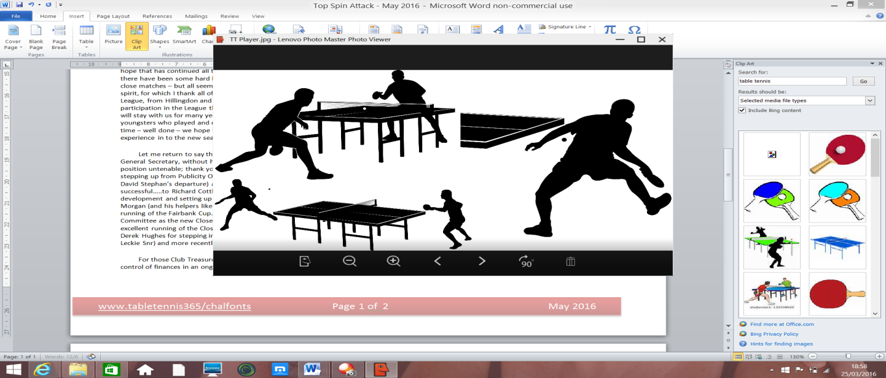

Many of the challenges that Table Tennis Leagues face across the country, as we heard from Sara Sutcliffe (CEO Table Tennis England) at the last AGM was finding new players and people willing to support. Our league is no different and as per Richard’s Development Officer Report, we all have a role to play in promoting our league, and contributing to its success and ongoing development.

Whilst it was disappointing to see a reduced number of League teams, ironically we may have actually seen a more competitive set of Divisions this year, as the results shown at the back of this report illustrate. Congratulations to everyone on the standard of play this season, and the spirit in which this year’s league has been conducted. With that in mind, we were delighted to welcome Brunel University into our fold this season, playing in Division One, and hope they will be with us for many seasons to come. Well done to all of their players – hopefully you all enjoyed it!

As the world moves into a more digital age, the Committee have agreed and implemented some changes of our own this season, including a new social media Facebook page:

[**www.facebook.com/chalfontsttleague**](http://www.facebook.com/chalfontsttleague)

and invested in the TT365 email module – further details in the General Secretaries report. I hope that both these changes will make communications to our members much easier and consistent, and visibility of our league to the wider public community even stronger. We can build on these foundations over the next 18 months.

Over the last two editions of Top Spin Attack we have talked about three key aims, all of which I am proud to say that the Committee has moved further forward on, and I hope you can see the evidence of this in the various reports included. To remind you of those aims:

* Encourage further participation and enjoyment through new competition formats
* Further development of the League structure with regards the number of teams in each Division, ensuring that each Division maintains a strong competitive edge
* Continue the expansion and development of our Junior League and Junior members, drawing on the support (financial and operational) of both League and County

There is still much more that can be achieved, with your help.

Please do read all the reports in the document, and as always please let us know your thoughts, suggestions and recommendations.

**And lastly, in the words that Bob Baines used in his final Chairman’s report “have a fantastic summer if you cannot attend (the AGM), and hopefully we can look forward to your participation in the new season ahead”.**

***Nigel Naylor-Smith***

Chairman (Acting)

# As we promote our league further, watch out for these flyers being circulated in to local communities….

# 

# Fairbank Cup Results - 2017-18 Season

***Round 1:* *Quarter-Finals:***

St Josephs vs Chalfont B 3-5 Hillingdon vs Ickenham 2-5

Hillingdon vs Denham Village C 5-3 Denham Village J vs Denham Village B 5-2

Denham Village A vs Chalfont C 5-2

Denham Village K vs Denham Village D 2-5

***Round 2:*  *Semi-Finals:***

Chalfont B vs Hillingdon 3-5 **Ickenham vs Denham Village J 5-3**

Denham Village F vs Ickenham 0-5 **Denham Village A vs Denham Village D 5-1**

Denham Village J vs Chalfont D 5-2

Brunel B vs Denham Village B 0-5

Chalfont A vs Denham Village A 3-5

Chalfont C vs Brunel A 5-1

Denham Village G vs Denham Village K 1-5 ***Final:***

Denham Village D vs Stoke Poges 5-0 **Ickenham vs Denham Village A 1-5**

# 

**Runners Up: Andrew Taylor, Norman Dennis, Ray Sippett**

**Winners: Richard Cottle, Yanu Aurelian, Nicholas Carter**

# 

# Closed Championship Results - 2017-18 Season

Unfortunately the League were unable to run the Closed Championships this year due to low attendance numbers, but we do expect to run this next season. We will review the timing of the event, and the day upon which it is held in order to encourage more league members to enter.

# Fairbank Cup Competition

The Fairbank Cup run for this season was quite successful with only two teams having to concede in the early stages. There were no big surprises although having to handicap players with only two matches played proved somewhat of a challenge. The final was between a team from the first division, Denham Village A, against one from the third division, Ickenham, which proved the handicap system seems to work quite well.

The semi-finals comprised three Denham teams and Ickenham, with Denham D and Denham J being the unlucky losers.

On the night of the final though, the strength in depth of Denham Village A proved just too much for Ickenham coming out winners by 5-1, but the matches were much closer than the final score showed, with several matches going the full distance of 3 games.

Commiserations to the gallant losing Ickenham team comprised of Norman Dennis, Andrew Taylor and Ray Sippett. A great effort made against a strong opposition.

Congratulations go to the winning team of Richard Cottle, Yanu Aurelian, and Nicholas Carter (the latter performing heroically at the young age of 10 years old).

Lastly, thanks to all the team captains for getting the matches played on time, and for those who have assisted me in running the Fairbank Cup this year.

***David Morgan***

Fairbank Cup Officer

# Junior League Competition

The Junior league plays a big part in my role with the league and this season I again ran four days of Saturday matches. I was delighted to welcome Reach Table tennis club and they joined our regular teams from CSP Academy, Hillingdon and Denham Village.

We again had two divisions and the sessions provided some first class TT that was enjoyed by players and spectators. After the first two days play we made a few tweaks to the placing of the teams. On days 3 and 4 each team played all the others in their division producing the final league tables as shown.

Medals were duly awarded to Reach Atticus for winning division one, and Denham Dodgers for winning division two.

The four club coaches got together and picked one player from each division to win the ‘special award’ medal and the winners chosen were Carlsson Wong (CsP , division one) and Mia Lakhani (Hillingdon, division two ).

CSP Academy hosted two of the days play for which the league is very grateful.

You will all remember John Underwood, the Headmaster who worked for many years there developing the schools Table Tennis. John has now retired but his son Joseph has taken on the post of TT coach and is doing sterling work at the school with weekly coaching sessions and even steering the Academy into the national finals.

Steve Keyes from Hillingdon and Roger Close from Reach (Chorleywood) clubs are also doing great work and it is a joy to see such enthusiasm from the players, coaches and parents.

Once our junior players have reached a certain standard I have been feeding them into the senior league and I plan to add some more next season. I hope you all agree that the juniors have been a welcome part of league matches and have competed well this season. Denham’s J team just missed out on a Fairbank final spot, however I was delighted to ‘borrow’ the J team’s 10 year old Nicholas Carter for my own A team's cup campaign and it was a delight to watch him in action at the final.

***Richard Cottle***

Development Officer

**Results from the Junior League Competition**

**JUNIOR LEAGUE DIVISION ONE**  **JUNIOR LEAGUE DIVISION TWO**

|  |  |
| --- | --- |
| Reach Atticus | 28 |
| Denham Demons | 23 |
| CSP Tornado’s | 17 |
| CSP Butterfly | 10 |
| Denham Dynamo’s | 9 |
| Reach Radley | 3 |

|  |  |
| --- | --- |
| Denham Dodgers | 20 |
| Hillingdon Harriers | 18 |
| Denham Dragons | 18 |
| CSP Aces | 15 |
| Hillingdon Heroes | 10 |
| CSP Allstars | 9 |

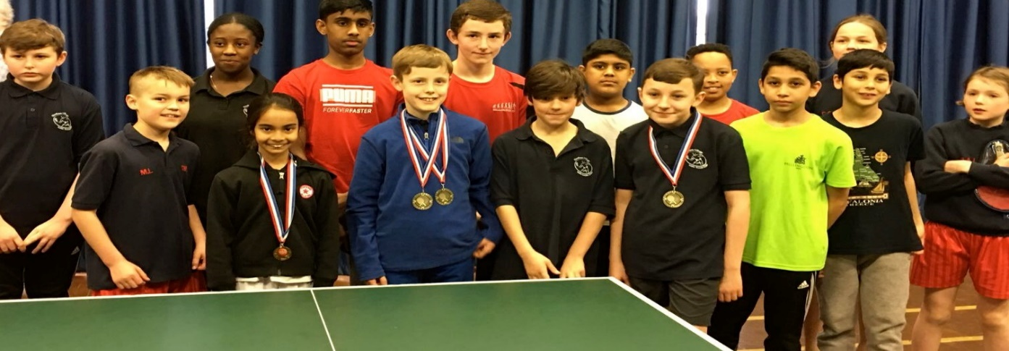

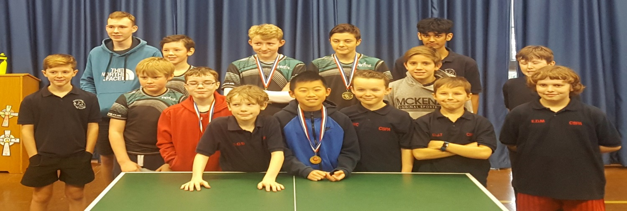

# Match Secretary’s Report

It has been another very successful year for the League.

As well as the very high standards throughout the Divisions, the matches have been conducted in the true sportsmanship we have come to expect from our players. It was particularly good to welcome a new club, Brunel, with two teams to the league.

There was one change of venue this season. Hillingdon moved into a new sports hall which is only 30 metres away, but it has a new entrance to the club.   
  
**League Update/Status**

Following discussions at our Club Secretary’s Meeting back in the early summer, our League continued with the three Divisions this season.

At that meeting, it was also decided to continue to play each team 3 times rather than the usual 2 times, due to the number of teams. There were 18 teams totalling 98 players. This gave 135 matches in total across the Divisions, of which, only three matches were conceded.

In Division 1, The top three teams were all Denham Village teams this year, in the order of A, B and C (as you would probably expect!). We were sad to lose the Hillingdon team from last year but we look forward to seeing if we have any new teams for next season to challenge Denham for the top position.

In Division 2, the honours went to Hillingdon, who were clear winners with Denham Village D in 2nd place. This means that we will probably have a Hillingdon team in the 1st Division again. We will discuss this and other matters at the Club Secretaries meeting in early August (expected to be 6th August).

In Division 3, the top two teams were both Denham Village teams, with the G team winning the division, followed by the F team.

Moving from a team performance to an individual lens, many congratulations go to the following players who played more than 60% of the League matches and were in the top 2 player averages:

* Division 1: [Yanu Aurelian](https://www.tabletennis365.com/Chalfonts/Results/Player/Statistics/Winter_2017-18/Yanu_Aurelian/209543) (Denham) and [Nigel Naylor-Smith](https://www.tabletennis365.com/Chalfonts/Results/Player/Statistics/Winter_2017-18/Nigel_Naylor-Smith/209546) (Denham)
* Division 2: Dave Hales (Chalfont) and [Stephen Wright](https://www.tabletennis365.com/Chalfonts/Results/Player/Statistics/Winter_2017-18/Stephen_Wright/217187) (Denham)
* Division 3: [Nathan McDonagh](https://www.tabletennis365.com/Chalfonts/Results/Player/Statistics/Winter_2017-18/Nathan_McDonagh/209585) (Denham) and [Jack Betts](https://www.tabletennis365.com/Chalfonts/Results/Player/Statistics/Winter_2017-18/Jack_Betts/211229) (Brunel)

In summary, this has been a very successful and enjoyable season with some top class players in the first Division and a good standard throughout all the Divisions, providing some very competitive table tennis, and close matches.

Finally, my thanks to all the Team Captains and Club Secretaries for all their support this season, for keeping all the matches ticking over and for submitting the scorecards in on time – it has enabled us to keep the League on track without issue.

I wish you all an enjoyable summer break and look forward to the next season.

***Hazel Williamson***

Match Secretary



***The Chalfonts and District Table Tennis League***

# General Secretary’s Report

In last year’s Top Spin Attack document, we discussed three aims for us as a Committee to focus on:

* Encourage further participation and enjoyment through new competition formats
* Develop further the League structure with regards the number of teams in each Division, ensuring that each Division maintains a strong competitive edge
* Continue the expansion and development of our Junior League and Junior members, drawing on the support (financial and operational) of both League and County

My belief is that we have again delivered well against these aims. The social tournament at the start of the season, and the more recent end of season tournament were great reminders of how to mix camaraderie with competition.

Similarly, the continuation of the three-tiered divisional structure has maintained the competitive edge, and the ongoing success of our juniors through the Junior League programme has seen some exciting talent emerge and develop. As always, thanks go to all those involved with promoting these three aims.

For the first time, as published on our League TT365 website, the Committee has discussed, signed and adopted the ETTA Safeguarding Policy to ensure we have the right focus, good practice in regards the welfare of children and vulnerable members of society.

As always, I would like to thank all of my fellow Committee members for their continued support and commitment in attending so many of our monthly meetings given how busy all of our own lives continue to be. Special thanks to Hazel and her husband for hosting us so graciously every month.

We are unfortunately losing two Committee members at the end of this season, one due to continued challenges with health, and one due to the need to focus his activities down to one league. If there are any players or parents of players who can spare a few hours every month to support or join the remaining Committee with regards to managing our publicity or Closed Championships, then you are most welcome…please let any of us know.

Reflecting back on the positive changes that we have made this season:

* Continued transparency – Committee minutes published on our TT365/Chalfonts.com website
* Continued focus on out of League events
  + 2 * social tournaments
  + Junior League
* Welfare – adoption of the ETTA safeguarding policies
* Financial management – only a small League deficit this year through sound cost management (see Treasurer report)
* As indicated in the Chairman’s report:
  + New Facebook page for our Table Tennis League
  + Purchase of the TT365 email module to provide more consistent and easier management of communications to all League members

I am sure the above list is not exhaustive, but does certainly demonstrate how our league continues to move forward across all areas of playing, management and administration.

A number of sub-committees were formed during the year to enable events such as Fairbank Cup and Social Tournament to run successfully, including both Committee members and non-Committee members – thanks to all those who have contributed to these – they have all run so smoothly, and been well attended.

As per the league rules the Executive Committee continued to meet regularly during the playing season to administer the affairs of the league, and govern the league subject to the annual General Meeting.

This administration covers liaising with Table Tennis England and Bucks County Table Tennis Association; ensuring the health of our finances; structuring the playing schedule of the three divisions; administering TT365 with all match results, rules, forms, minutes; organising the tournaments; supporting the development of players and clubs; and driving the right culture within the league, such that playing is enjoyable, sociable, competitive, and undertaken in the right spirit.

**Just a reminder that the AGM will take place on the 14th May at the Gerrards Cross Memorial Hall from 8pm – it would be great to see as many of you there as possible, and sharing your thoughts.**

As always, many thanks to all players, Club Secretaries and Team Captains for their support to the Chalfonts and District league during the season.

***Nigel Naylor-Smith***

General Secretary

# Development Officer’s Report

In preparation for the season, we were faced with our first challenge when we received less team entries than the previous year with no teams from Rickmansworth and just one team from Hillingdon.

However, good news came in the way of a new team of students from Brunel University. Although they considered themselves a division two side they bravely accepted my request to play in division one in order to even up the divisional structure - I must applaud the students and especially their committed leader Yoey Pang for doing so and completing their first season without complaint against tough opposition.

On a mission to find more team entries I contacted ex-Rickmansworth player Cosmin who bravely agreed to captain a new team with us, we then came up with the plan of connecting him with one of Brunel’s Tutors John and creating a Brunel B side, which we can hopefully build in seasons to come.

It was a shame the annual **Closed Championships** did not run this season due to insufficient entries. We will be looking at plans for future championships so please let the committee know about your thoughts on the best format/dates/times for the tournament or why you decided not to enter this season.

I would be interested to know what players would think of a new format whereby the various events would be played on weekday evenings specially set aside for the championships.

The **Junior League** (as per my earlier detailed report in Top Spin Attack) saw teams enter from Reach Table tennis club, joining with our regular teams from CSP Academy, Hillingdon and Denham Village.

In summary across the four Saturdays and two divisions, the sessions provided some really first class TT that was enjoyed by players, and appreciated by the large number of parents, and other spectators. Congratulations to Reach Atticus for winning division one, and Denham Dodgers for winning division two.

As important as the standard of playing is the all-round enjoyment and participation and ‘special award’ medals were awarded to Carlsson Wong (CsP , division one) and Mia Lakhani (Hillingdon, division two).

My thanks to all the coaches for their sterling work, and to all the players and parents for their commitment and enthusiasm.

Once our junior players have reached a certain standard I have been feeding them into the senior league and I plan to add some more next season. I hope you all agree that the juniors have been a welcome part of league matches and have competed well this season. Denham’s J team just missed out on a Fairbank final spot, however I was delighted to ‘borrow’ the J team’s 10 year old Nicholas Carter for my own A team's cup campaign and it was a delight to watch him in action at the final.

In response to the success of last year’s **senior coaching sessions** I have again organized some sessions for this year. These were advertised to our players through the league email system, The current sessions with Eli Baraty are now fully booked up but I hope to be announcing some more dates over the next month,

I will make a concerted effort over the next month to seek out new players /teams /clubs who may want to join our league, you can also help in this regard by please spreading the word about our friendly Chalfont’s league, or do pass on any contacts of interested parties and I’ll be happy to make contact.

I am delighted that Hillingdon will be entering at least one more team next season.

They have now re-located to their super new venue and at the time of writing, we are looking forward to holding a social tournament there at the end of April.

I would like to congratulate Steve Keyes and his team for making such great strides in developing their fine club.

Last year we had the sad news that our Chairman Bob Baines passed away.

Bob’s wife Beverly has kindly sponsored an annual award in Bob’s memory, we were all keen to have something to remember Bob by, and we think this is a lovely and fitting tribute. There will be more info on this elsewhere and at the AGM where Beverly will be present.

Many thanks to my fellow committee members for all their sterling work again this season, and please do let us know if you feel you can offer some help in any way with the promotion of our fine league.

***Richard Cottle***

Development Officer

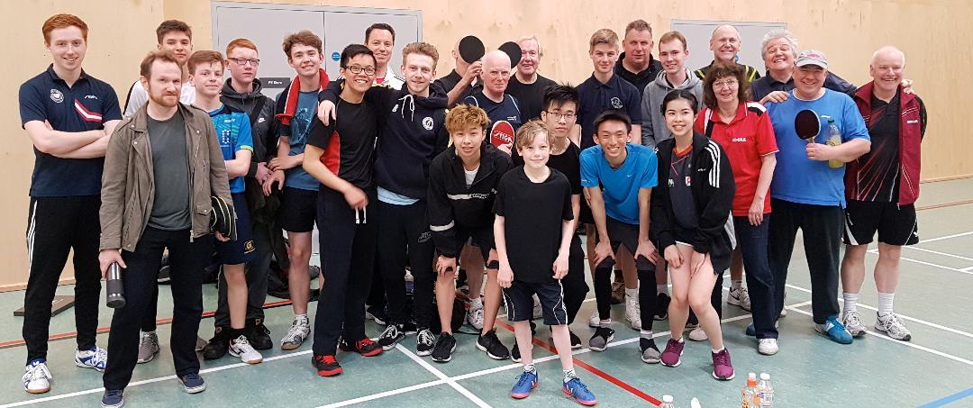End of Season Social Tournament held at Hillingdon Table Tennis Club – April 2018

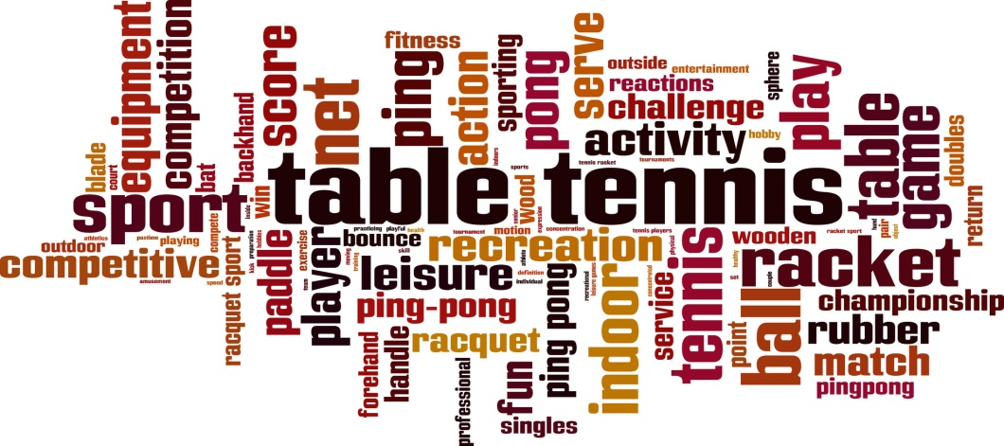

# Bucks County Table Tennis Representative’s Report

Meetings take place on the first Friday of the month - please advise me of any issues or items you wish to raise as far in advance as possible.

I outline below some of the issues that have been discussed in County meetings:-

1. The National scene was dominated by the suspension of Table Tennis England’s funding when we failed to approve the structural changes required at the 2017 AGM. The major issue was representation and after it was agreed to set up an Independent Review to consider this issue, funding was restored. As we go to press it looks as if the review will recommend a Membership Advisory Panel to represent all aspects of the game and advise the Board of TTE. Hopefully agreement will be reached at the AGM on July 17th at Hinckley.
2. Website - Chairman Brian Whitehead (Aylesbury) has begun to set up a County website which will hopefully be more extensive for the 2018/19 season.
3. Inter League Competition – Held in Aylesbury, High Wycombe A topped the first division unbeaten and Wycombe B were unbeaten in Division 2 which included our Chalfonts team of Nigel Naylor-Smith, Simon Pells, Rob Storey and Richard Cottle. We finished in 3rd position. For your Diary – 2018 Inter – League is on November 25th, same venue.
4. County Championships – I don’t have any up to date results as we go to press but earlier in the year the Veterans only just lost to Norfolk who fielded two national players. Before that the first team had beaten Herts, Cambridgeshire and Surrey.

Generally still concerned about youngsters leaving the sport though. Anyone with suggestions/support please contact Ron Hedley on rjhatters@yahoo.co.uk

1. Bucks Closed Championships – this was due to be held in October but was cancelled due to insufficient entries.
2. Bucks’ School tournament was held at Cippenham on 1.12.17. with many schools represented and play was of a high standard.
3. Umpires – Tony Green resigned as the Umpires Secretary and withdrew from umpiring, so I make my annual plea for anyone who may, for example be coming to the end of their playing days to consider training as an umpire.
4. AGM – the 2018 County AGM will be held on Friday June 1st, at Aylesbury again. Please email me for details if interested in attending.
5. Condolences were formally expressed on behalf of the committee to the families of Tony Chatwin, Carol Beames, Steve Welch, Brian Leonard, Brian Dudley and Des Morris some of whom you may remember.
6. Minutes – the minutes of our meetings are emailed to myself and to Nigel our General Secretary and can be forwarded to anyone interested.

Comments/feedback – please do not hesitate to contact me if you have any comments or questions or want me to table any information to the County committee. You can email me on [dereknmarnie@hotmail.com](mailto:dereknmarnie@hotmail.com).

***Derek Hughes***

County Representative

 **BUCKINGHAMSHIRE COUNTY**

**TABLE TENNIS ASSOCIATION**

# Treasurer’s Report – 2017-18 Season



**Financial Summary:**

|  |
| --- |
| 1. Financially the League finished the year 2017/2018 with a small deficit of £53.53 compared to the previous year, which closed with a surplus of £115.97. |
| 2. The League would like to thank James Johnson for sponsoring the 2018 Newsletter and Johnson's Group, Bribar, Robert Stephens and Bullseye for placing adverts in the 2017/18 Handbook. |
| 3. The Committee is proposing to leave the League's team and player registration fees unchanged for the forthcoming season 2018/2019. |

**Stefan Koenig**

**Treasurer**

# Final Player Averages – 2017-18 Season

Congratulations to all players who played in the League this season, and especially those below who played in more than 60% of the matches and were in the top seven player averages for their Division:





# Final League Tables – 2017-18 Season

Congratulations to all the teams for a great season – well played – final positions for each of the three Divisions are shown below:

**Division One:**

|  |  |  |  |  |  |  |  |  |
| --- | --- | --- | --- | --- | --- | --- | --- | --- |
| **Position** | **Team** | **P** | **W** | **D** | **L** | **SF** | **SA** | **Points** |
| 1 | Denham Village A | 15 | 12 | 1 | 2 | 121 | 29 | 121 |
| 2 | Denham Village B | 15 | 9 | 4 | 2 | 105 | 45 | 105 |
| 3 | Denham Village C | 15 | 7 | 2 | 6 | 70 | 80 | 70 |
| 4 | Chalfont B | 15 | 7 | 3 | 5 | 68 | 82 | 68 |
| 5 | Chalfont A | 15 | 2 | 1 | 12 | 46 | 104 | 46 |
| 6 | Brunel A | 15 | 2 | 1 | 12 | 40 | 110 | 40 |
|  |  |  |  |  |  |  |  |  |

**Division Two:**

|  |  |  |  |  |  |  |  |  |
| --- | --- | --- | --- | --- | --- | --- | --- | --- |
| **Position** | **Team** | **P** | **W** | **D** | **L** | **SF** | **SA** | **Points** |
| 1 | Hillingdon | 15 | 14 | 1 | 0 | 110 | 40 | 110 |
| 2 | Denham Village D | 15 | 7 | 3 | 5 | 86 | 64 | 86 |
| 3 | Stoke Poges | 15 | 9 | 1 | 5 | 78 | 71 | 78 |
| 4 | Chalfont C | 15 | 7 | 0 | 8 | 75 | 75 | 75 |
| 5 | Chalfont D | 15 | 4 | 3 | 8 | 67 | 83 | 67 |
| 6 | St Josephs | 15 | 0 | 0 | 15 | 33 | 116 | 33 |
|  |  |  |  |  |  |  |  |  |

**Division Three:**

|  |  |  |  |  |  |  |  |  |
| --- | --- | --- | --- | --- | --- | --- | --- | --- |
| **Position** | **Team** | **P** | **W** | **D** | **L** | **SF** | **SA** | **Points** |
| 1 | Denham Village G | 15 | 11 | 1 | 3 | 96 | 54 | 96 |
| 2 | Denham Village F | 15 | 8 | 3 | 4 | 86 | 64 | 86 |
| 3 | Brunel B | 15 | 6 | 5 | 4 | 82 | 68 | 82 |
| 4 | Denham Village J | 15 | 4 | 6 | 5 | 75 | 75 | 75 |
| 5 | Ickenham | 15 | 2 | 5 | 8 | 57 | 93 | 57 |
| 6 | Denham Village K | 15 | 2 | 4 | 9 | 54 | 96 | 54 |
|  |  |  |  |  |  |  |  |  |

