RULES
- All players must attend an affiliated school or college and be in full time education.
- Eight events - Boys and Girls under 19, 16, 13, and 11. Ages as at 1st September 2017 (Current School Year).
- Players may enter ONE EVENT only.
- Schools should not enter more than ten players in any one event.
- Entries to the Organiser by the closing date 09/02/18
- Players, or teachers in charge should report to control by 30mins prior to their event starting
- Late arrivals are liable to be scratched.
- Suitable sports wear MUST be worn. NO WHITE CLOTHING. Tracksuit trousers not to be worn during play.
- All correspondence or requests for information re the competition should be addressed to Hugo Brown. hugo100@btinternet.com PLEASE NOTE THAT A CONFIRMATION WILL BE SENT WHEN ENTRY FORM IS RECEIVED. IF YOU DON’T RECEIVE A EMAIL PLEASE CONTACT ME BY EMAIL.
- Matches will be played best of 5 games, 11 up changing service after every 2 points.

No entries will be accepted unless accompanied by the appropriate fees.

It is hoped to play in groups. The number in each group will depend on the size of entry.

The winner of each age group will represent their county in the ESTTA Butterfly National Schools' Individual Championships.

CAMBRIDGESHIRE SCHOOLS’
TABLE TENNIS ASSOCIATION
INDIVIDUAL
CHAMPIONSHIPS
Wednesday 14th Feb 2018
(10am to 2pm)
ST NEOTS TTC
The Common St. Neots Cambs PE19 1AJ
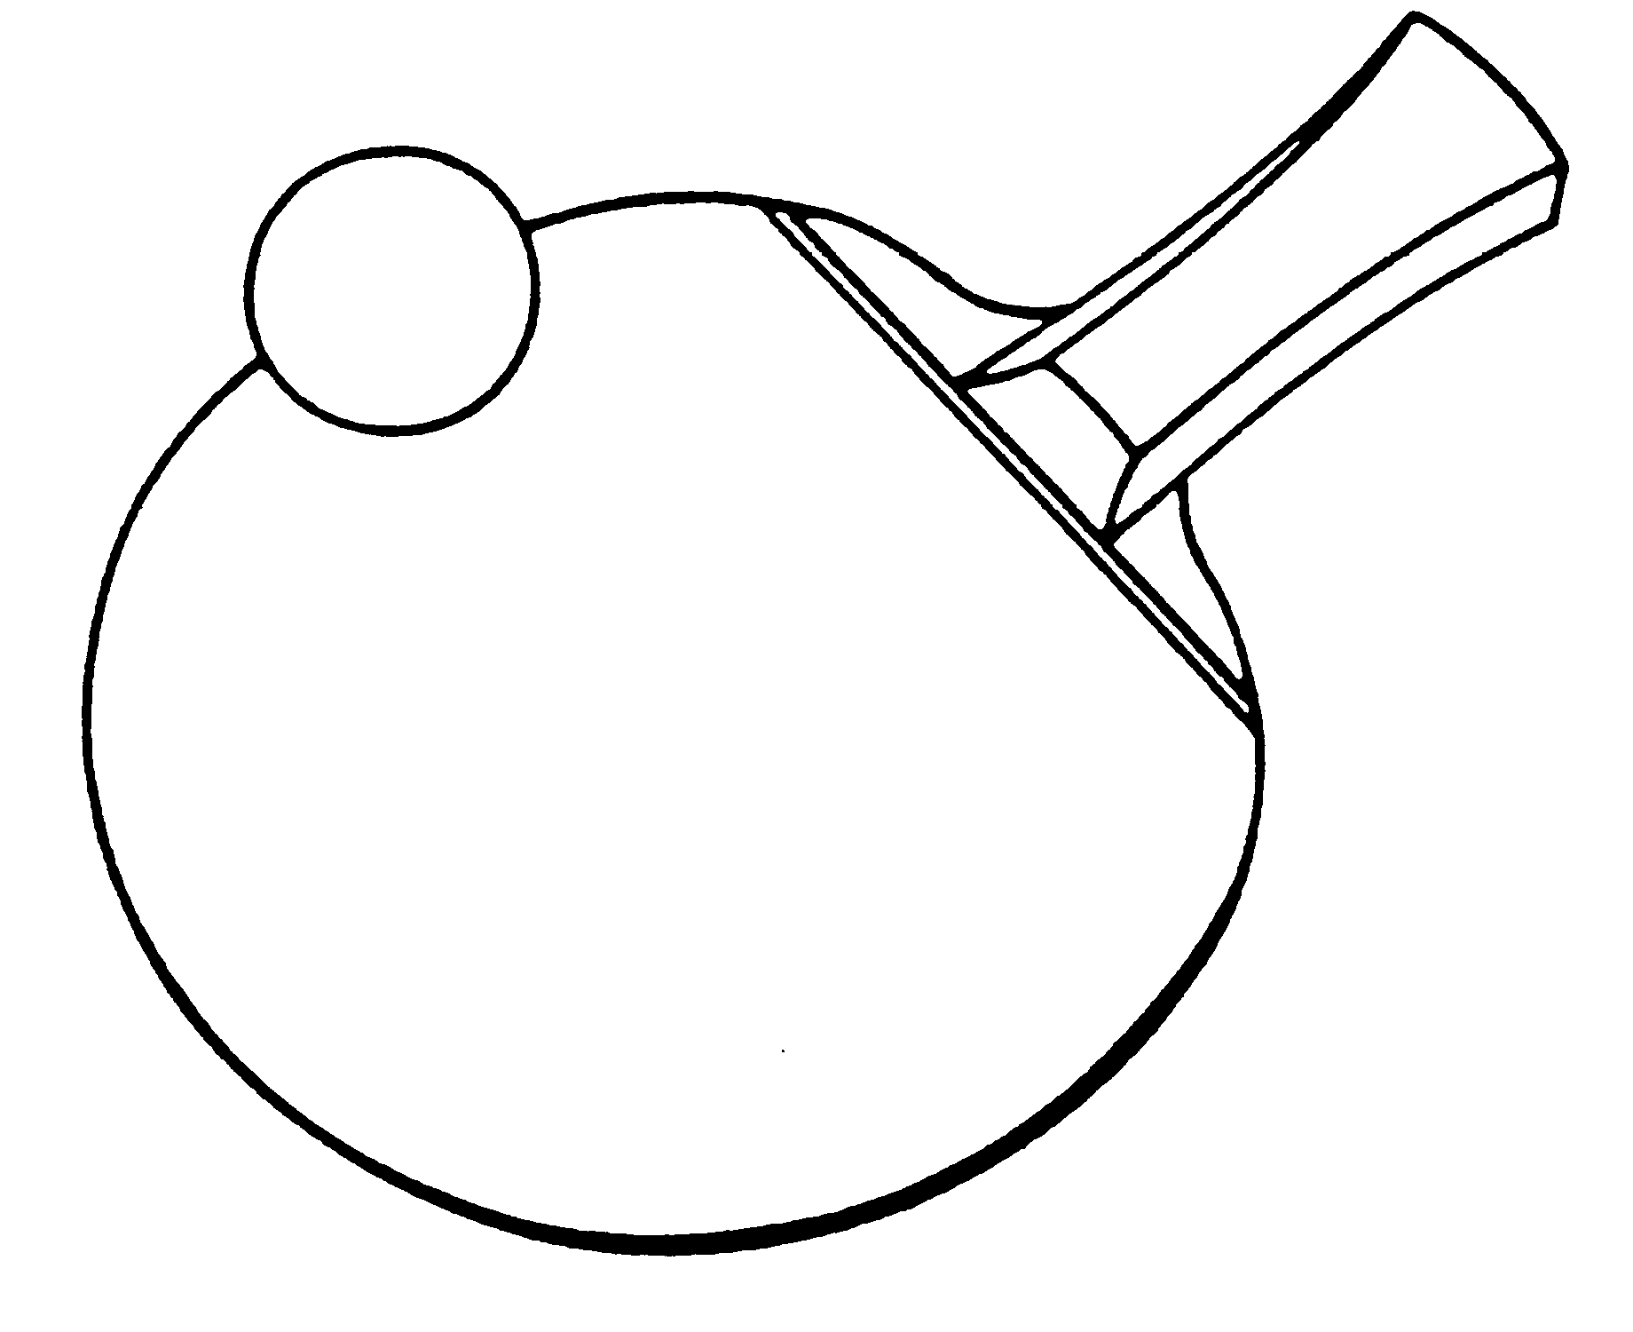
www.estta.org.uk

Closing date for entries: Friday 9th Feb 2018
This event is a qualifying competition for the
Butterfly Schools' National Individual Championship Finals
CAMBRIDGESHIRE SCHOOLS’ TABLE TENNIS ASSOCIATION
Individual Championships

ENTRY FORM
Name of School:
Address of School:
Post Code:
Teacher in charge:
E-mail:
Mobile No: (for emergencies)
Signed:
Headteacher/Deputy Headteacher

N.B. This form must be signed by the Headteacher/Deputy Headteacher

I enclose the entry fee for ……….. players at £6 each. Total £ _______

Cheques and Postal Orders should be made payable to Mr. H Brown

Please list players overleaf
(if more space is required please attach separate sheet)

Please return to:
Hugo Brown, 13 High Street, Wilburton, Cambs. CB6 3RB
by 9th Feb 2017
Text only: 07741488763
Email: hugo100@btinternet.com
YOU WILL RECEIVE A EMAIL WITH YOUR PLAYING TIMES.

LATE ENTRIES WILL NOT BE ACCEPTED ON THE DAY.

CAMBRIDGESHIRE SCHOOLS' TABLE TENNIS ASSOCIATIONINDIVIDUAL CHAMPIONSHIPS

ENTRY FORM
Please enter the following players, listed in ranked order.

BOYS | GIRLS
UNDER 19 (6th Form)  1.  2.  3.  4. | UNDER 19 (6th Form)  1.  2.  3.  4.
UNDER 16 (Yr 9, 10, 11)  1.  2.  3.  4. | UNDER 16 (Yr 9, 10, 11)  1.  2.  3.  4.
UNDER 13 (Yr 7, 8)  1.  2.  3.  4. | UNDER 13 (Yr 7, 8)  1.  2.  3.  4.
UNDER 11 (Primary)  1.  2.  3.  4. | UNDER 11 (Primary)  1.  2.  3.  4.

