Burwell Table Tennis Club Meeting
11th April 2018 at 7.30pm
Burwell Community Sport Centre
MINUTES
Present: Michel Scarff, Ivan Stiff, Keith Richardson, Astra Carter-Marsh, Dan Odling
- Apologies for Absence
Emily Birt, Martyn Livermore, Kin Cho Chan,
- Minutes from the last meeting
Approved and signed as correct by Chairman.
- Matters Arising
Wording on last minutes changed and signed. Up to date constitution is signed.
Playing matches downstairs seems to be fine, players have been more attentive of the match, less knocking up on spare tables.
Keith has chased up the shirt supplier Cho! regarding shirts that are the wrong colour but the new ones have not turned up yet.
Mick has been looking at using the business facebook page and has come to the conclusion that it is probably best to use the original facebook account as it has the most followers but needs to get admin control from Phil Morris.
Ivan has asked Dan G about us getting a new table. Dan does not want us to as he is concerned about storage space.
No news about the work on the car park yet.
- Correspondence
Astra emailed Dan G to see if he had news or communications for us, below is a copy of his reply:
We'll look to fill the gallery on Thursday evenings, since it's no longer required for matches. I think there might be odd dates you'd still like to use it and as long as we have fixtures in advance this should be fine.

Ivan mentioned interest in starting the Thursday session at 6:15pm for younger players. The slot is vacant at the moment, but may not be available in the long term, as we would really like to see the gymnastics session increase to three hours as it was previously. Certainly this won't happen before September.
Ivan has probably made you aware that we're having the roof replaced. This will likely happen in May and there will be no closure or real impact other than the loss of some parking for a few weeks.
There are no planned increases to hall hire costs (we typically implement these from August) and we're satisfied with the £300 hire charge we currently receive for all day events.
- Treasurer’s Report (Michel)
(A copy of the cashbook was provided.)
The tournaments went well and we raised money as a result.
Maybe we should consider doing some refreshments at next years tournaments.
We haven't had a loss making session since our last meeting. Currently we have £1320 in hand.
- Team Captains Reports
Cambs League Captain’s Report (Kin)
During the season we were idling between bottom and third bottom position. We were at risk of dropping a division. During the last few weeks our team has been fighting back. We have reached the safe land to stay in division 2 and likely to overtake parkside as well.
Ely League Captain’s Report (Ivan)
Ely League Team Report 11th April 2018
I’d like to thank all our team members for their support throughout the season. All of our matches have been very enjoyable, and played in a spirit of good sportsmanship and good humour.
At the end of the season, we have, as expected, finished 6th in Division 3, with a total of 82 points. Individual player statistics are as follows:

Played Won Percentage

Ivan 39 27 69.23
Mick 30 12 40.00
Gordon 27 7 25.93
Richard 15 11 73.33
Antony 18 13 72.22
Anna 3 3 100.00
Emily 0

Three matches were played with only 2 players, which obviously means that we need to recruit 1 or 2 additional team members for next season. With several new reasonably good players having joined the club over the last few months, I don’t think this will be a problem.
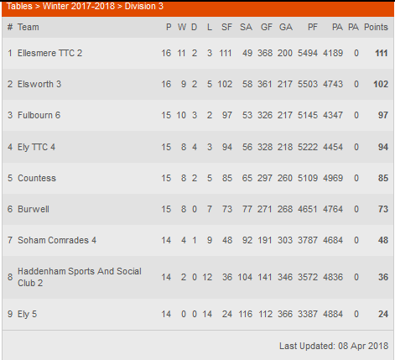
- Welfare
Nothing to report

- Coaching Section
We've had no contact from Hugo or Tony.
Keith would like to do more multiball training with the juniors. Keith will sort out a stand to hold balls.
Dan suggested that other adults could help with multiball training. Keith will teach those that are interested in helping how to do multiball training.
There was a discussion about how disruptive this type of training could be as there are a lot of balls in use and they will go into neighbouring courts. As we could not think of a practical solution to this it was decided that the best place to do multiball practice is in the court nearest the garage, which only has one adjacent court. (Upstairs was suggested but ruled out as this presents a safeguarding issue, i.e. the coach being alone with junior players.)
- Equipment
Equipment is all ok, we will check the condition of the nets before the next tournament.
Keith will contact Jarvis sports to come and collect the ad stand and drop off score boards.
- Any Other Business
Thursday session times
Under consideration is an earlier start time of 6:15 for Juniors, this would cost an extra £16 per session. We would need an influx of junior players to make this viable so we'll stick with 7:15 for now and review at the start of September.
General Data Protection Regulations (GDPR)
Keith has questioned whether we are storing more personal data than we need to by storing data through the tabletennis365 website as well as our own spreadsheet, this data only really needs to be entered for team members.
Keith will draft a data protection policy for us using the template provided by TTE. He read out what activities the template would apply to and it would cover our club activities.
Then Mick will email all members about the info we hold on them and see if they want to opt out.
Burwell Carnival
The date for this is 16th June and Ivan has found out that we can get a pitch in a tent and put on a game/competition e.g. knocking table tennis balls into pots. This would give us some publicity and maybe some funding. We need to come up with ideas for games and prizes.
- Date of Next Meeting
Thursday 14th June AGM. Free play for attendees.
- Close of Meeting
Meeting closed at 9:00pm

