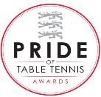

Club of the Year

2016

Brandon Community

Hall
, Brandon

Lane, DURHAM, DH7 8SH

Tel: Tony Taylor 0
7
539 275048

Registered Charity No.1192279

Issue 61
13th September 2022
Welcome to the 61st issue of our newsletter. It is with much sadness that our Club joins the nation and the wider Commonwealth in mourning the death of Her Majesty, Queen Elizabeth II. We extend our heartfelt condolences to the Royal Family at this sad time.

EDWIN RECEIVES CLUB FELLOWSHIP
It is with great pleasure that the Club has honoured Edwin Fellows who has been a Club member since 2013. He received his fellowship award and worthy accolade at the session he regularly attends, on a Wednesday morning, in front of many of his table tennis friends. Apart from giving him free sessions and membership for life it also, apparently (according to Chris) gives him the rights to drive his sheep around Brandon Village!!) Congratulations to a lovely man and a true gentleman.
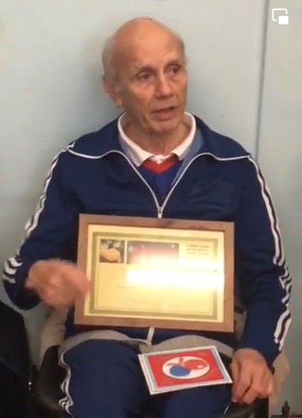

SUMMER SUCCESS
Congratulations to our Bravehearts team (Dave Brown, Phil Hansom and Paul Dale) who became 3rd Division league champions in the Northumbria Summer League with an impressive 95 points from 12 matches. Our Fusion team of young players also played in the league finishing in a credible fourth place.
The Anacondas team in the 2nd division unfortunately just missed out on a promotion place finishing third with the same points as Durham Scorpions and only losing out on matches won.
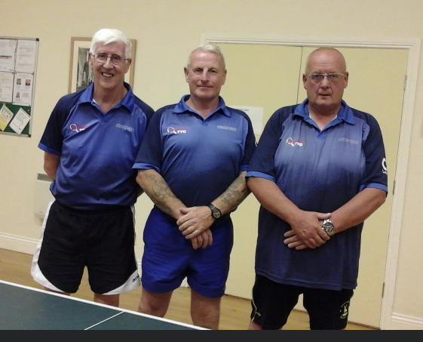
Brandon Bravehearts

VETTS NORTH EAST MASTERS TOURNAMENT
The VETTS North East Masters tournament took place on the 3/4th September at the Beacon of Light, Sunderland. A number of Brandon members participated but the glory again went to Geoff Salter who became the over 70’s champion beating the Swedish player Hans Borjesson in a well fought final.

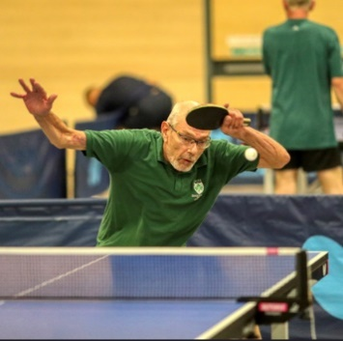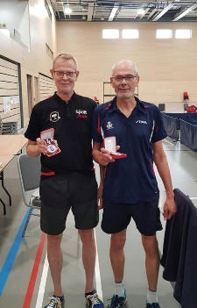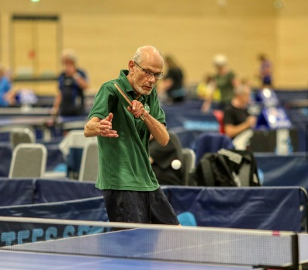

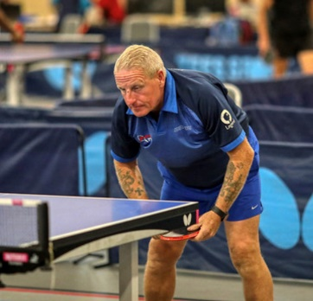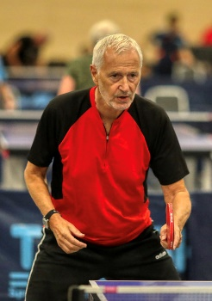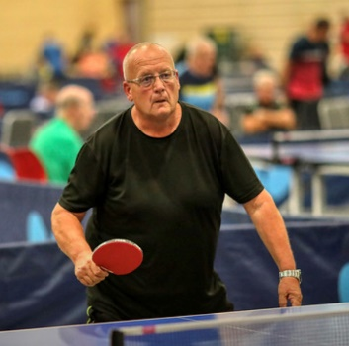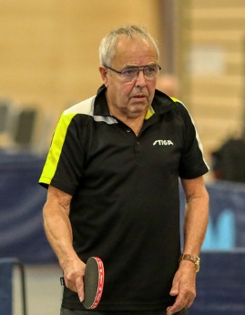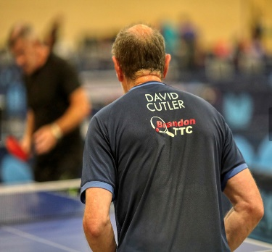
Phil Hansom Paul Stead Dave Brown John Williamson Dave Cutler

COACHING OPPORTUNITIES
Over the summer the Club has been reviewing its coaching programme to provide increased access to quality coaching.
Monday evening 5.00pm to 6.30pm – Junior coaching for Intermediate and Beginners. (£5 per session)
Thursday evening 5.00pm to 7.00pm – Junior coaching – team players (invite only) (£5 per session)
Friday evening 5.00pm to 7.00pm – Individual bookable one hour coaching with our head coach, Dave Godbold. (£20 per hour). To book your session please contact Dave (07841432400)
Saturday morning 10.00am – 12 noon – Bookable group coaching organised by our Head Coach (£6 per session) To book please contact Rita Dixon (07774592432 or ritadixon13@outlook.com)
We are hoping to extend this coaching programme to offer beginners session or sessions on Mondays and/or Thursdays 4.00pm to 5.00pm utilising our level 1 coaches.

THE NEW WINTER SEASON
I’m sure everyone is gearing up to competitive Table Tennis once again. Our eight Sunderland league teams commence their challenge for success in the week beginning September 19th and our two Northumbria teams begin their leagues on the 27th September. Could we remind all our players that they must have at least Table Tennis England compete membership as well as paid up Club membership 48 hours before they play.
SUNDERLAND LEAGUE |  |  | NORTHUMBRIA LEAGUE
Division 1 | Division 2 | Division 3 | Division 1 | Division 2
Brandon Air  Brandon Bullets | Brandon Crusaders  Brandon Joules  Brandon Outlaws | Brandon Devils  Brandon Energy  Brandon Fire | Brandon Anacondas | Brandon Bravehearts

CARD READER
No need to worry about having the correct cash to pay for your session or membership fees or anything else (generous donations accepted!!) as the Club now has a card reader and we are able to take contactless payments.

WOMEN’S AND GIRL’S SESSIONS
Following on from the success of the free summer sessions we are pleased that these sessions will be continuing supported by a grant from Table Tennis England’s new Level the Table Grant Scheme. Thanks to John Spencer for his terrific efforts in accessing grant funding.

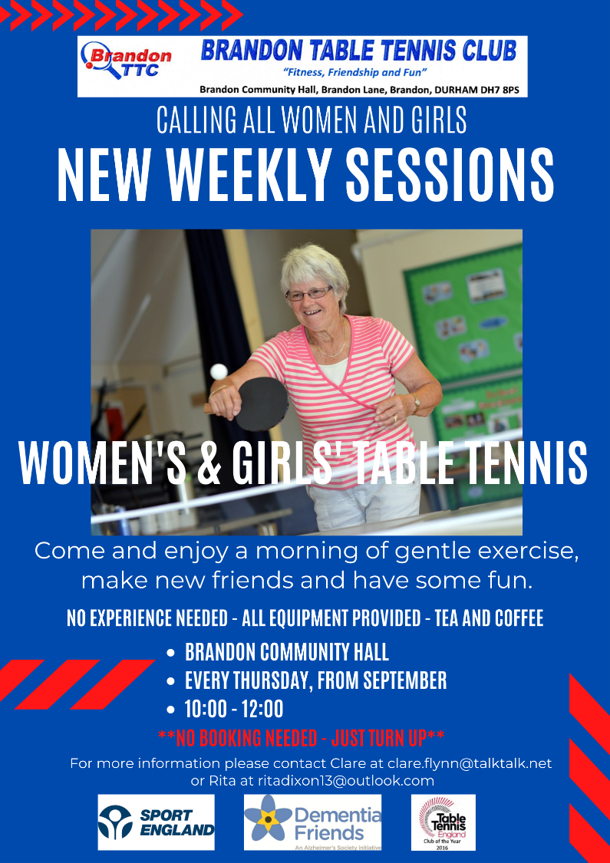

DABGC GO-KARTING
Brandon has a go-karting champion. Congratulations Dominic McCabe on winning his title at the Durham Association of Boys and Girls Club Go-Kart Challenge that took place on 1st September. Our membership of DABGC has given our junior club members opportunities to participate, not just in Table Tennis events but a variety of other activities so we offer a big thank you to DABGC.
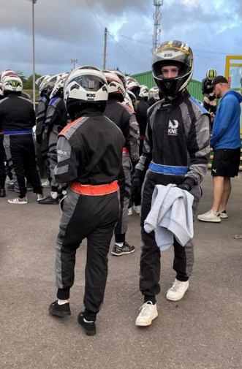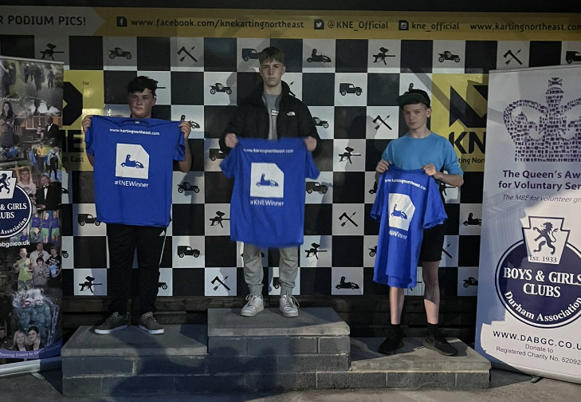

LEVEL 1 UMPIRE COURSE
We have two new level 1 umpires. Chris Leishman and Paul Henderson successfully qualified as umpires having attended an enjoyable course at Ormesby on Sunday 11th September. It would be good to know if we have any more qualified umpires within the Club. Please let us know.
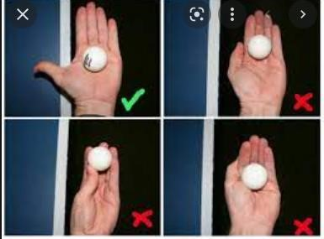
Interestingly in terms of umpiring one of the things that has been a hot
topic with the Sunderland Association is the prevalence of FOUL SERVES
and they are asking teams in general, and umpires in particular to watch
out for them. This is always contentious and can cause a lot of dispute in
the heat of a match.
In simple terms :-Toss the ball vertically up 16cm(6”) or more from a
stationary open palm and make sure your opponent can see it from the
moment you release it until you strike it. The ball should be behind the
service line (the end of the table) or an extension of that line when struck
(i.e. NOT over the table). If you are concerned about the legality of your serve please ask your practice partner/s to help ensure it’s acceptable. If we sort it whilst practicing then it shouldn’t cause problems in matches. Umpires don’t need to warn you they can immediately give a point to your opponent. You could even ask our newly qualified umpires to advise you about your serve.

NATIONAL CADET AND JUNIOR LEAGUES
The Club has entered teams into the National Cadet League for under 15’s and the National Junior League for under 19’s. These leagues are seen as feeder competitions to the Junior British League. Once again all the competitions will be held at Ormesby TTC. Good luck to all our young players.

National Cadet League | National Junior League
Sunday 6th November  Sunday 27th November  Sunday 8th January  Sunday 12th March | Saturday 15th October  Saturday 19th November  Saturday 21st January  Saturday 25th February

We would also like to wish good luck to Freya Williams as she plays her second season for Northern Girls in the prestigious Girls Junior British League. Congratulations also to Max Hancock who has been selected to play for the Durham County Cadets.

THE QUEEN’S FUNERAL – TABLE TENNIS ENGLAND ADVICE
“All table tennis activity, planned for the day of Queen Elizabeth’s funeral (Monday 19th September) should be postponed or cancelled. Even though the guidance allows for activity to continue on the day of the funeral, Table tennis England respectively asks for the pausing of all table tennis on this day.”
As a result, please be aware that all the League matches scheduled for the 19th September have been postponed and the Club will be closed on that day as a mark of respect for the occasion.

NEW EDITOR REQUIRED
It was pleasing to hear this week that our trustee, John Foster’s health is improving. In his absence, I’ve been acting as newsletter editor for the past six months however this will be my last newsletter. Any member interested in taking on this role please contact Tony Taylor.

Thanks to all our readers
Alan Perry (acmperry24@gmail.com or 07443037254)
That’s All Folks

